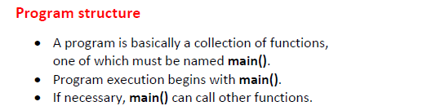

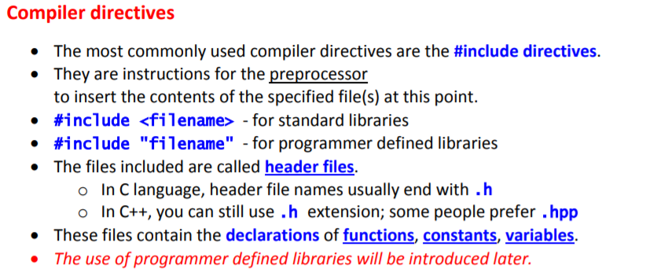

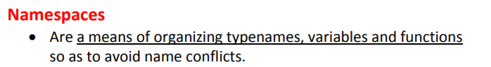

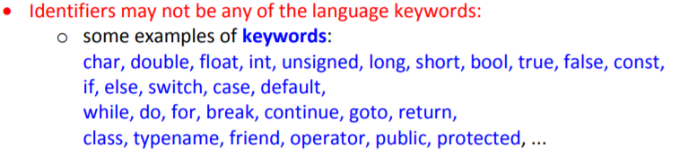

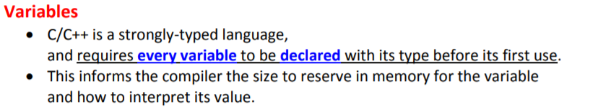

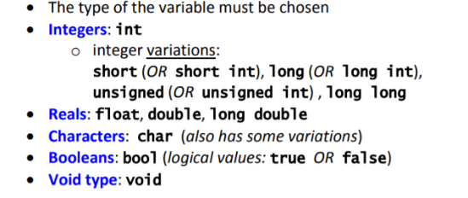



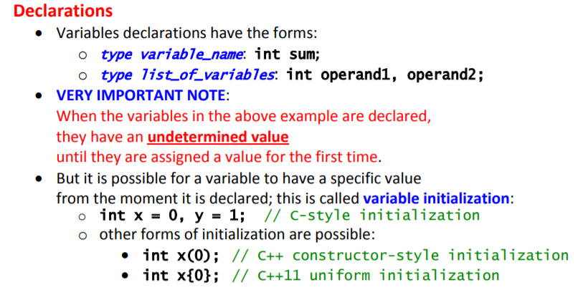

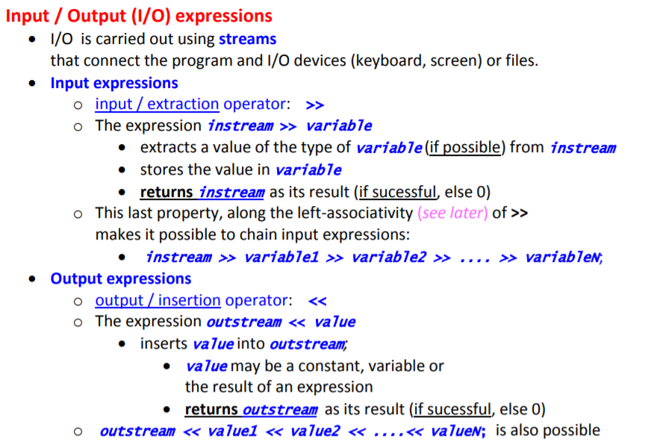

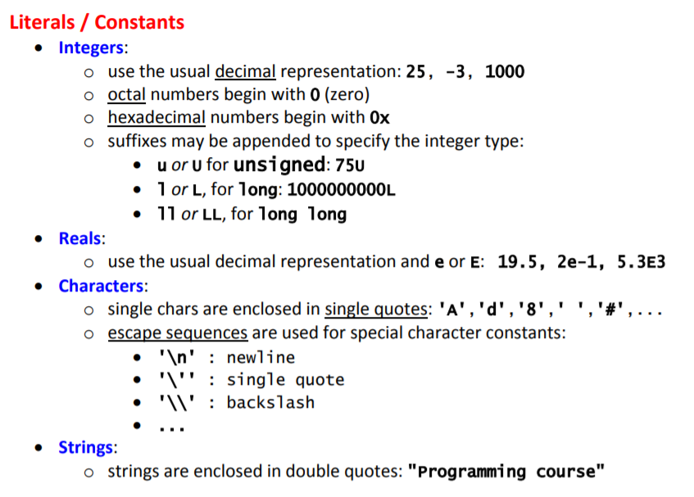

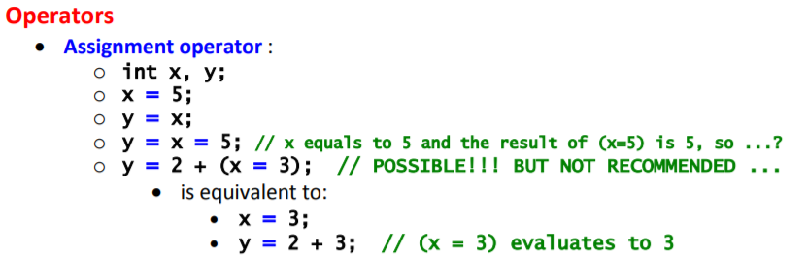

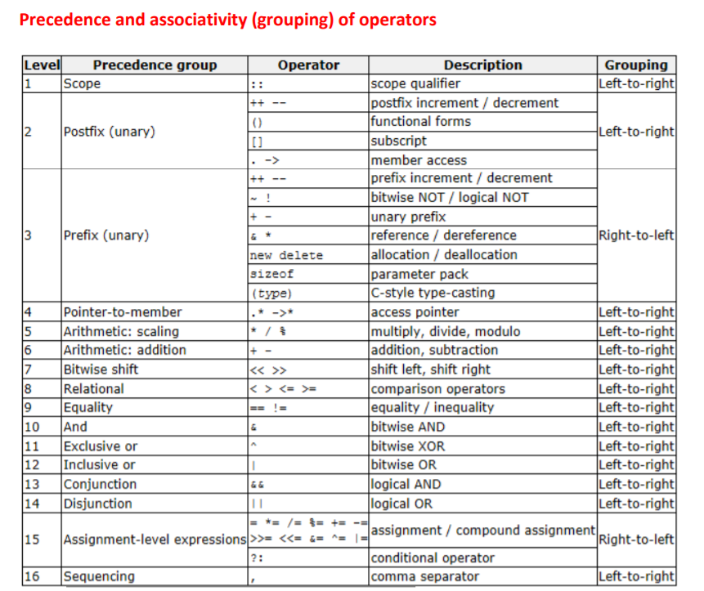

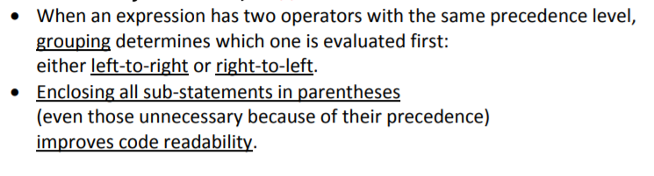

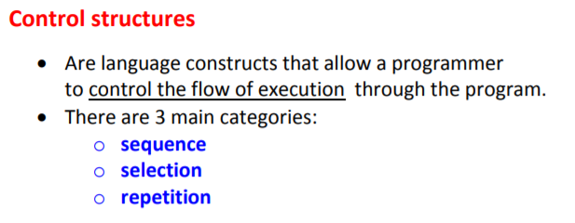

If…else…, switch… case…

Sequência das instruções

For, while, do…while

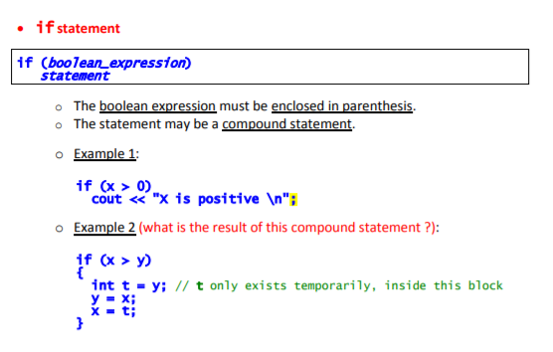

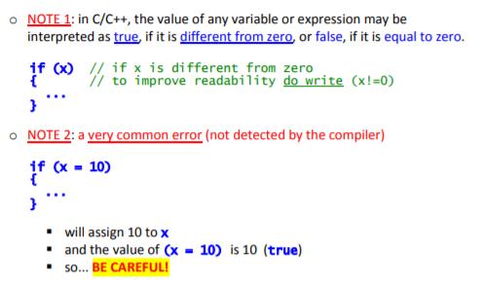

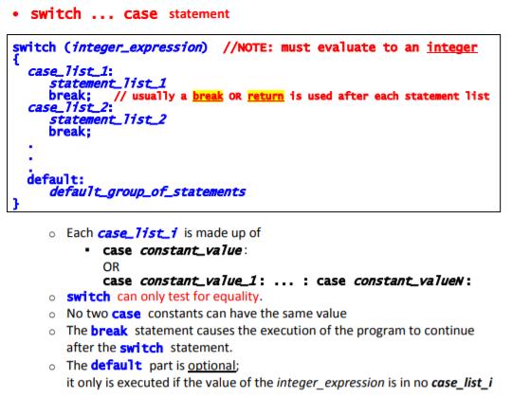

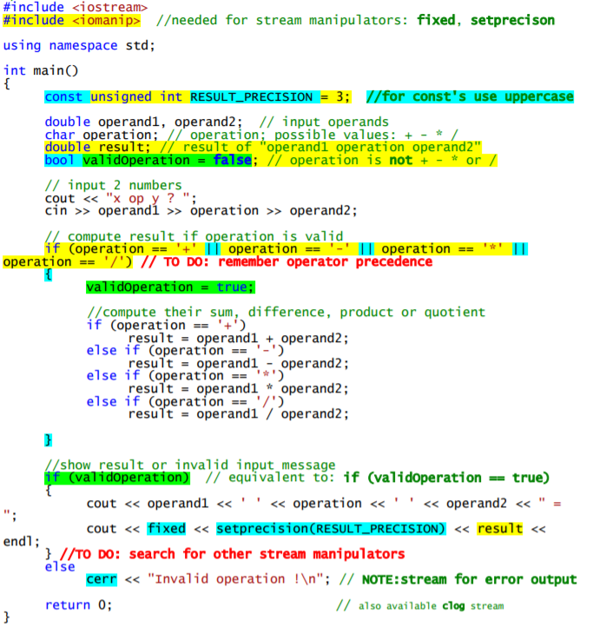

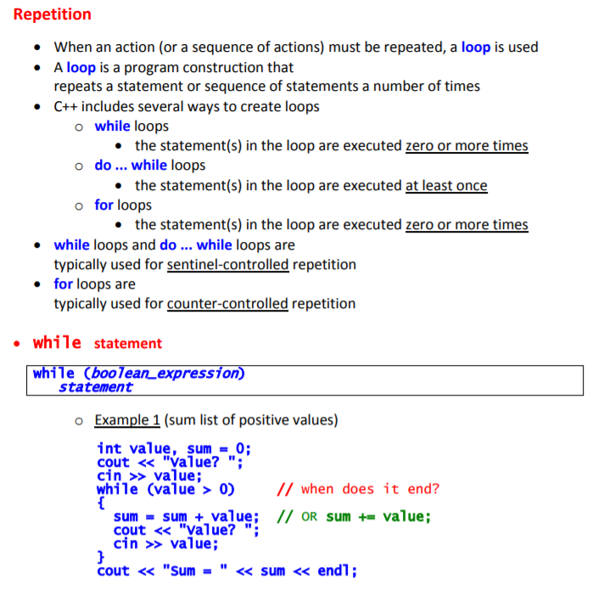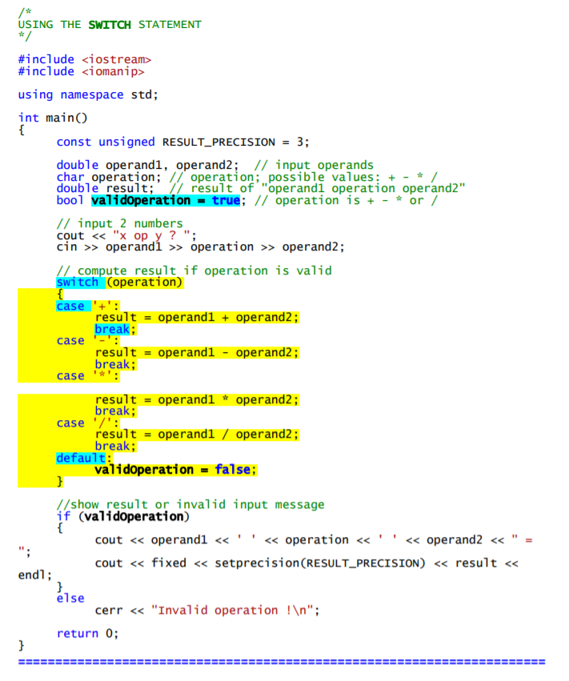

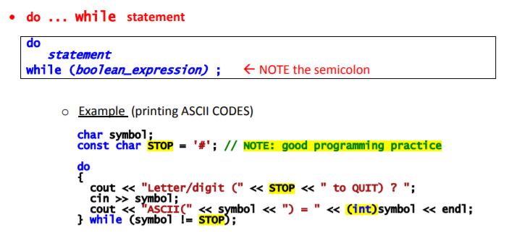

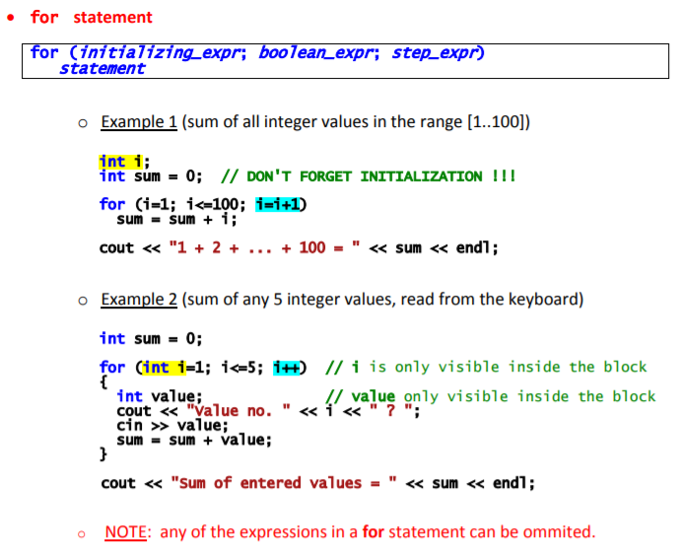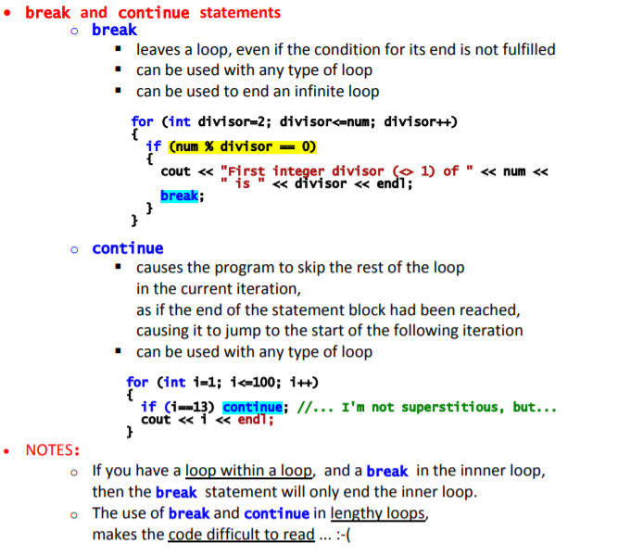

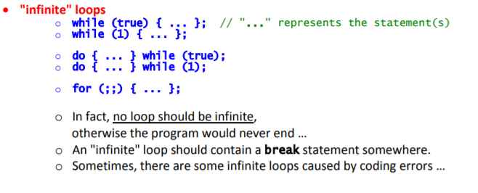

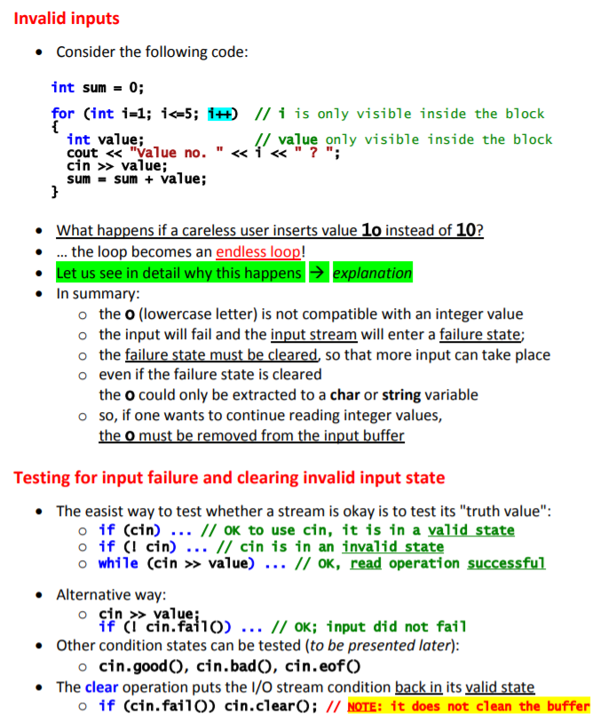

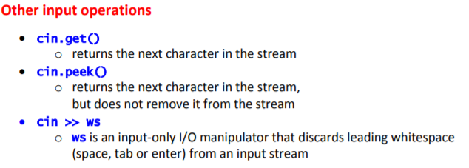

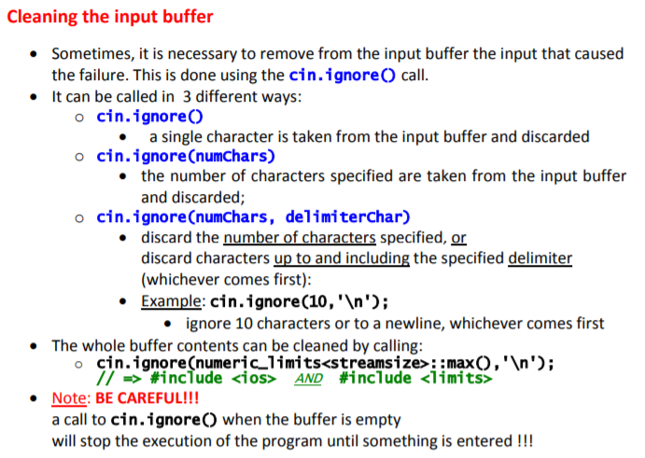

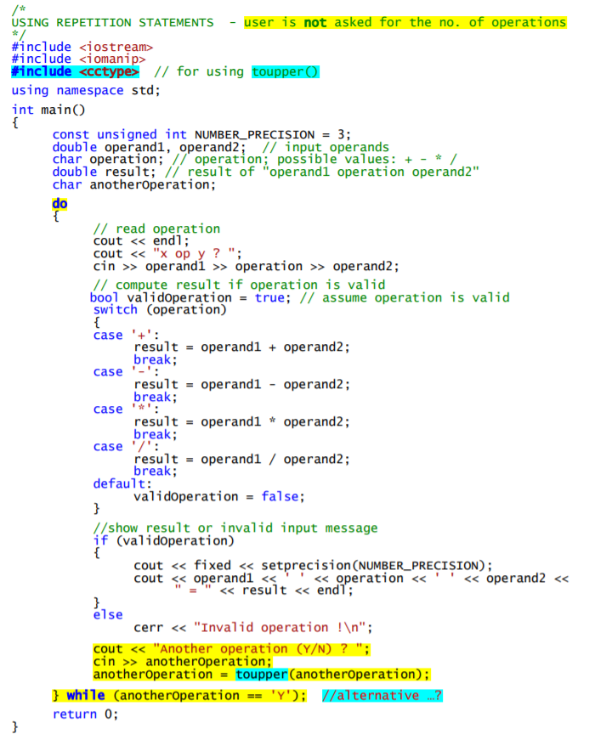

Example of cin.clear() e cin.ignore():

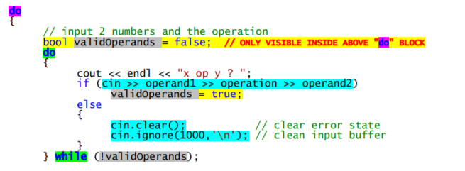

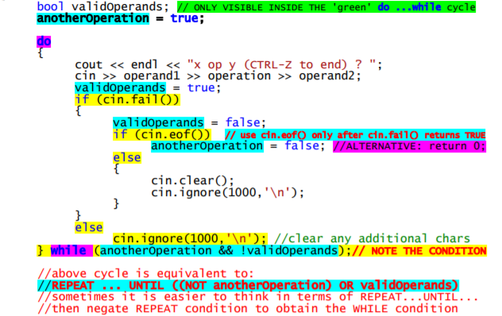

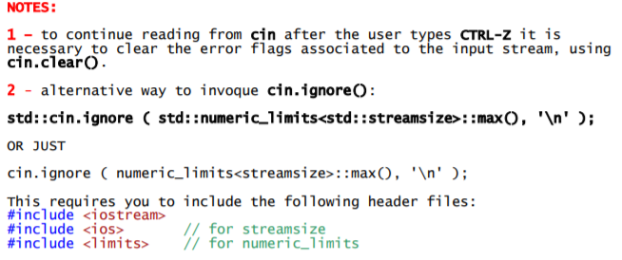

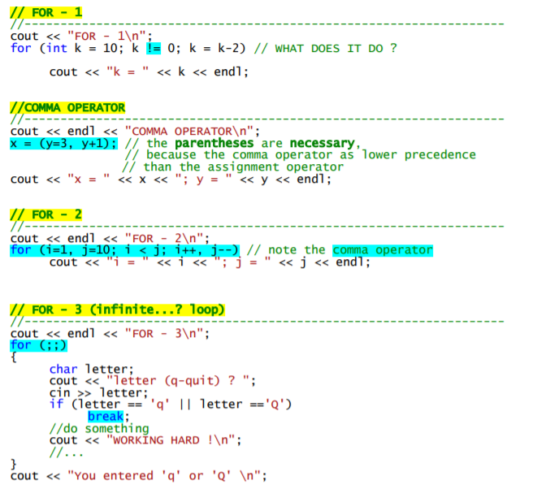

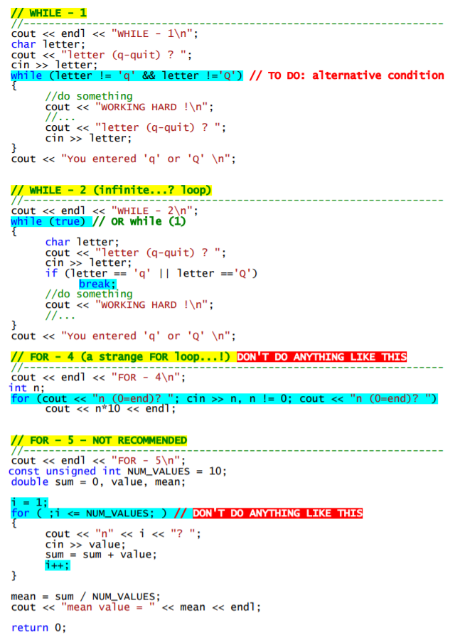

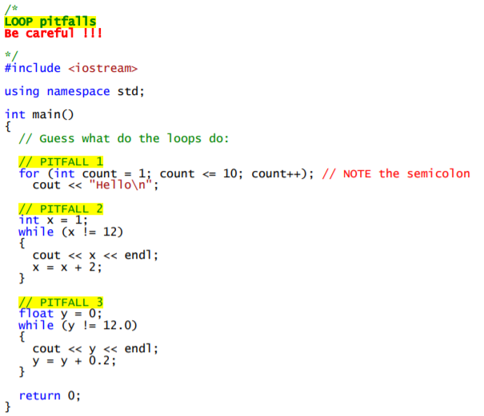

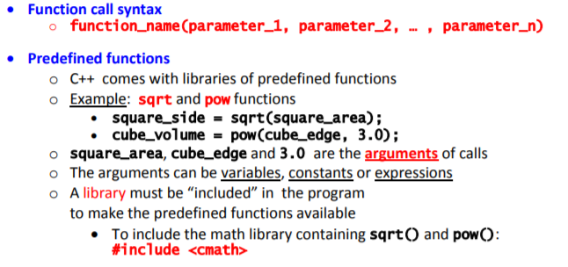

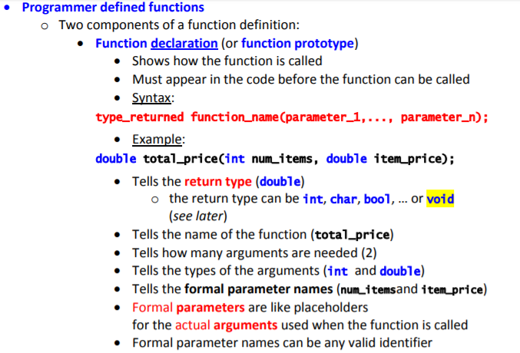

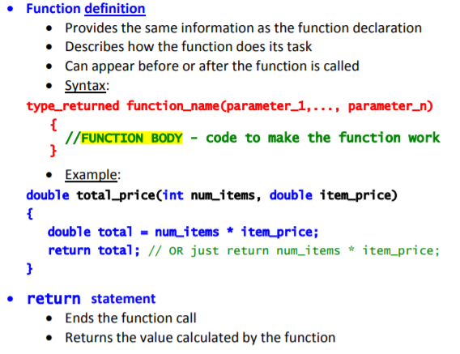

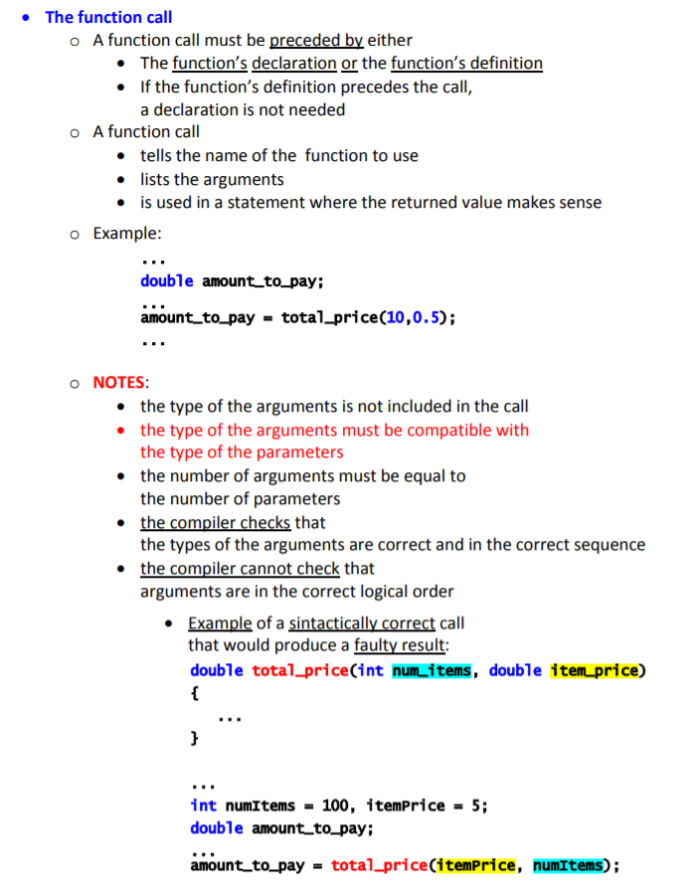

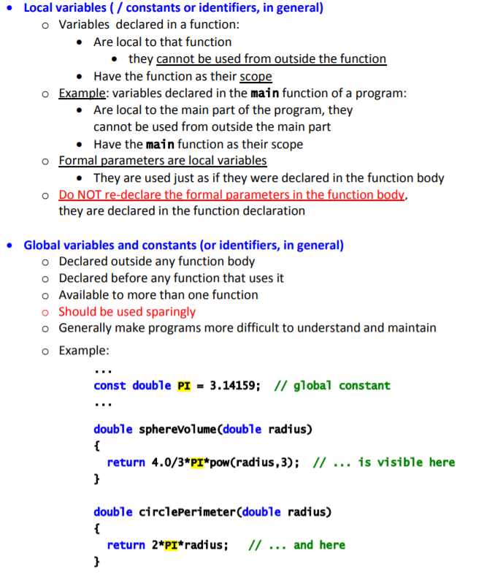

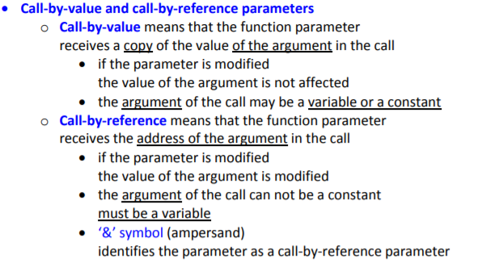

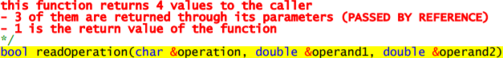

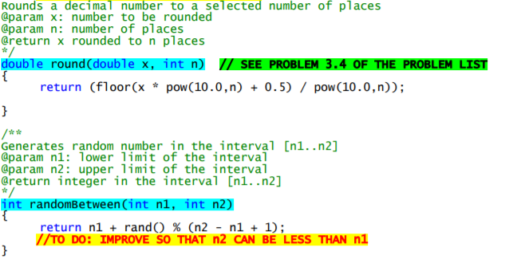

ATTENTION!!

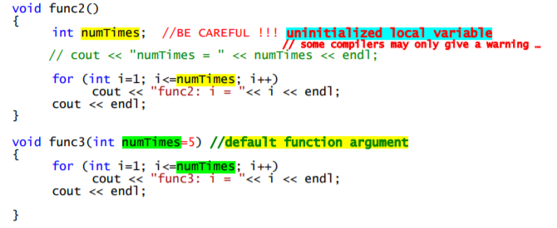

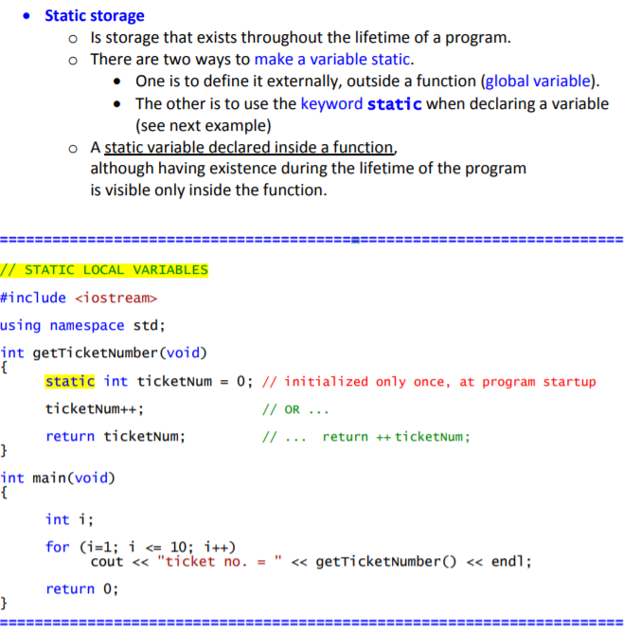

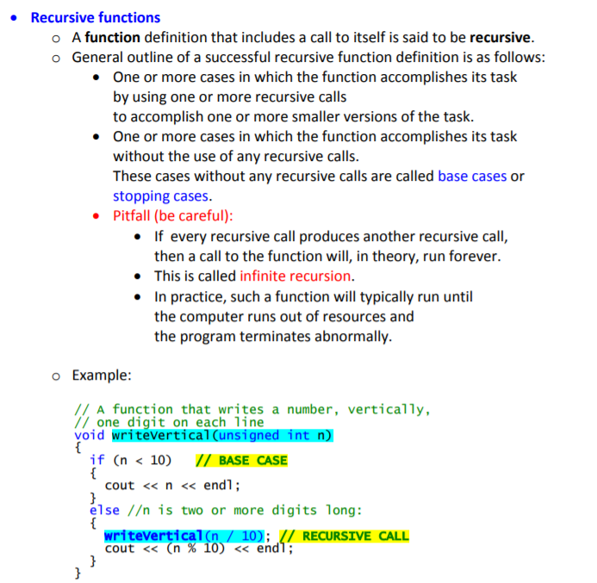

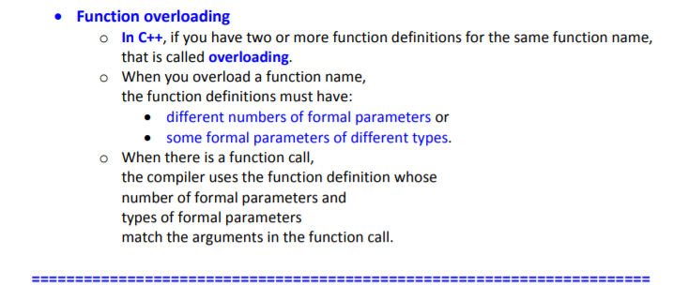

Função como parâmetro:

double func(double);

double integrateTR(double f(double), double a, double b, int n);

Na main: integrateTR(func,a,b,n); 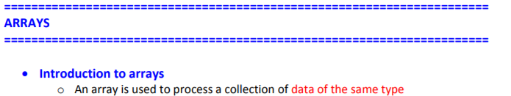

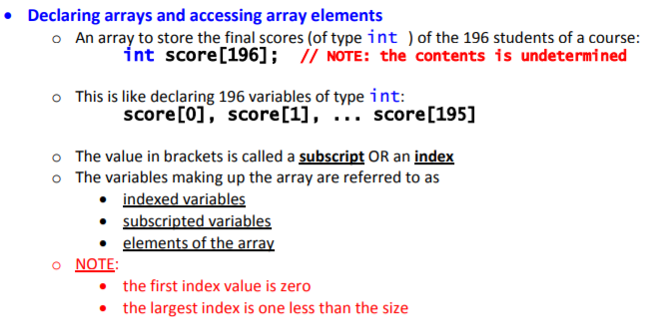

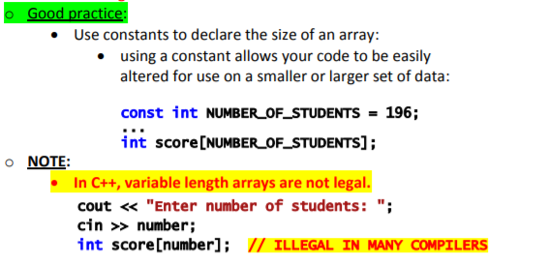

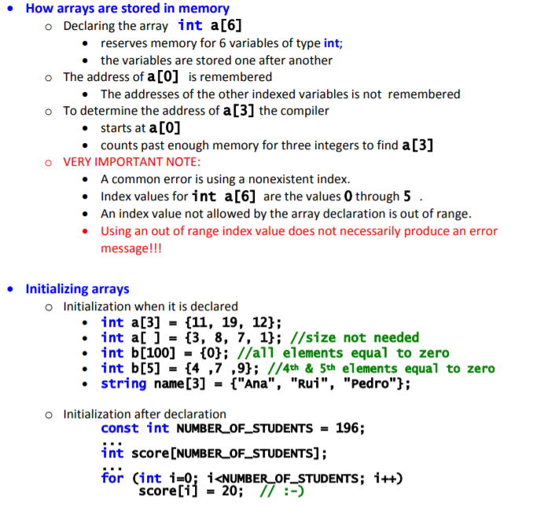

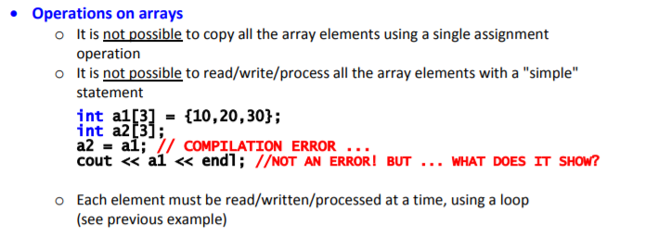

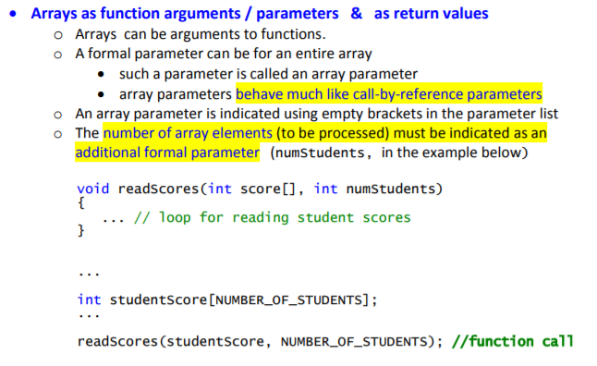

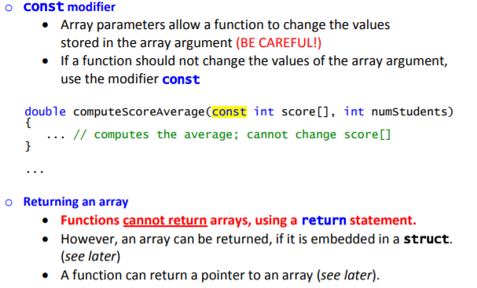

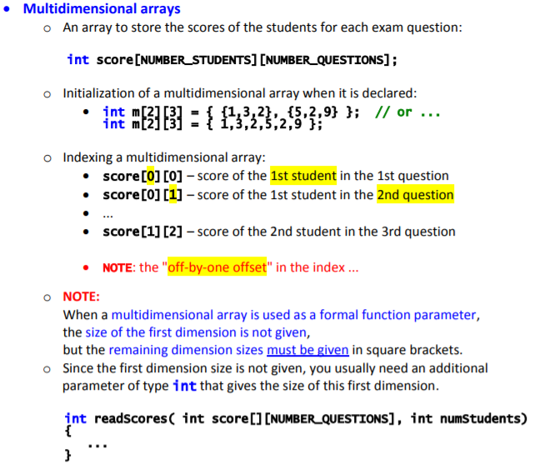

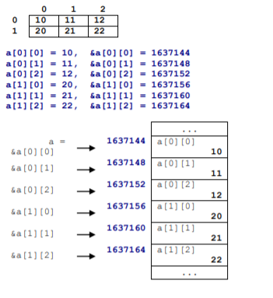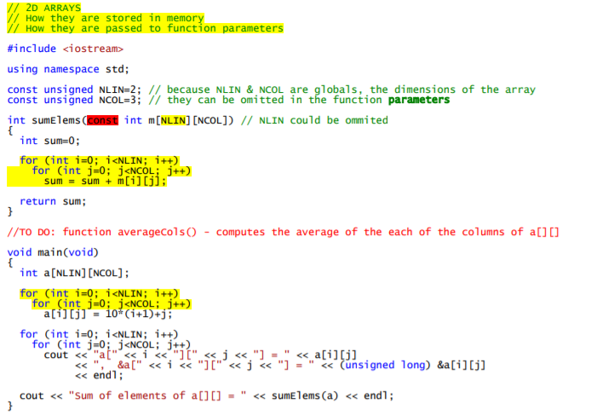

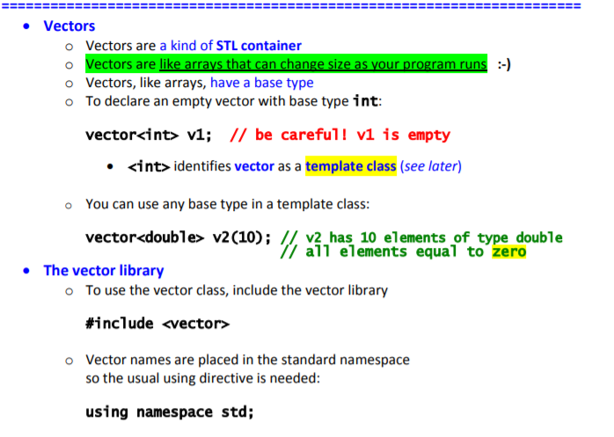

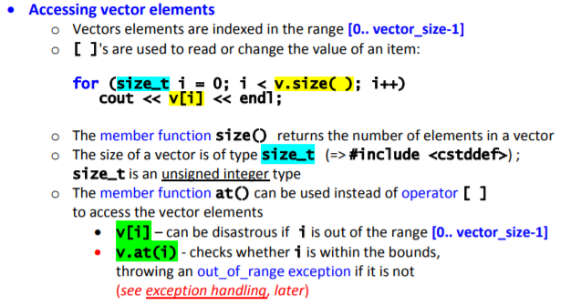

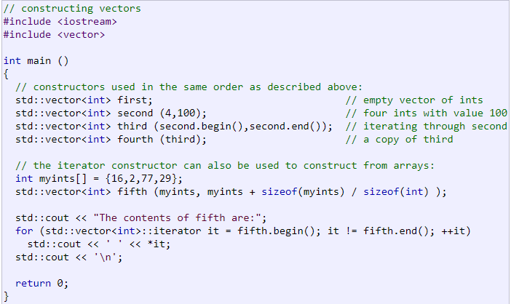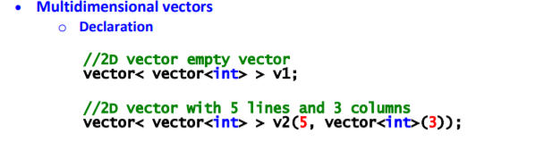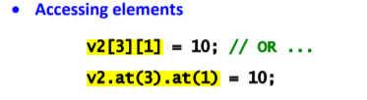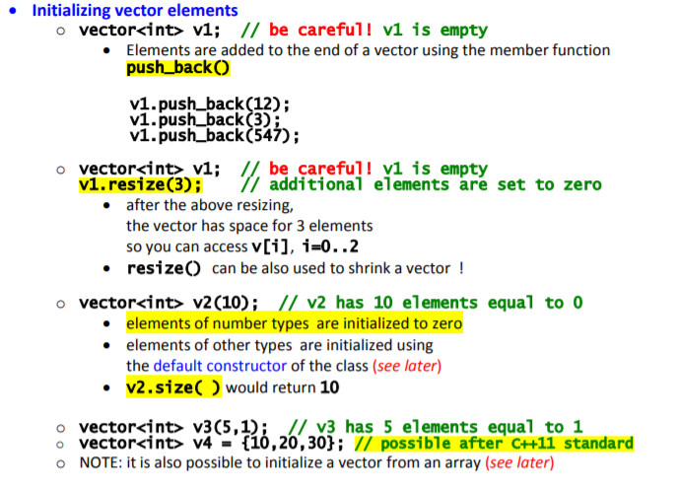

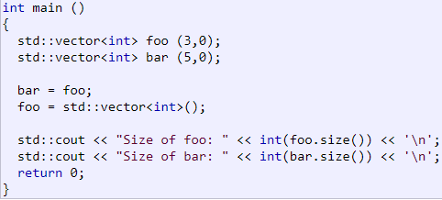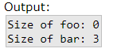

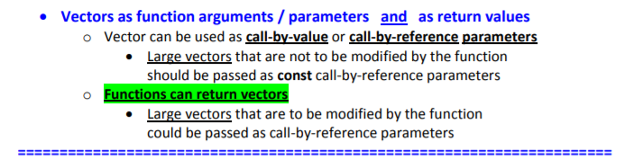

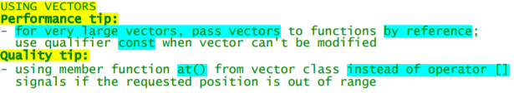

**Vector.size()**

**Vector.max_size()** -> Returns the maximum number of elements that the [vector](http://www.cplusplus.com/vector) can hold.

**Vector.resize(n)** -> Resizes the container so that it contains n elements

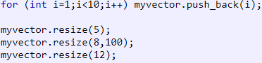 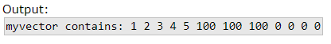

**Vector.capacity()** -> Returns the size of the storage space currently allocated for the [vector](http://www.cplusplus.com/vector), expressed in terms of elements.

**Vector.empty()** -> Returns whether the [vector](http://www.cplusplus.com/vector) is empty (i.e. whether its [size](http://www.cplusplus.com/vector::size) is 0), true if empty, false otherwise

**Vector.shrink_to_fit()** -> Requests the container to reduce its [capacity](http://www.cplusplus.com/vector::capacity) to fit its [size](http://www.cplusplus.com/vector::size).

**Vector.front()** -> Returns a reference to the first element in the [vector](http://www.cplusplus.com/vector).

**Vector.back()** -> Returns a reference to the last element in the [vector](http://www.cplusplus.com/vector).

**Vector.data()** -> Returns a direct pointer to the memory array used internally by the [vector](http://www.cplusplus.com/vector) to store its owned elements.

**Vector.assign()** -> Assigns new contents to the [vector](http://www.cplusplus.com/vector), replacing its current contents, and modifying its [size](http://www.cplusplus.com/vector::size) accordingly.

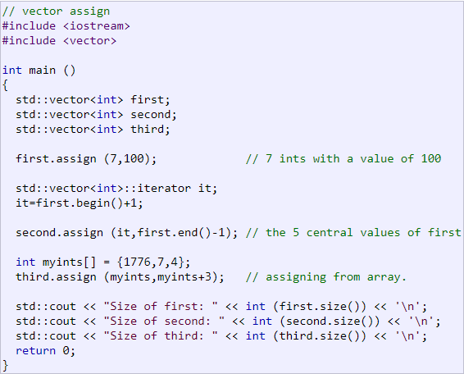 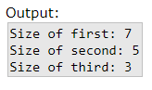

**Vector.push_back(element)** -> Adds a new element at the end of the [vector](http://www.cplusplus.com/vector), after its current last element.

**Vector.pop_back()** -> Removes the last element in the [vector](http://www.cplusplus.com/vector), effectively reducing the container [size](http://www.cplusplus.com/vector::size) by one.

**Vector.swap()** -> Exchanges the content of the container by the content of x, which is another [vector](http://www.cplusplus.com/vector) object of the same type. Sizes may differ. A = {1,2}; B = {2,3,4}; A.swap(B); 🡪 A= {2,3,4}; B={1,2};

**Vector.clear()** -> Removes all elements from the [vector](http://www.cplusplus.com/vector) (which are destroyed), leaving the container with a [size](http://www.cplusplus.com/vector::size) of 0.

**Vector.insert()** -> The [vector](http://www.cplusplus.com/vector) is extended by inserting new elements before the element at the specified position, effectively increasing the container [size](http://www.cplusplus.com/vector::size) by the number of elements inserted.

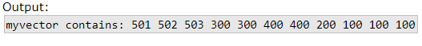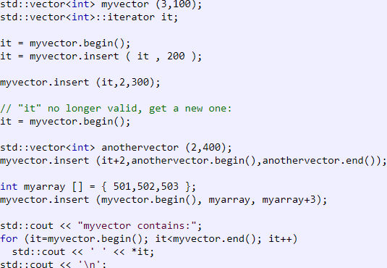

**Find (using vector)** -> Returns an iterator to the first element in the range [first,last) that compares equal to val. If no such element is found, the function returns last.

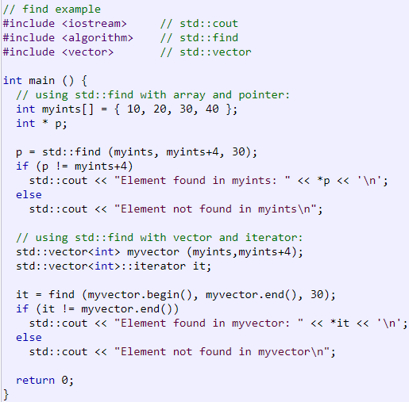 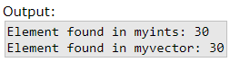

**count() ­**-> Returns the number of elements in the range [first,last) that compare equal to val.

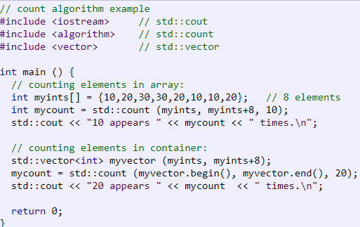 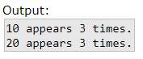

**Vector.erase(n):**

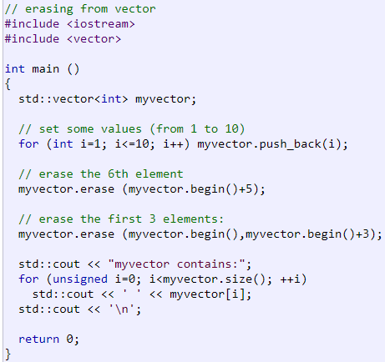

**sort()** -> Sorts the elements in the range [first,last) into ascending order.

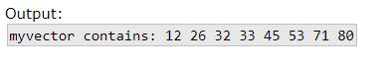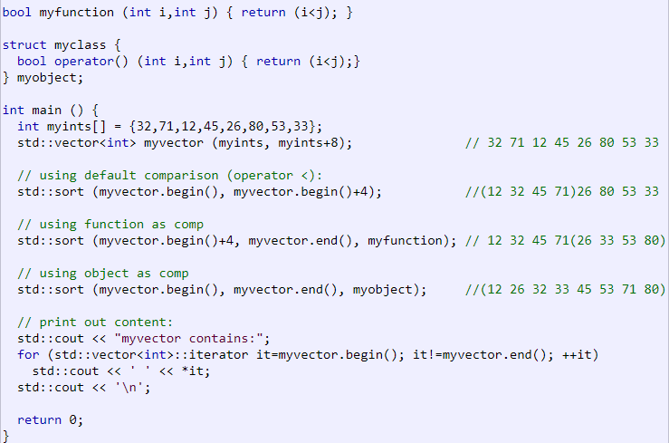

**set_intersection()** -> Constructs a sorted range beginning in the location pointed by result with the set intersection of the two sorted ranges [first1,last1) and [first2,last2).

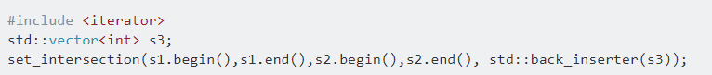

**set_union()->** União entre dois vetores ordenados.

std::vector<int> v;

std::set_union(x.begin(), x.end(), y.begin(), y.end(), std::back_inserter(v));

**unique()** -> Removes all but the first element from every consecutive group of equivalent elements in the range [first,last). (Para remover todos os duplicaods, ordenar primeiro)

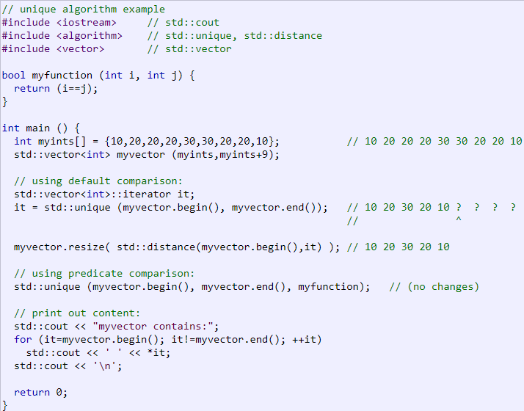 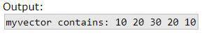

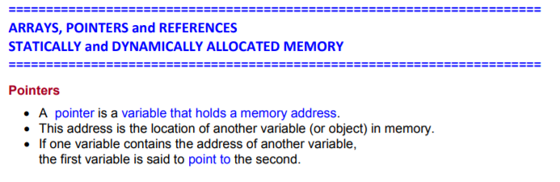

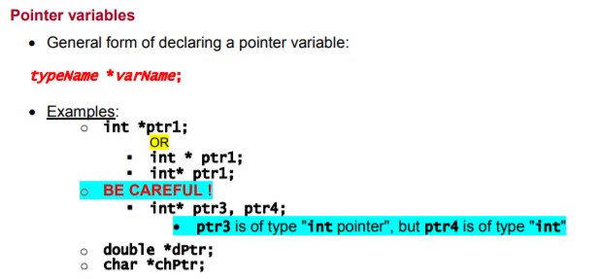

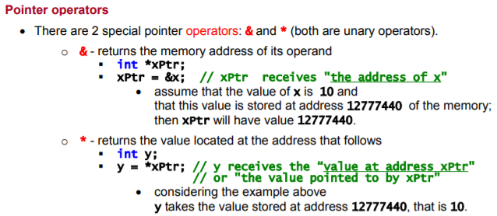

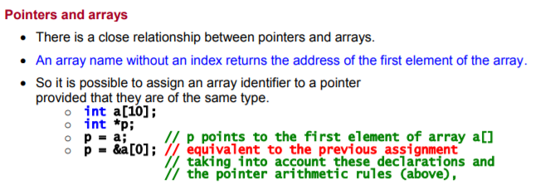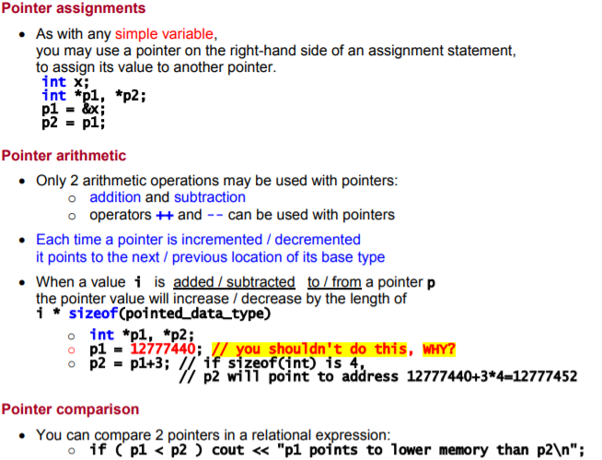

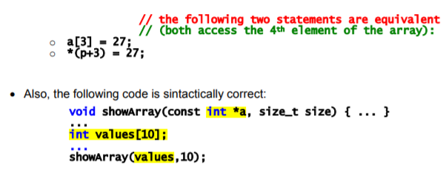

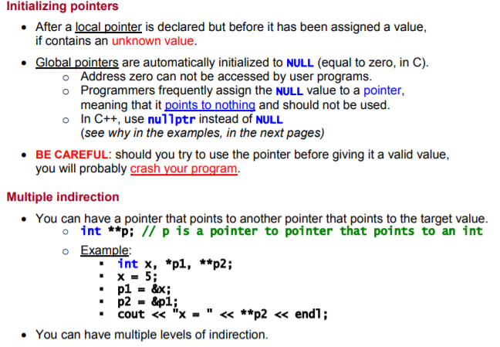

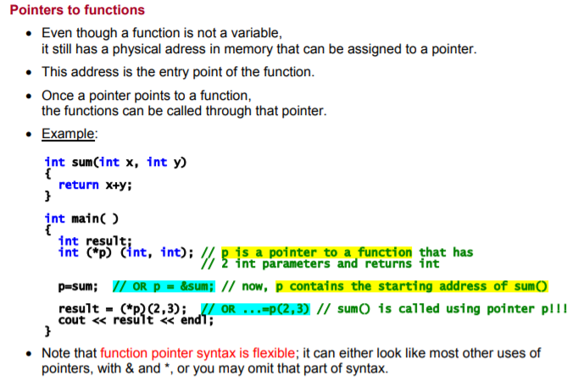

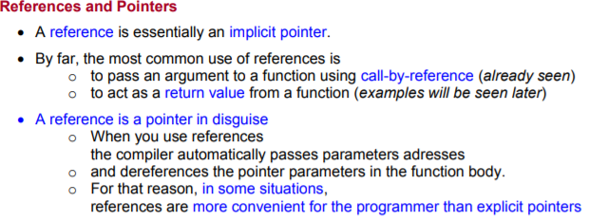

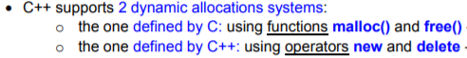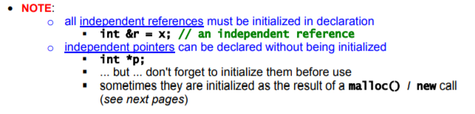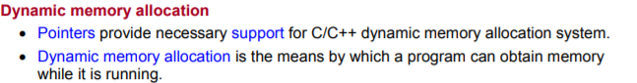

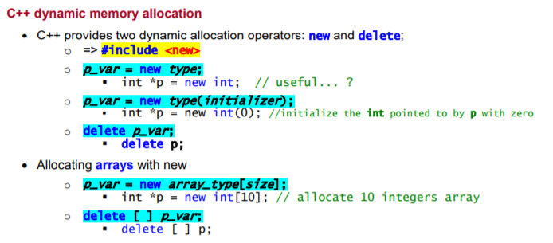

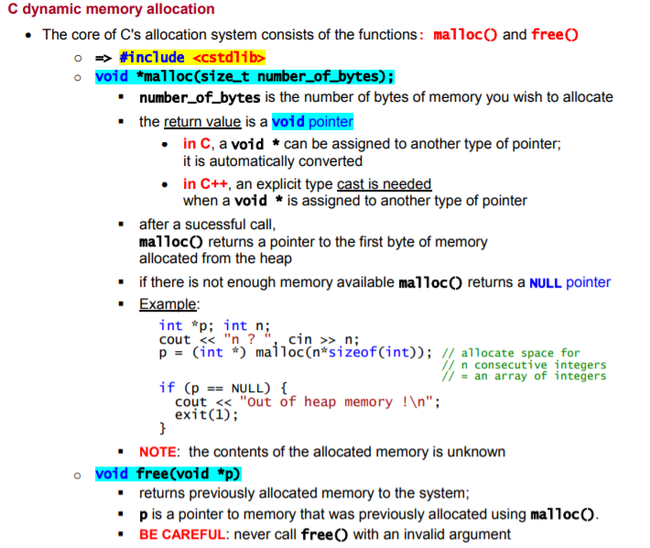

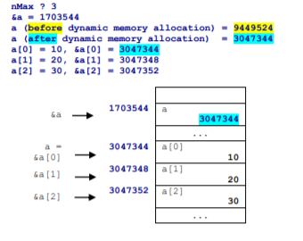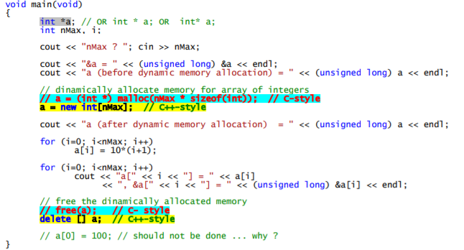

Em C: (Alocar 2D)

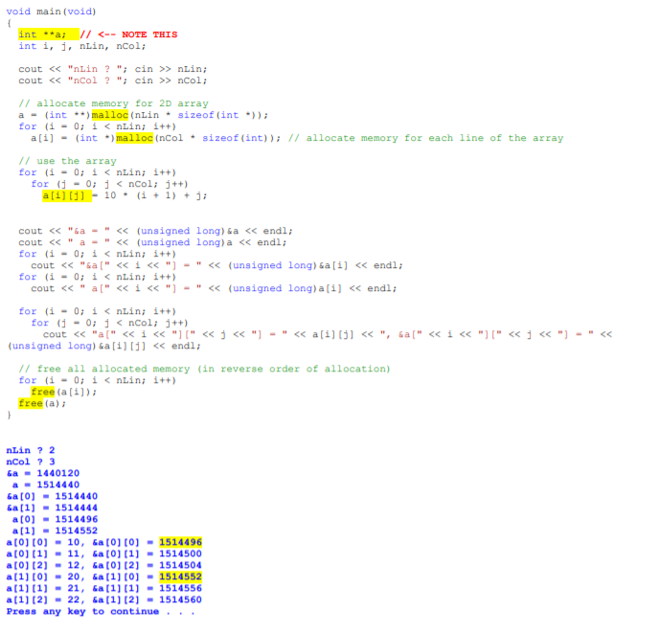



**REALLOC->**

Em C++:

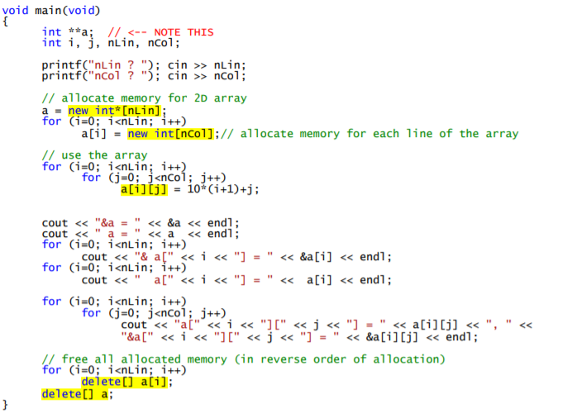

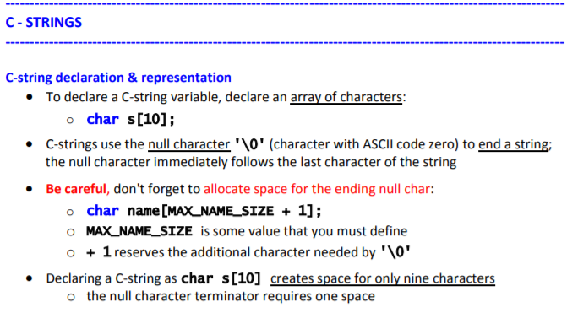

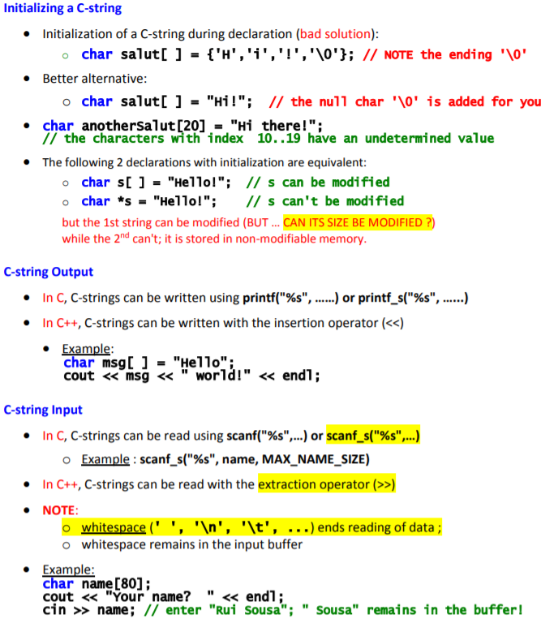

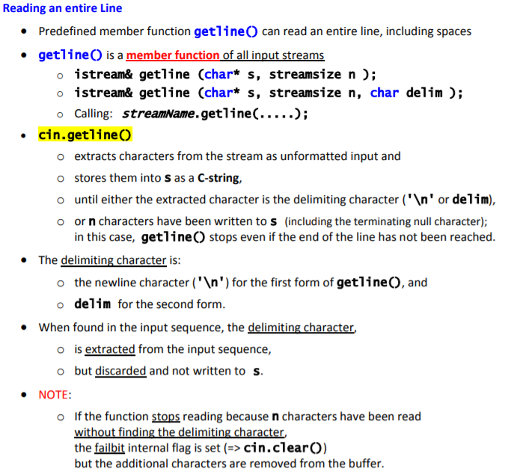

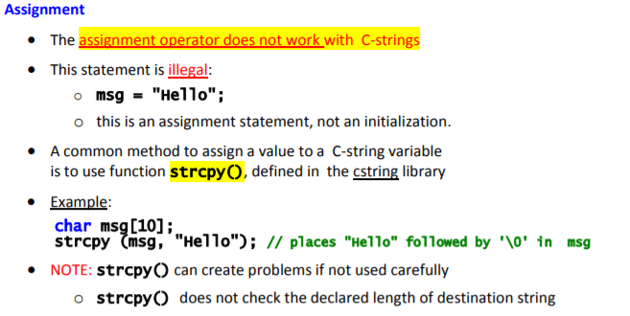

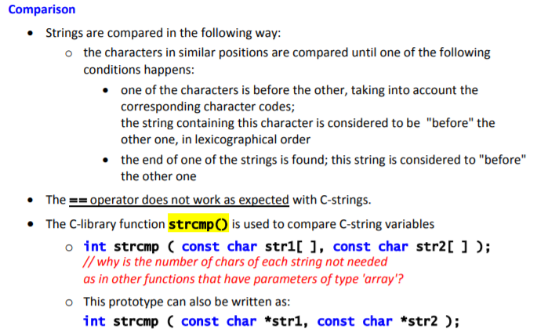

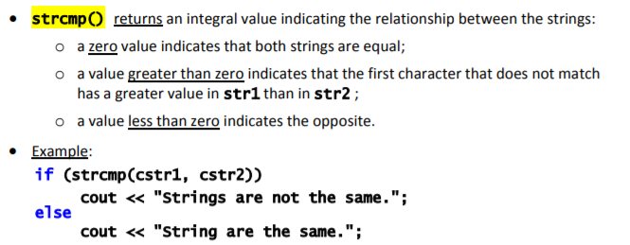

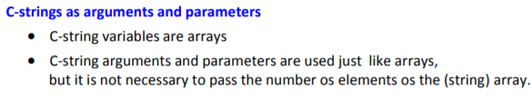

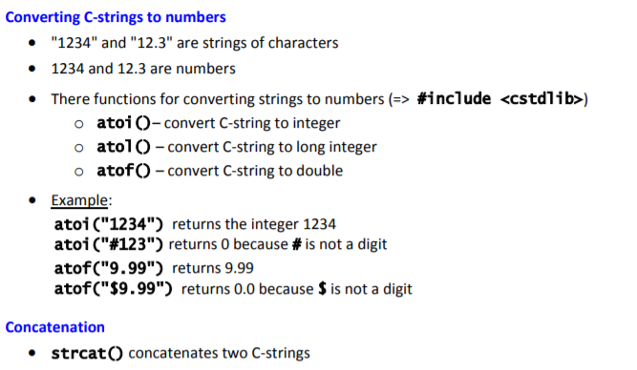



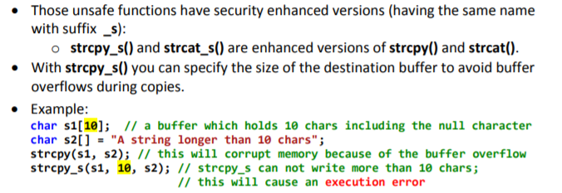



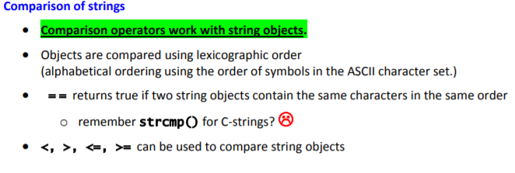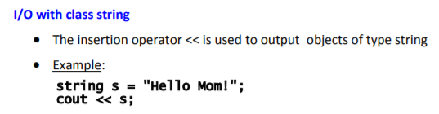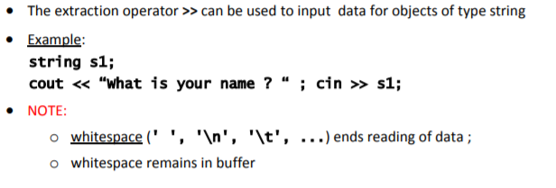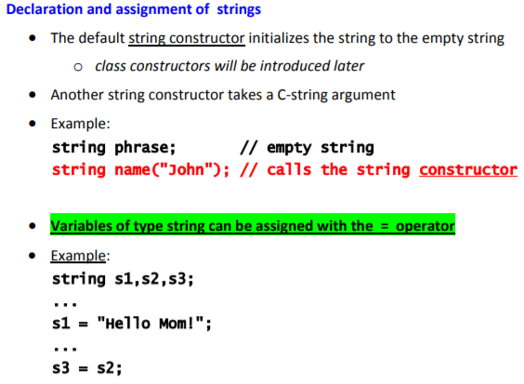 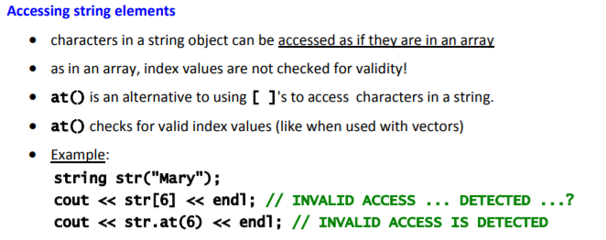

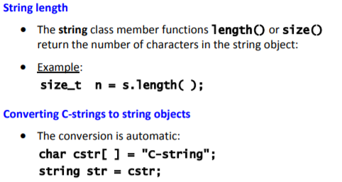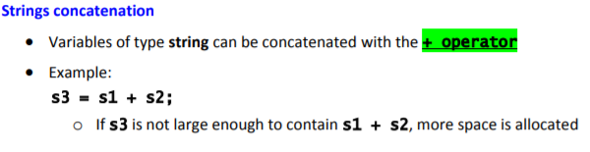

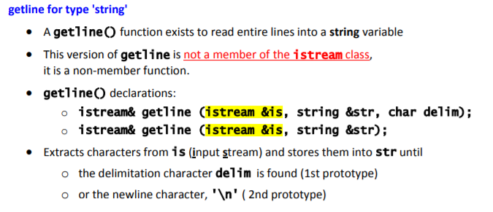 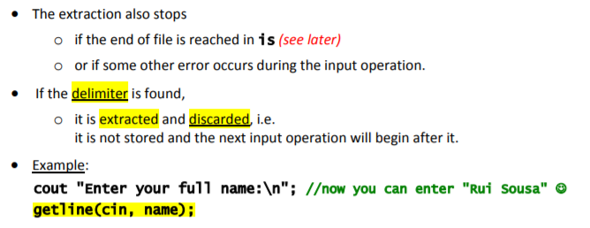 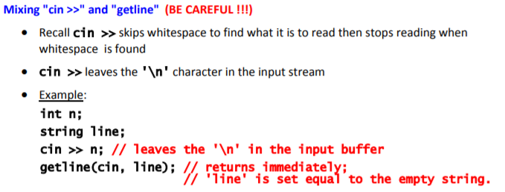

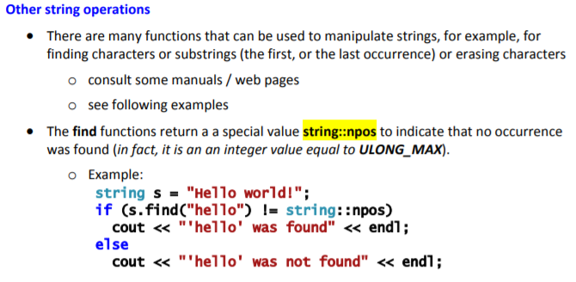

**Constructor:**

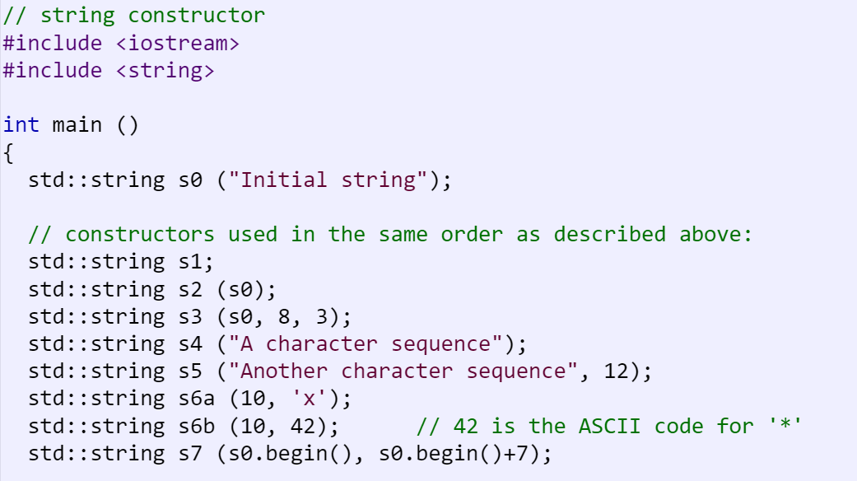 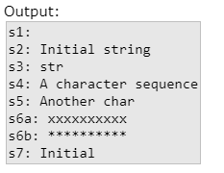

**String.size()** -> Returns the length of the string, in terms of bytes.

**String.length()** -> Returns the length of the string, in terms of bytes.

**String.max_size()** -> Returns the maximum length the [string](http://www.cplusplus.com/string) can reach.

**String.capacity()** -> Returns the size of the storage space currently allocated for the [string](http://www.cplusplus.com/string), expressed in terms of bytes.

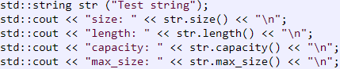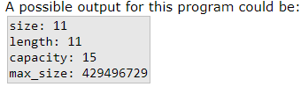

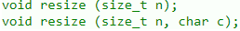**String.resize(n)** ->Resizes the string to a [length](http://www.cplusplus.com/string::length) of n characters.

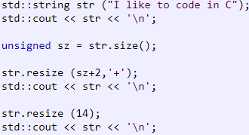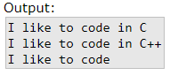

**String.resize(n)** -> Requests that the [string capacity](http://www.cplusplus.com/string::capacity) be adapted to a planned change in [size](http://www.cplusplus.com/string::size) to a [length](http://www.cplusplus.com/string::length) of up to n characters.

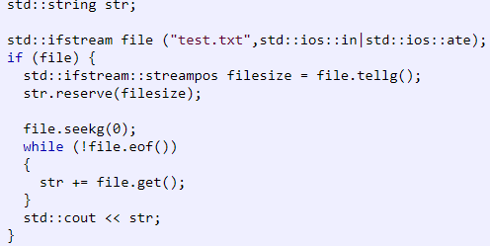

**String.clear()** -> Erases the contents of the [string](http://www.cplusplus.com/string), which becomes an [empty string](http://www.cplusplus.com/string::empty) (with a [length](http://www.cplusplus.com/string::length) of 0 characters).

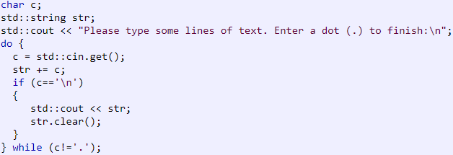

**String.empty()** -> Returns whether the [string](http://www.cplusplus.com/string) is empty (i.e. whether its [length](http://www.cplusplus.com/string::length) is 0).

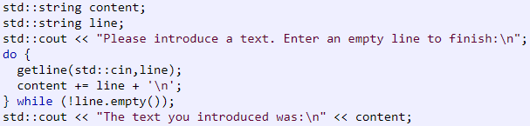

**String.shrink_to_fit()** -> Requests the [string](http://www.cplusplus.com/string) to reduce its [capacity](http://www.cplusplus.com/string::capacity) to fit its [size](http://www.cplusplus.com/string::size).

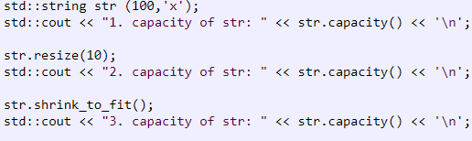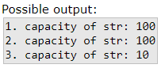

**String.back()** -> Returns a reference to the last character of the [string](http://www.cplusplus.com/string).

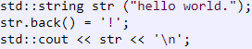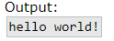

**String.front()** -> Returns a reference to the first character of the [string](http://www.cplusplus.com/string).

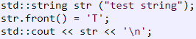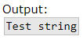

**String.append(n)** -> Extends the [string](http://www.cplusplus.com/string) by appending additional characters at the end of its current value.

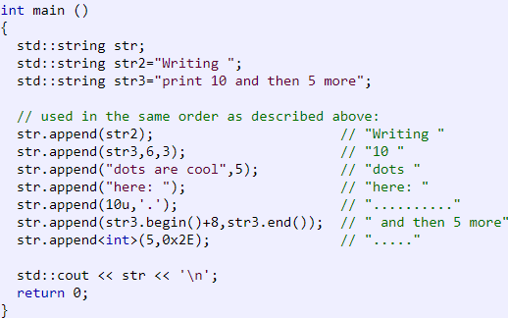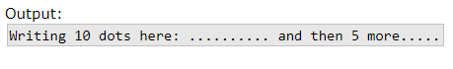

**String.push_back(n)** -> Appends character c to the end of the [string](http://www.cplusplus.com/string), increasing its [length](http://www.cplusplus.com/string::length) by one.

**String.assign(n)** -> Assigns a new value to the string, replacing its current contents.

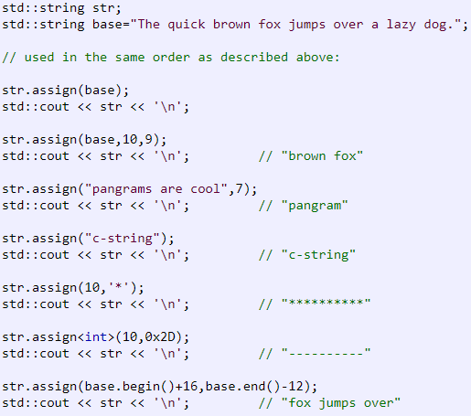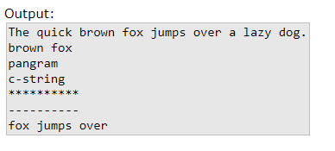

**String.insert(n)** -> Inserts additional characters into the [string](http://www.cplusplus.com/string) right before the character indicated by pos (or p).

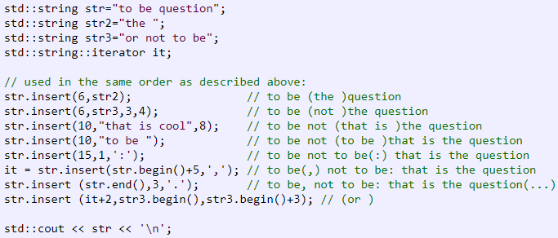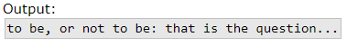

**String.erase(n)** -> Erases part of the [string](http://www.cplusplus.com/string), reducing its [length](http://www.cplusplus.com/string::length).

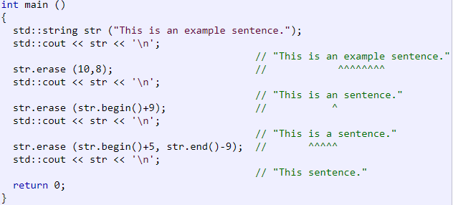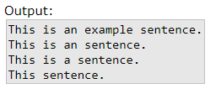

**String.replace(n)** -> Replaces the portion of the string that begins at character pos and spans len characters (or the part of the string in the range between [i1,i2)) by new contents.

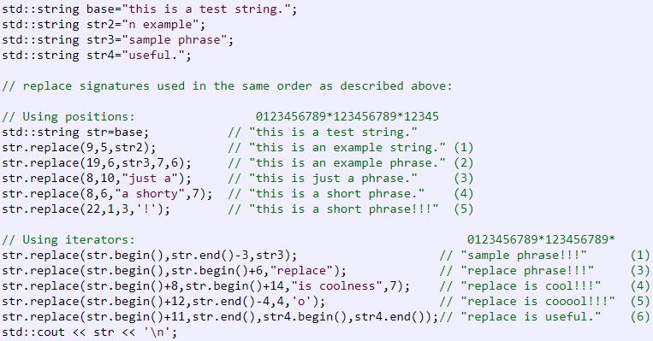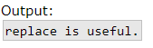

**String.swap(n)** -> Exchanges the content of the container by the content of str, which is another [string](http://www.cplusplus.com/string) object. [Lengths](http://www.cplusplus.com/string::length) may differ.

**String.pop_back()** -> Erases the last character of the [string](http://www.cplusplus.com/string), effectively reducing its [length](http://www.cplusplus.com/string::length) by one.

**String.c_str()** -> Returns a pointer to an array that contains a null-terminated sequence of characters (i.e., a C-string) representing the current value of the [string](http://www.cplusplus.com/string) object.  
This array includes the same sequence of characters that make up the value of the [string](http://www.cplusplus.com/string) object plus an additional terminating null-character ('\0') at the end.

**String.copy(n)** -> Copies a substring of the current value of the [string](http://www.cplusplus.com/string) object into the array pointed by s. This substring contains the len characters that start at position pos.

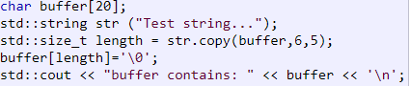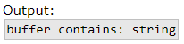

**String.find(n)** -> Searches the [string](http://www.cplusplus.com/string) for the first occurrence of the sequence specified by its arguments.

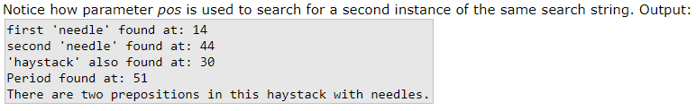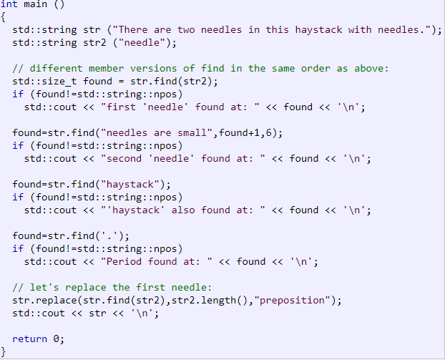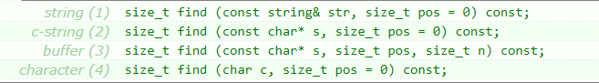

**String.rfind(n)** -> Searches the [string](http://www.cplusplus.com/string) for the last occurrence of the sequence specified by its arguments.

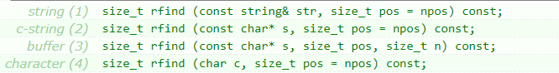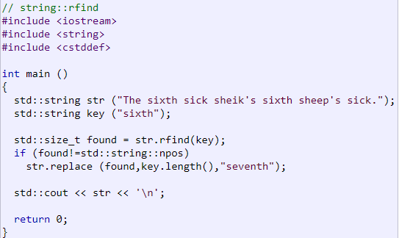

**String.find_first_of(n)** -> Searches the [string](http://www.cplusplus.com/string) for the first character that matches any of the characters specified in its arguments.

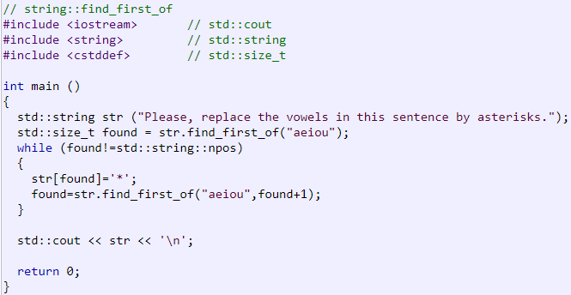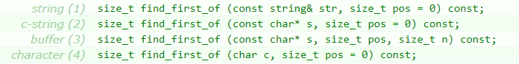

**String.find_first_not_of(n)** -> Searches the [string](http://www.cplusplus.com/string) for the first character that does not match any of the characters specified in its arguments.

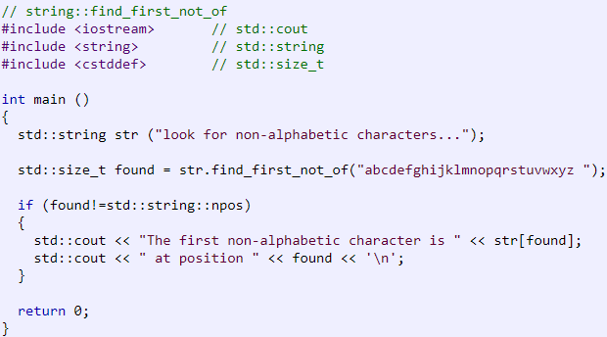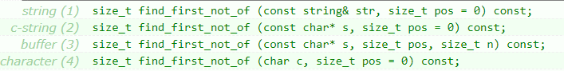

**String.find_last_of(n)** -> Searches the [string](http://www.cplusplus.com/string) for the last character that matches any of the characters specified in its arguments.

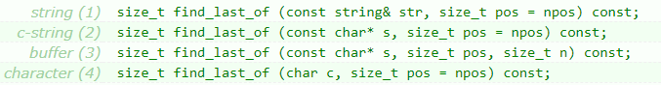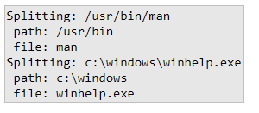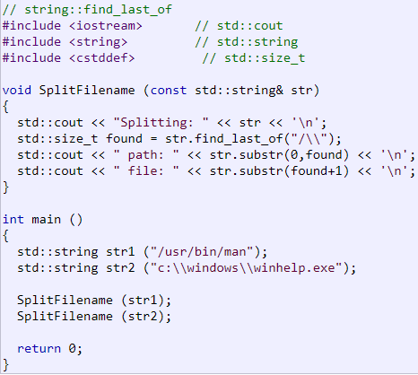

**String.find_last_not_of(n)** -> Searches the [string](http://www.cplusplus.com/string) for the last character that does not match any of the characters specified in its arguments.

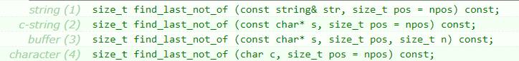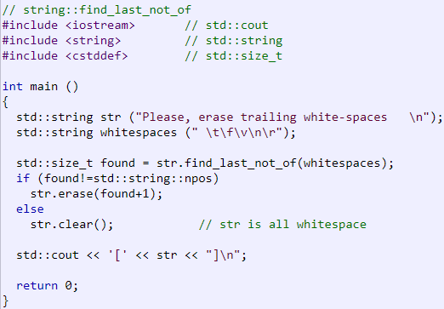

**String.substr(n)** -> Returns a newly constructed [string](http://www.cplusplus.com/string) object with its value initialized to a copy of a substring of this object.

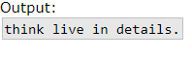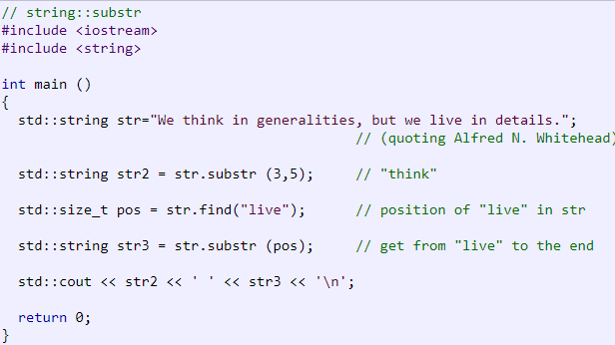

**Swap(String)** -> Exchanges the values of [string](http://www.cplusplus.com/string) objects x and y, such that after the call to this function, the value of x is the one which was on y before the call, and the value of y is that of x.

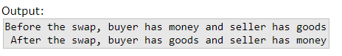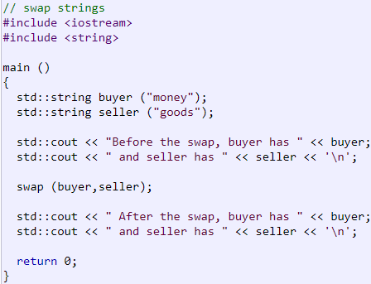

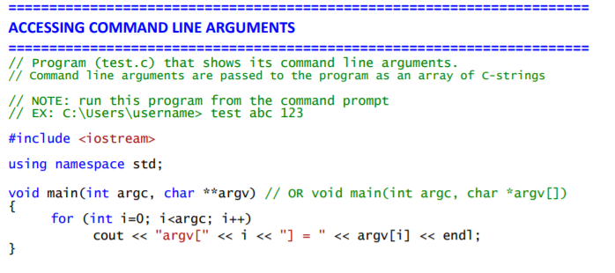

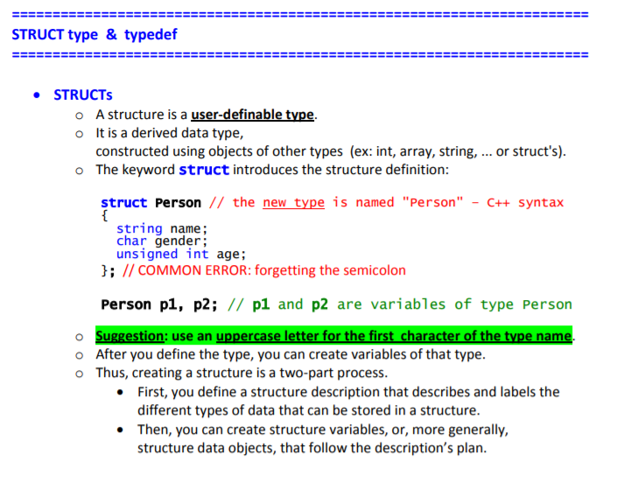

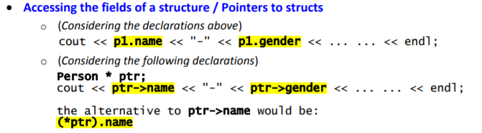

Definir uma struct e inicializar um pointer do tipo node

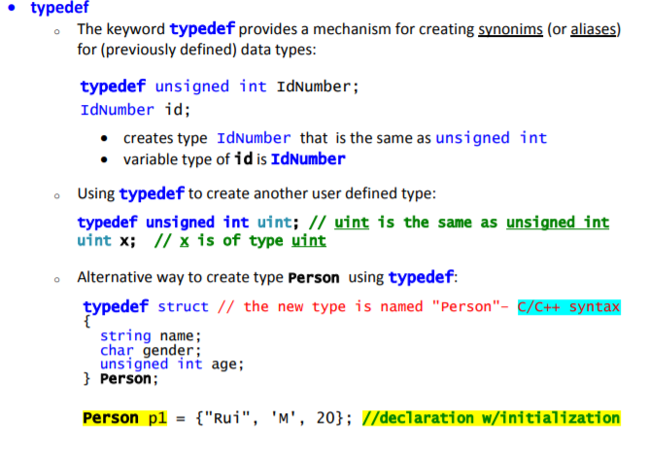

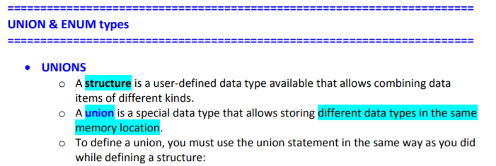

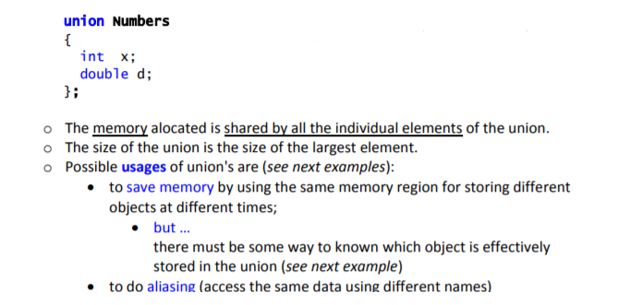

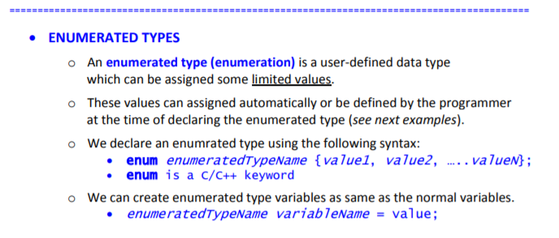

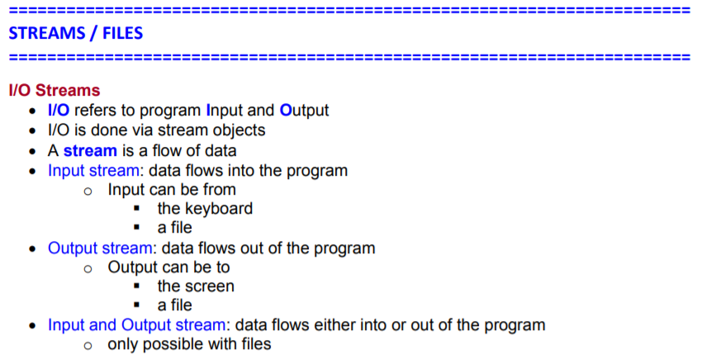

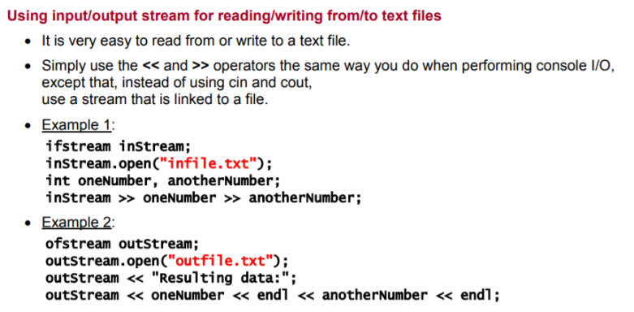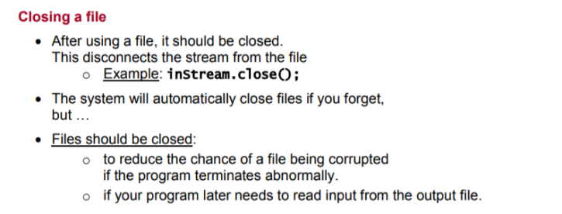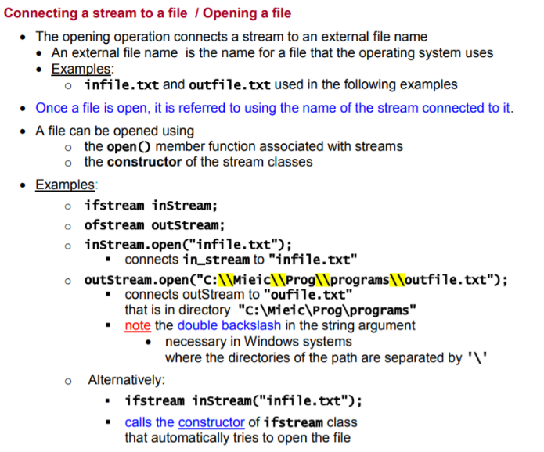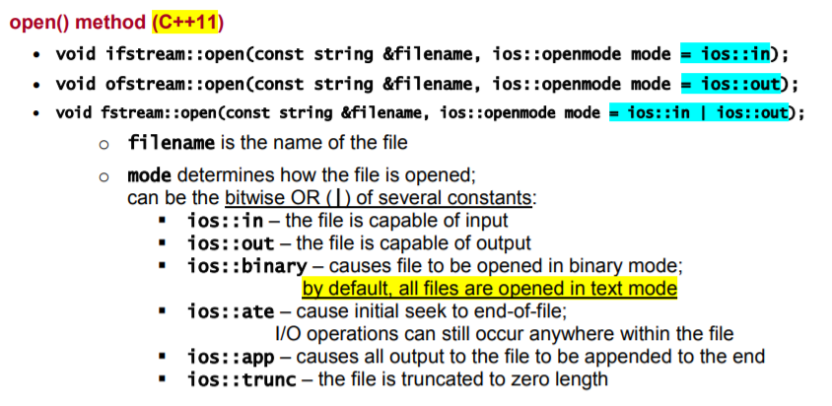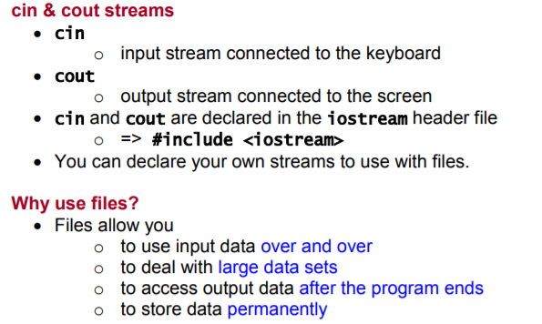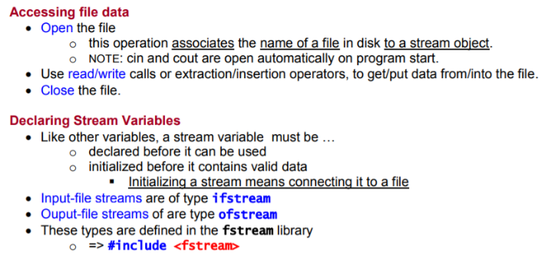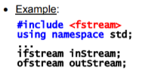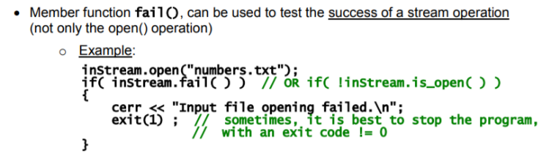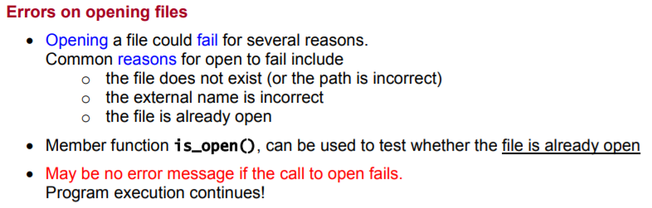

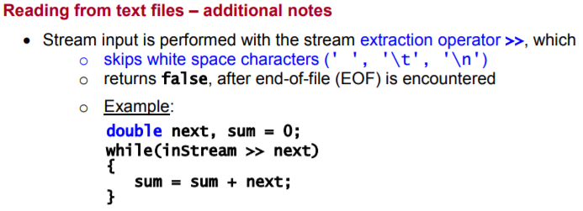

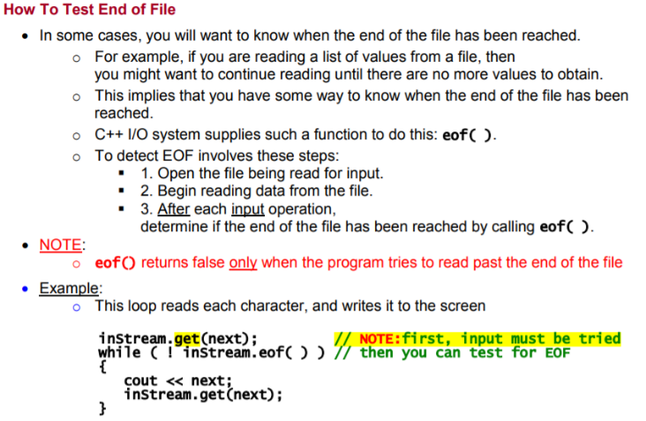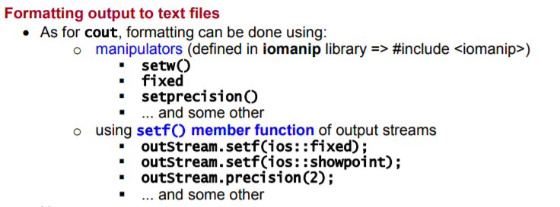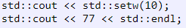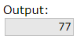

**setw(n)** -> Sets the field width to be used on output operations.

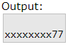

**setfill(n)** ->

**fixed** -> Sets the floatfield format flag for the str stream to fixed.

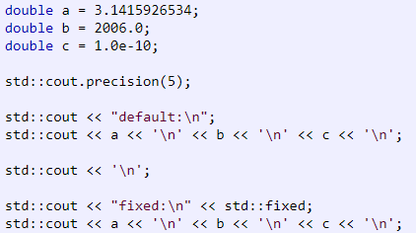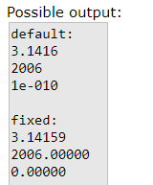

**Setprecision(n)** -> Sets the decimal precision to be used to format floating-point values on output operations.

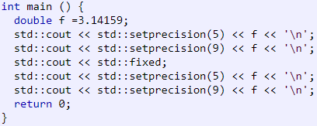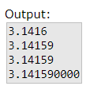

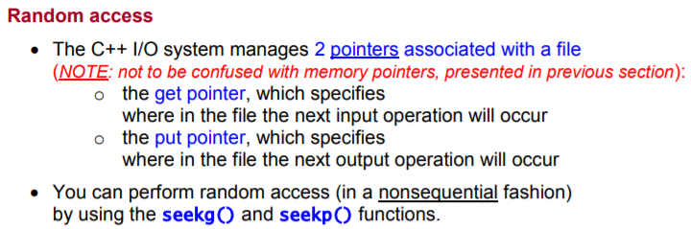

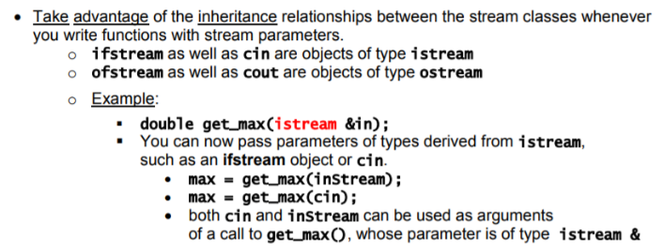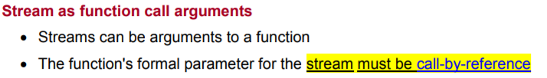

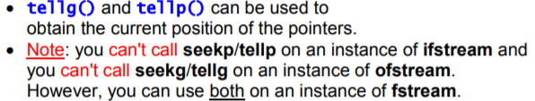

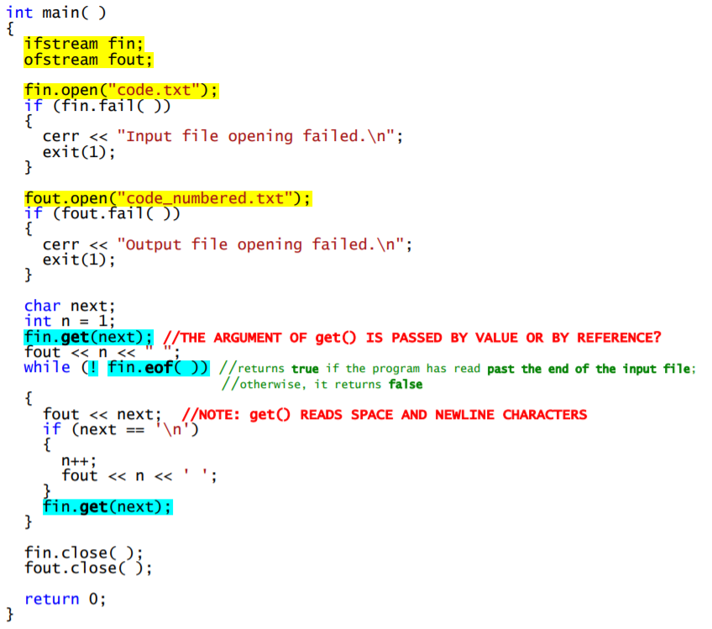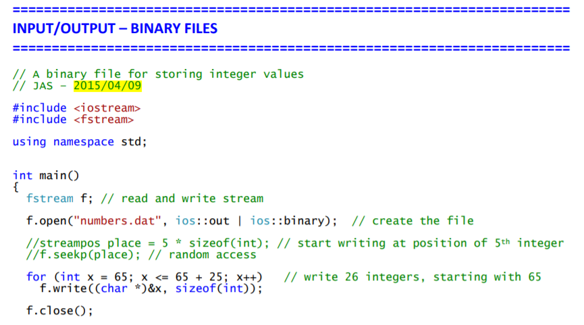

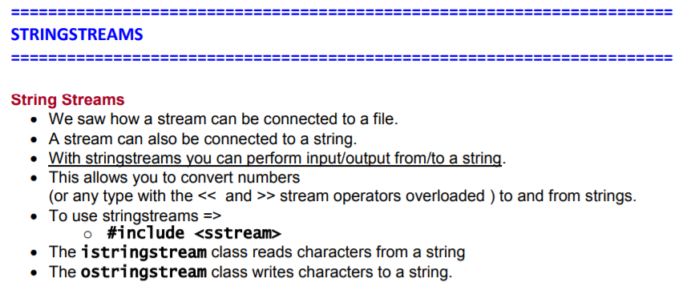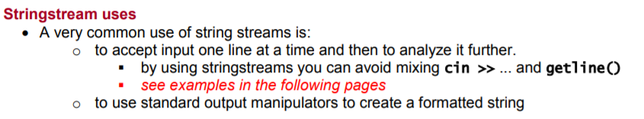

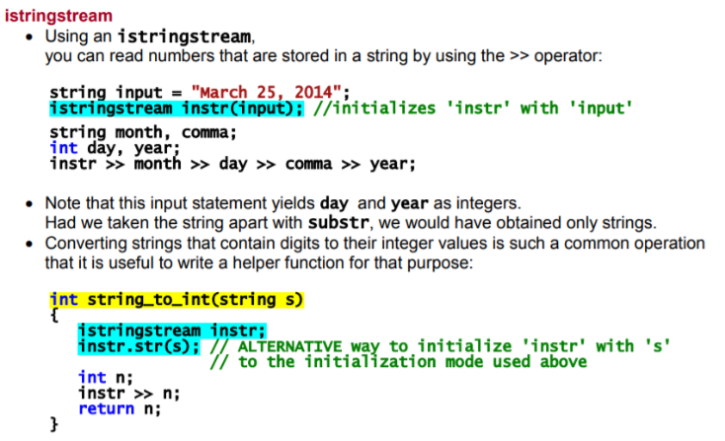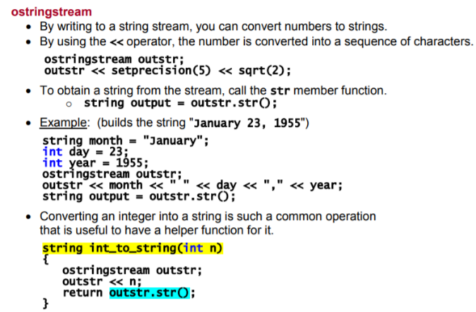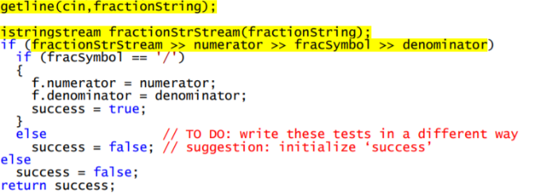

Example:

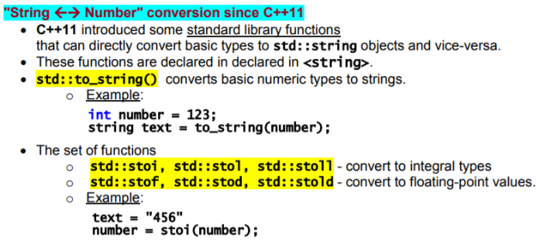

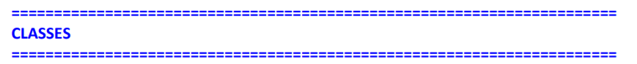

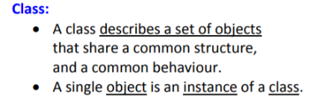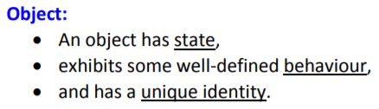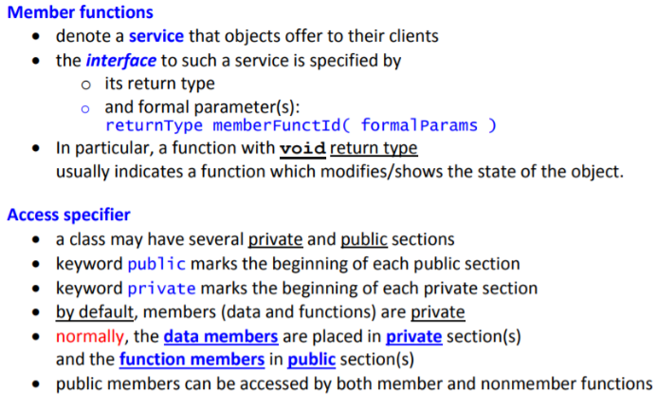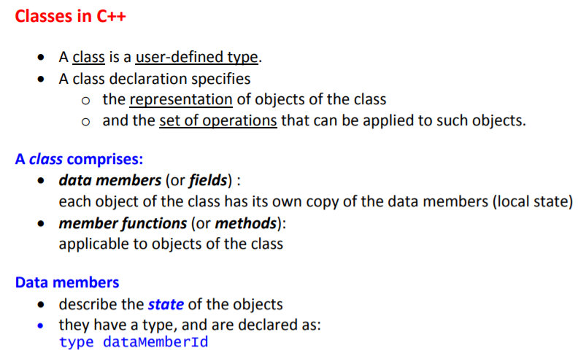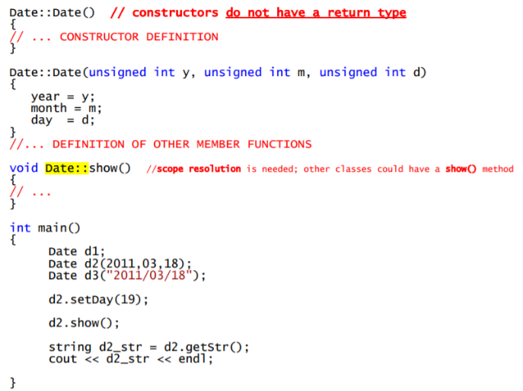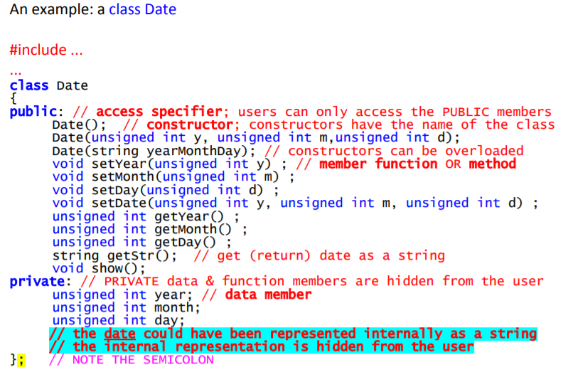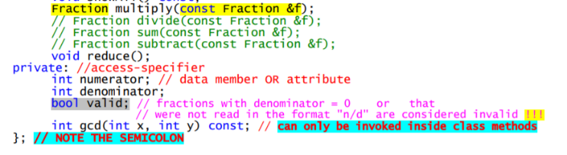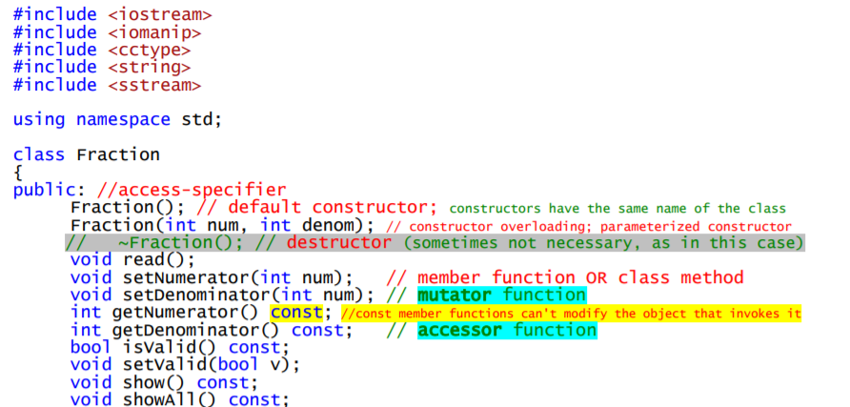

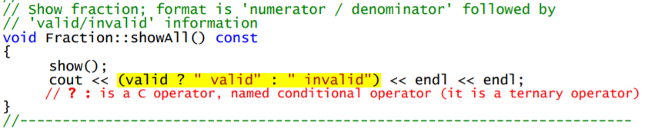



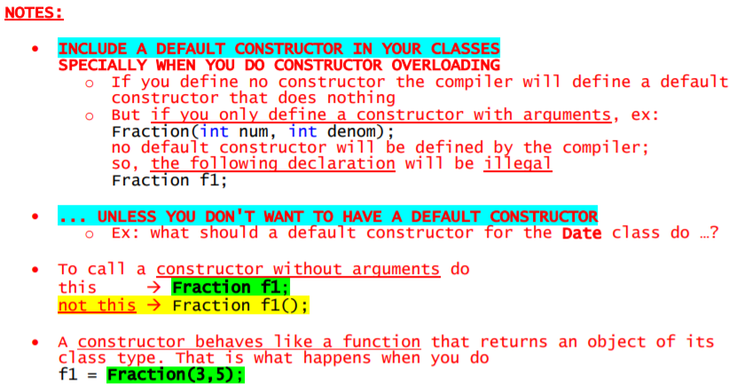

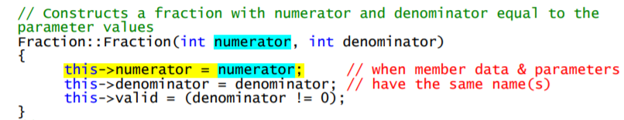

Another example:

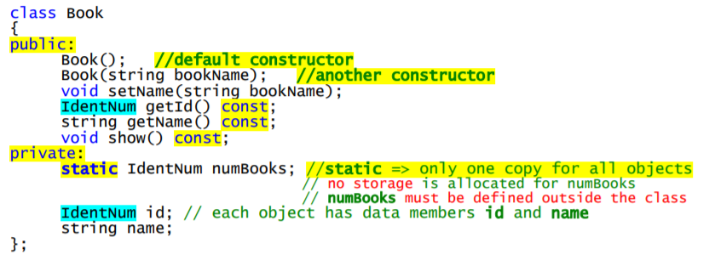

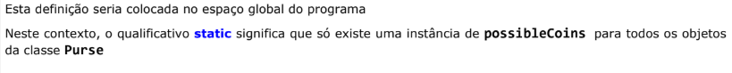

numBooks

**Static** ->

Book





Example 2:

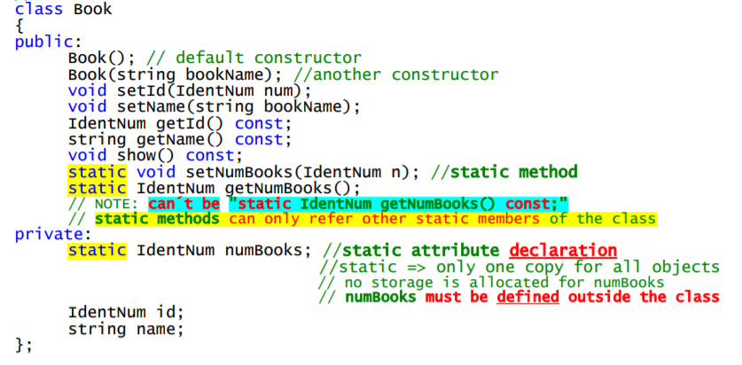

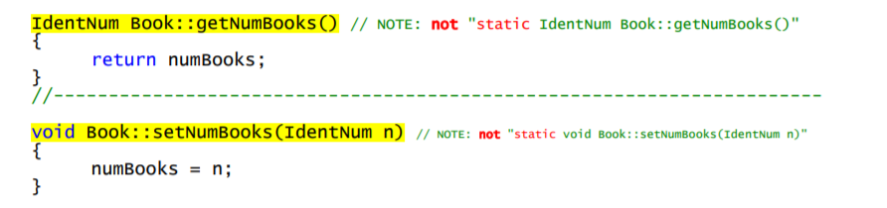

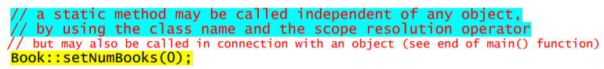

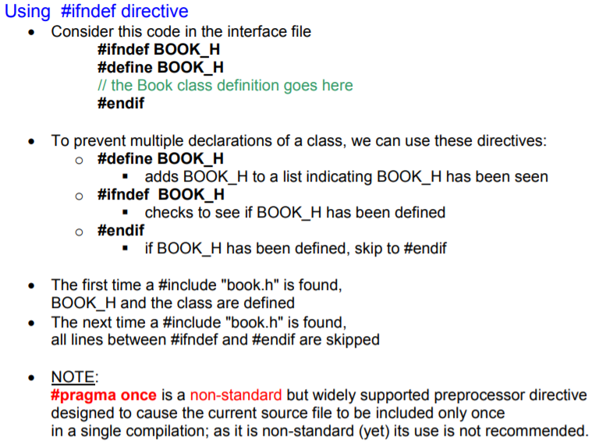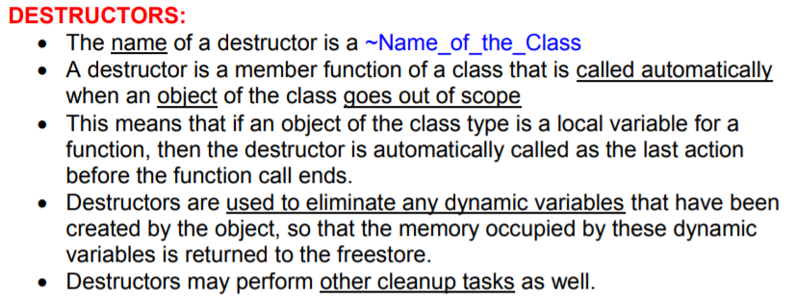

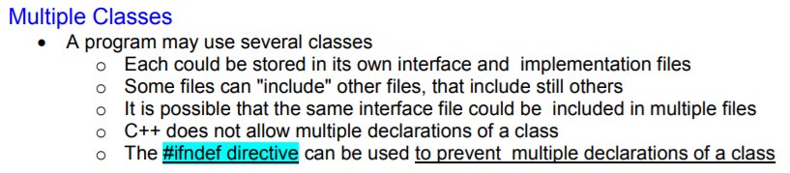

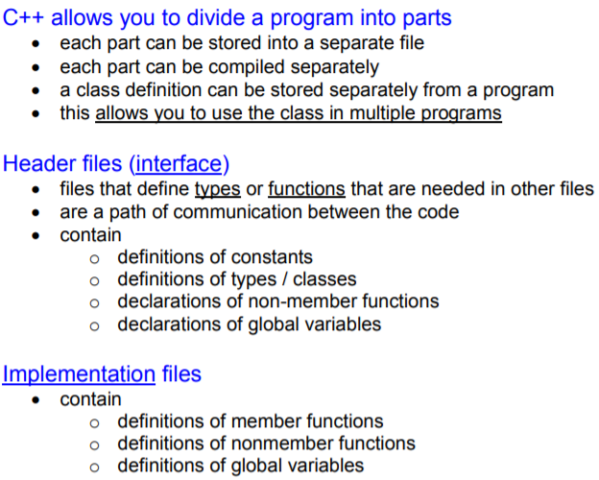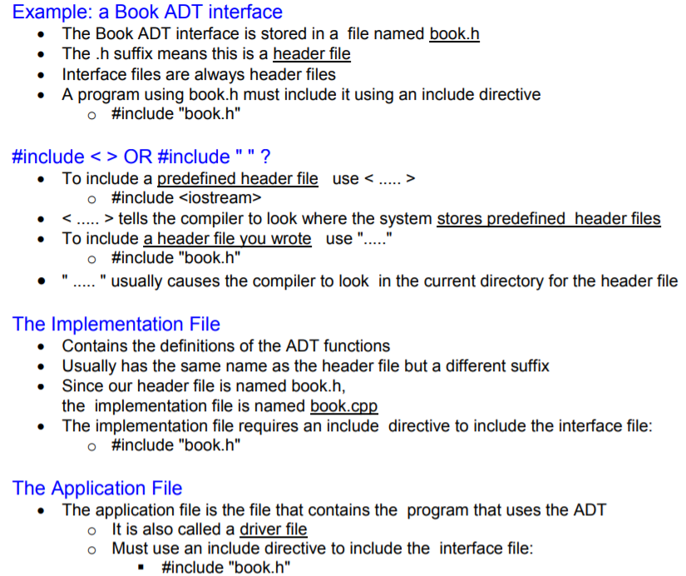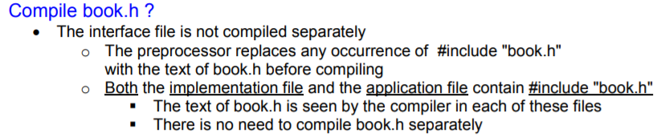

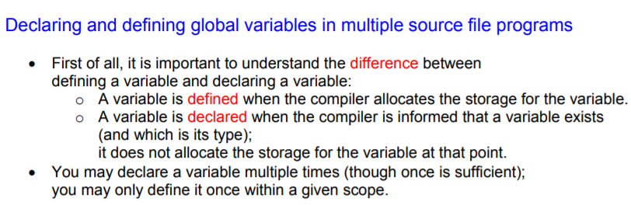

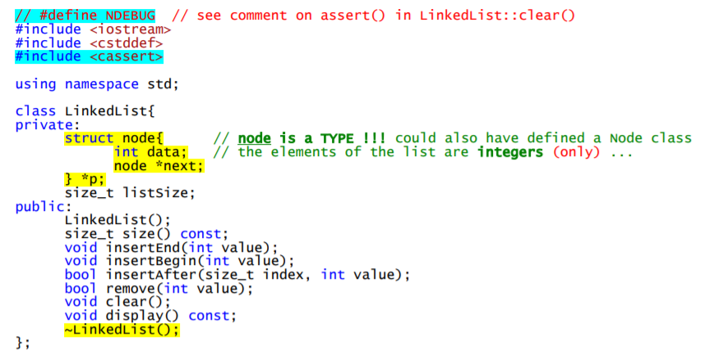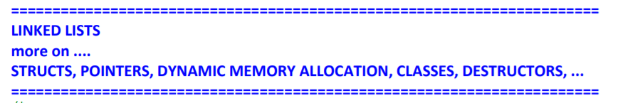

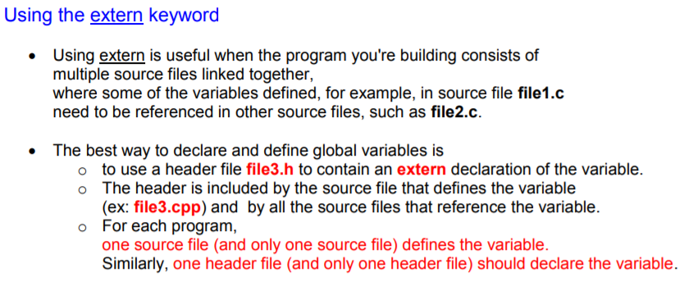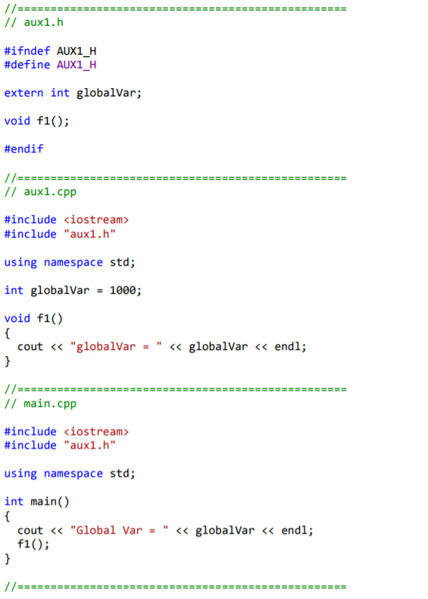

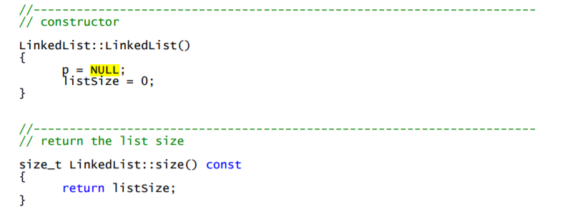

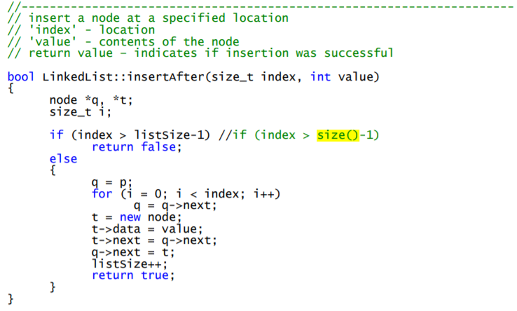

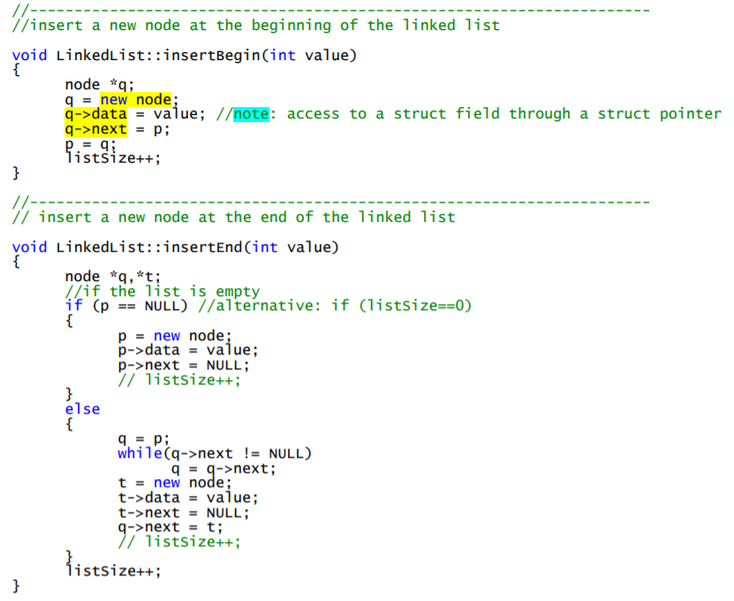

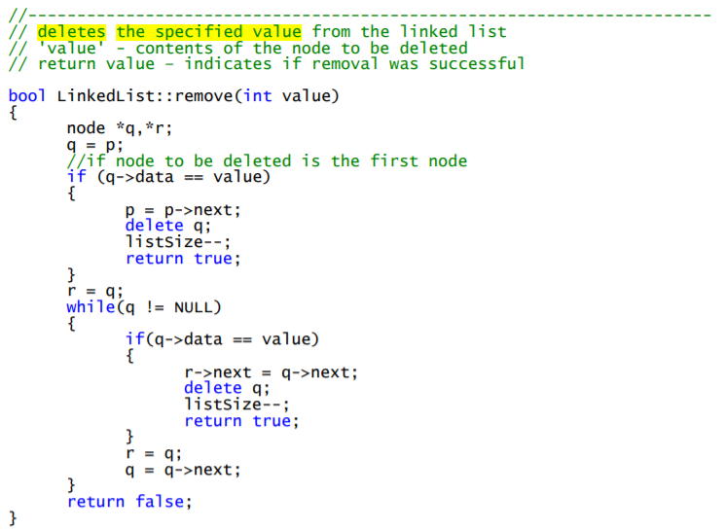

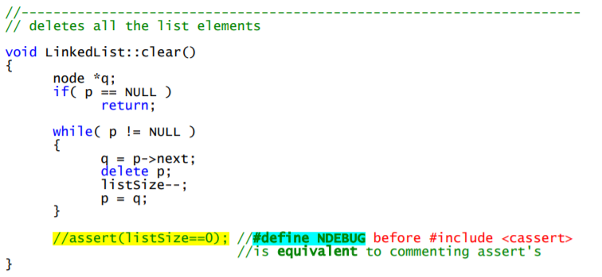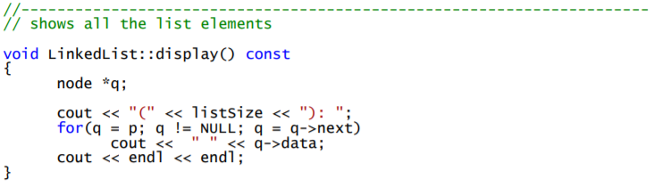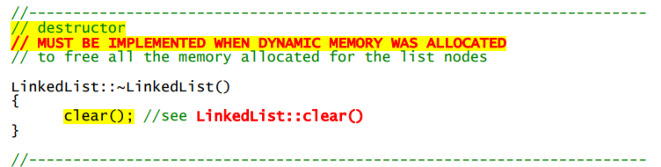

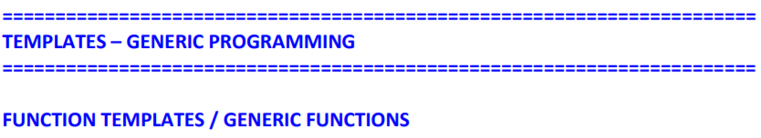

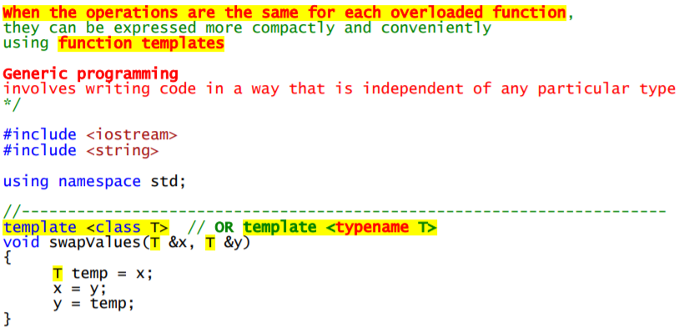

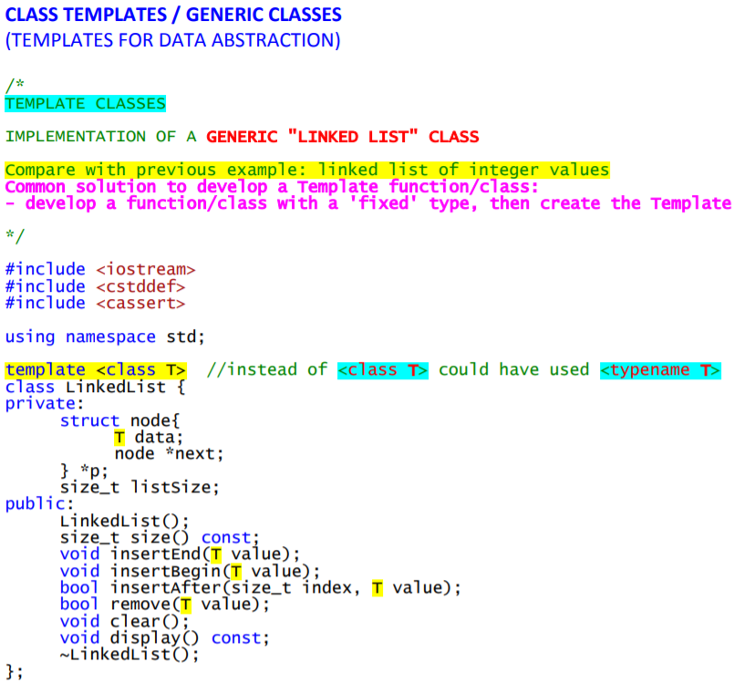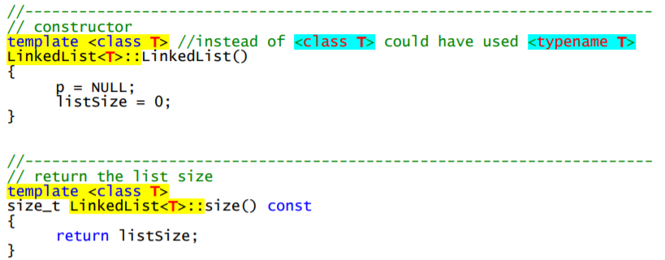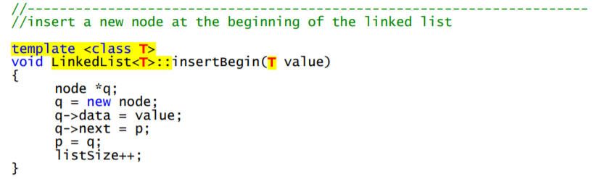

Para definir uma variável com 2 tipos:

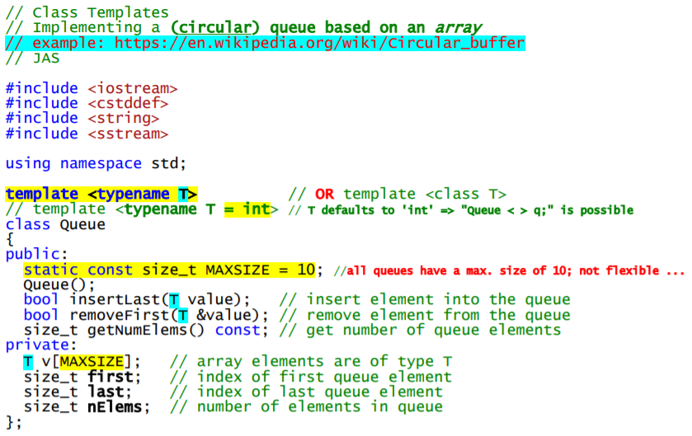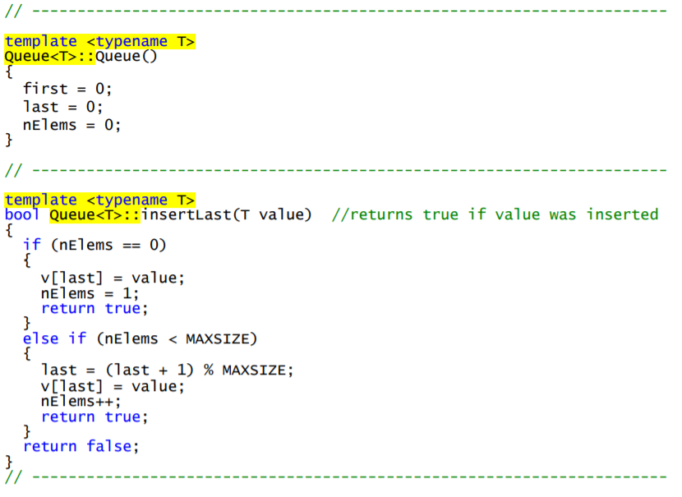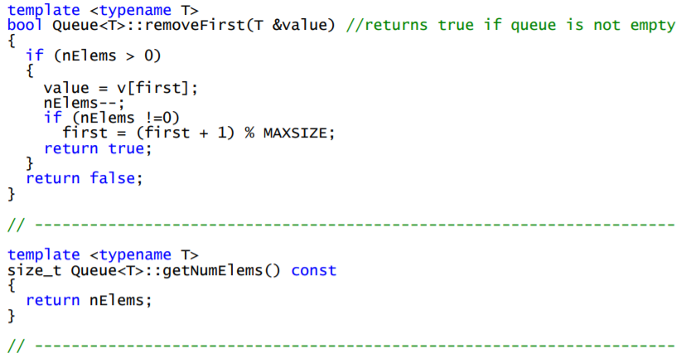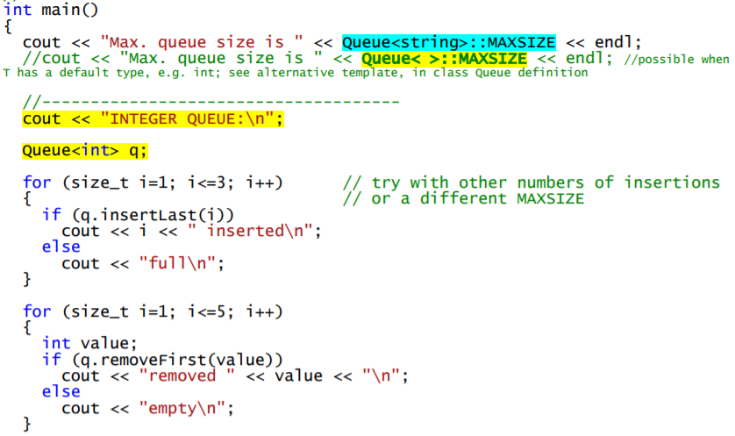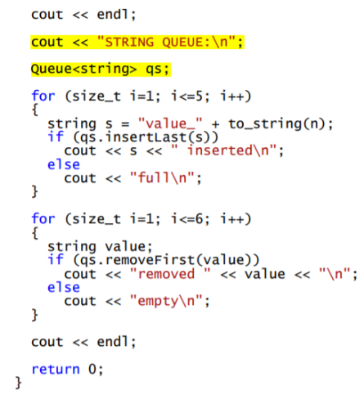

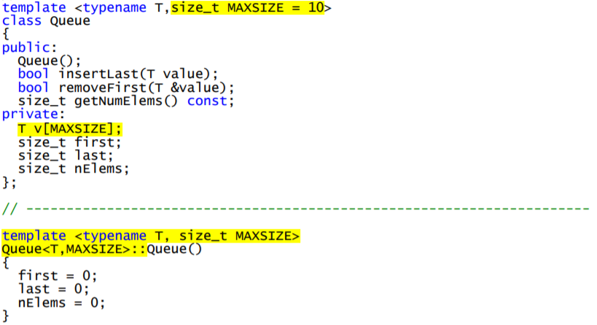

E desta forma pode-se fazer:





Classe de com dois objetos de tipos diferentes com template:

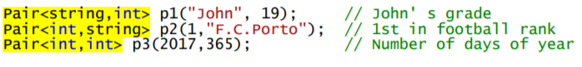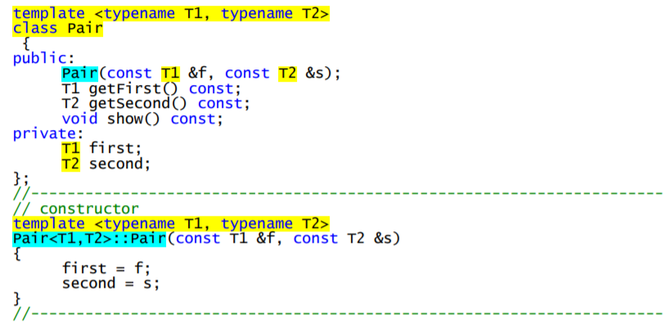



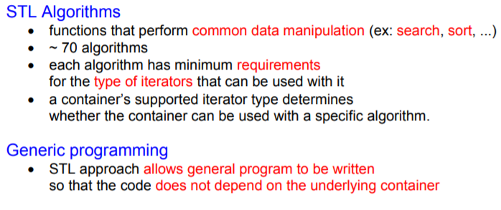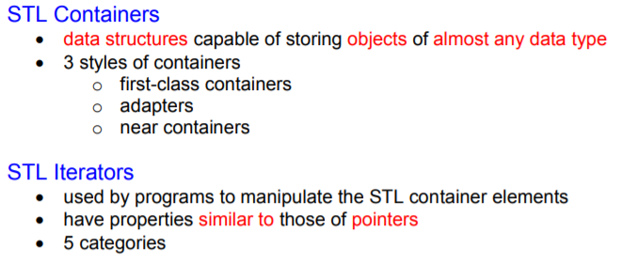

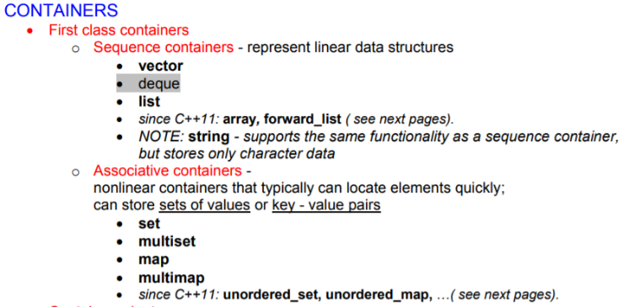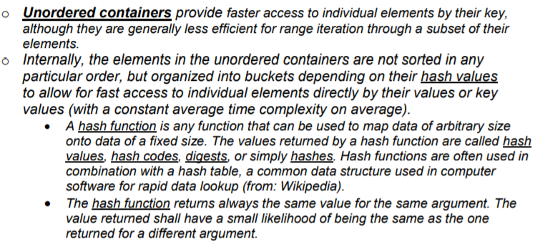

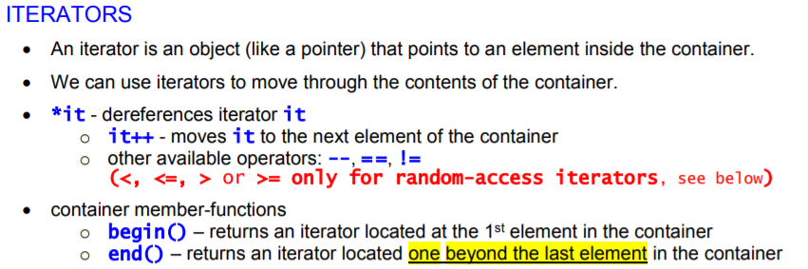

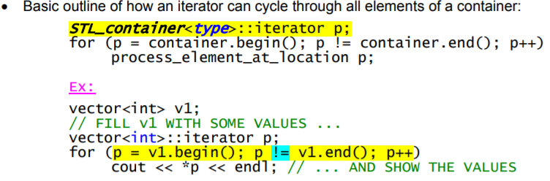

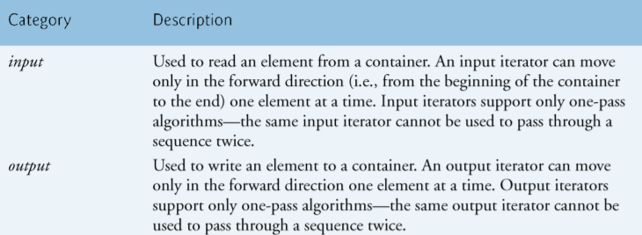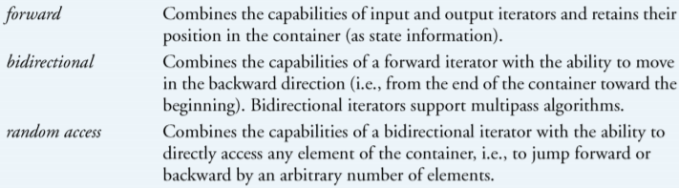

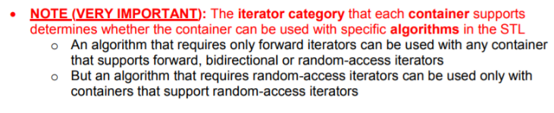

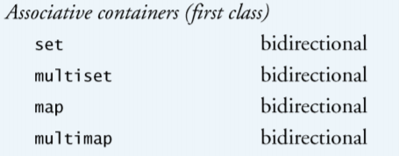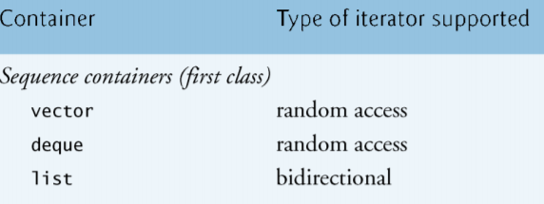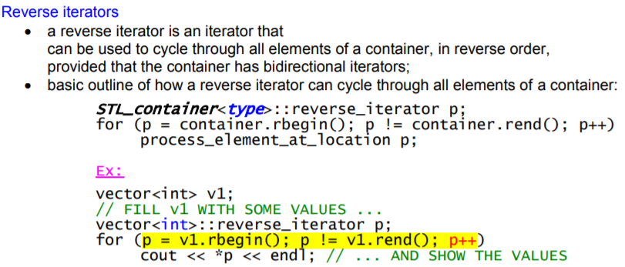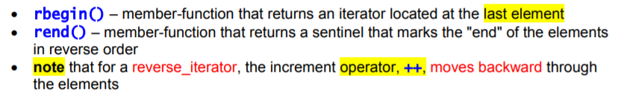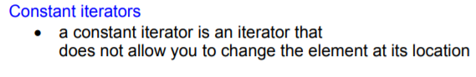

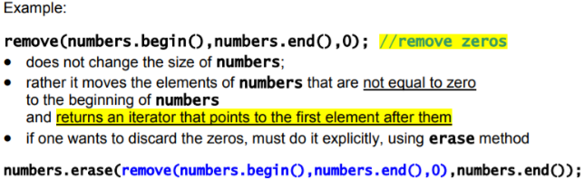

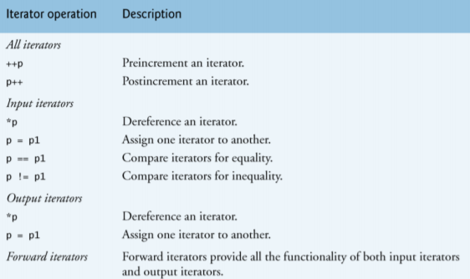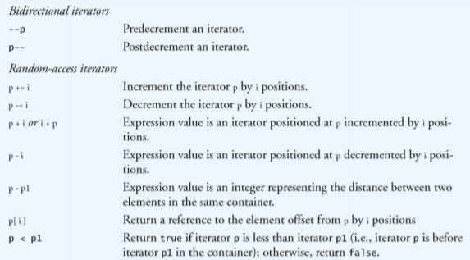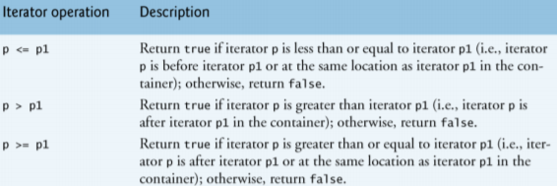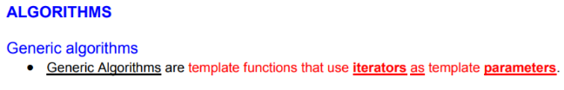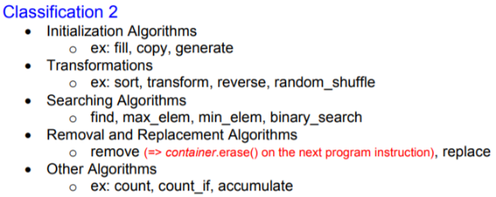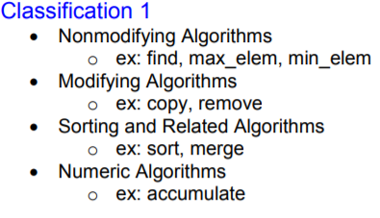

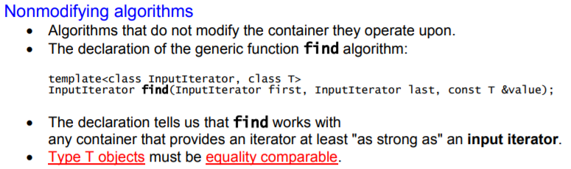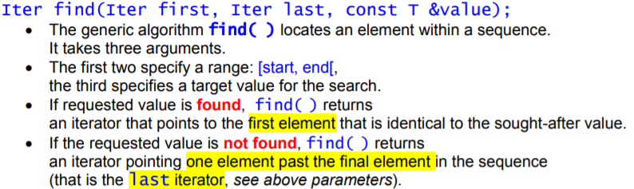

**Count(n)** -> Returns the number of elements in the range [first, last) that compare equal to val.

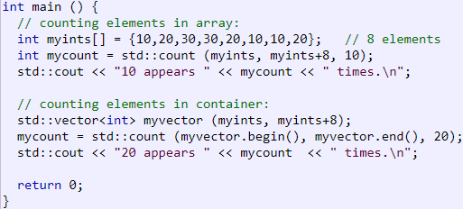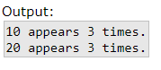

**Equal(n)** -> Compares the elements in the range [first1,last1) with those in the range beginning at first2, and returns true if all of the elements in both ranges match.

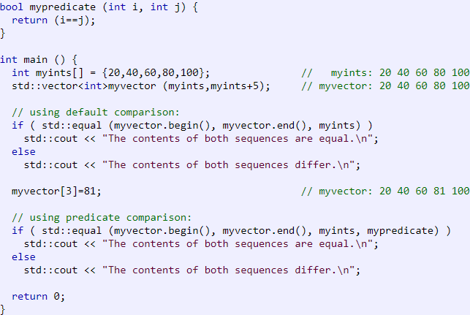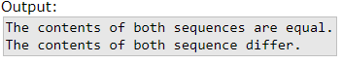

**Remove(n)** -> Transforms the range [first,last) into a range with all the elements that compare equal to val removed, and returns an iterator to the new end of that range.

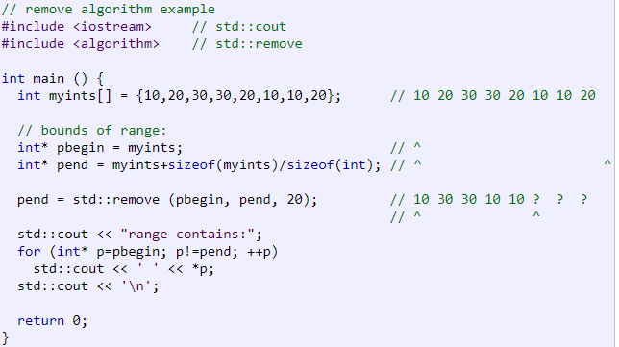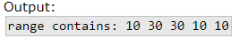

**Copy(n)** -> Copies the elements in the range [first,last) into the range beginning at result.

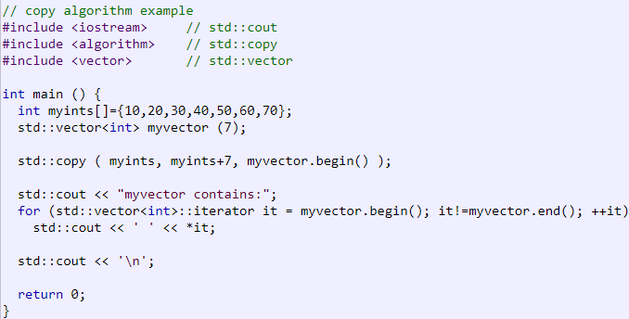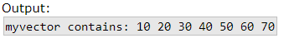

**Random_shuffle(n)** -> Rearranges the elements in the range [first,last) randomly.

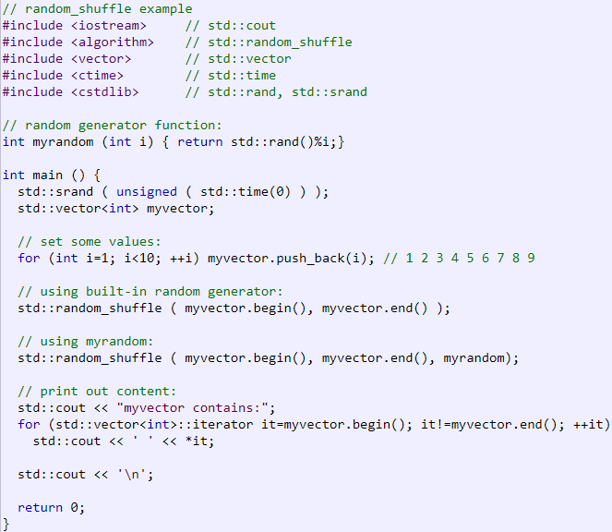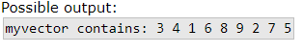

**Sort(n)** -> Sorts the elements in the range [first,last) into ascending order.

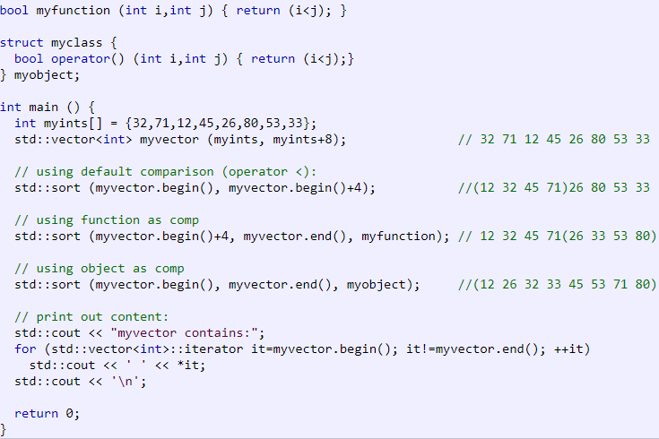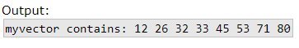

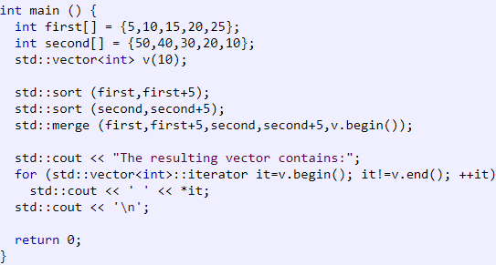**Merge(n)** -> Combines the elements in the sorted ranges [first1,last1) and [first2,last2), into a new range beginning at result with all its elements sorted.

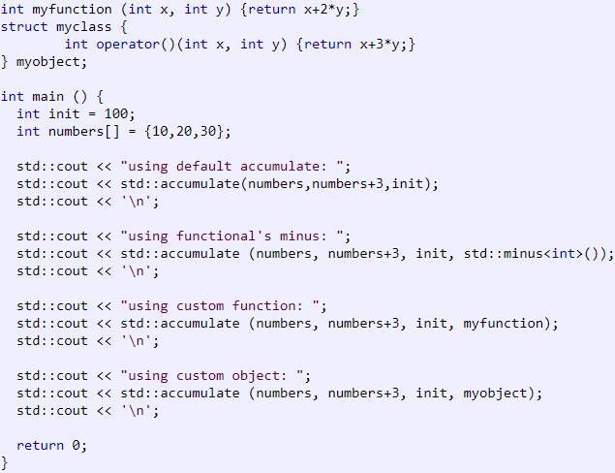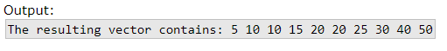

**Accumulate(n)** -> Returns the result of accumulating all the values in the range [first,last) to init.

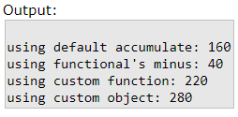

Ao fazer esta instrução, evitamos ter sempre de escrever vector<int>::conts_iterator :

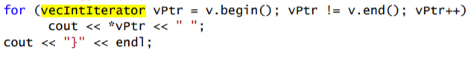

Assim:

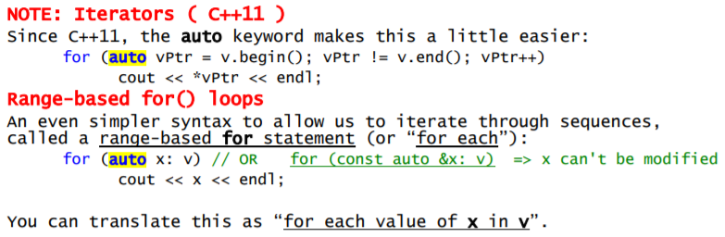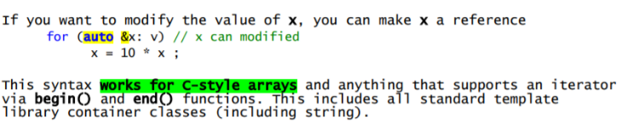

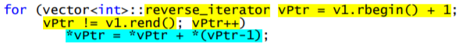Reverse iterators:

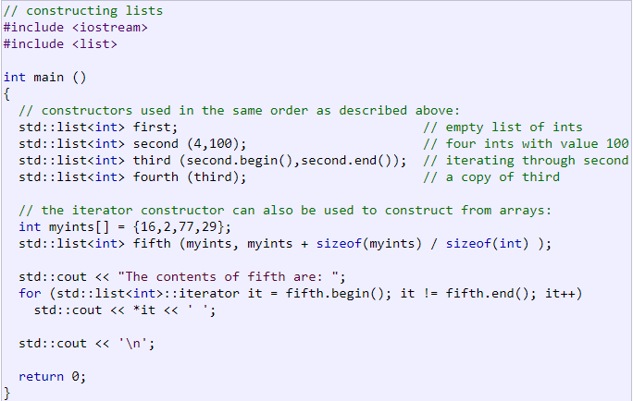**LIST/SET:**

**Constructor:**

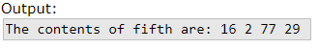

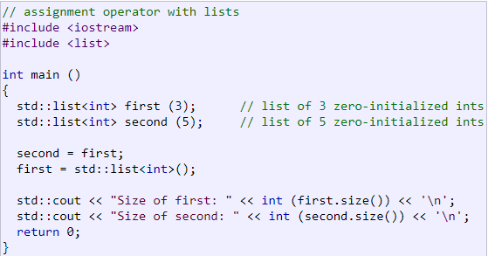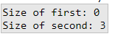

**(LIST/SET)Operator=** ->

**(List/Set/Map).empty()** ->Returns whether the [list](http://www.cplusplus.com/list) container is empty (i.e. whether its [size](http://www.cplusplus.com/list::size) is 0).

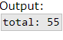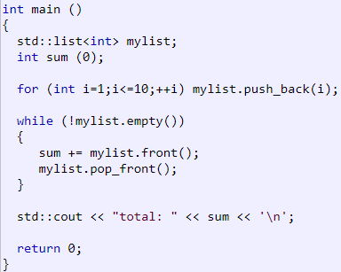

**(List/Set/Size).size()** -> Returns the number of elements in the [list](http://www.cplusplus.com/list) container.

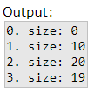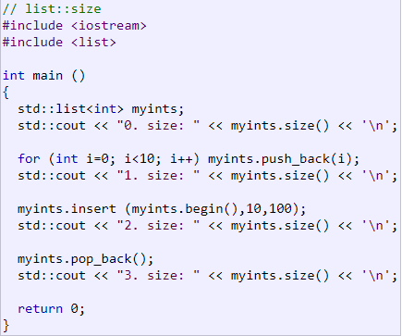

**(List/Set/Map).max_size()** -> Returns the maximum number of elements that the [list](http://www.cplusplus.com/list) container can hold.

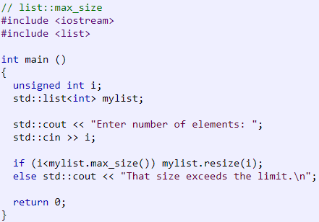

**List.front()** -> Returns a reference to the first element in the [list](http://www.cplusplus.com/list) container.

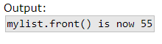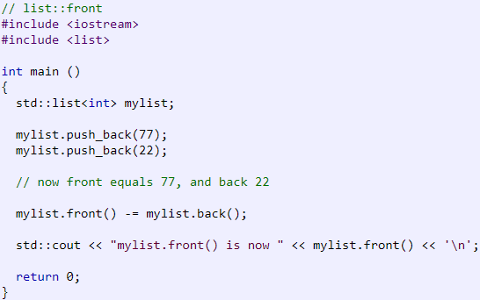

**List.back()** -> Returns a reference to the last element in the [list](http://www.cplusplus.com/list) container.

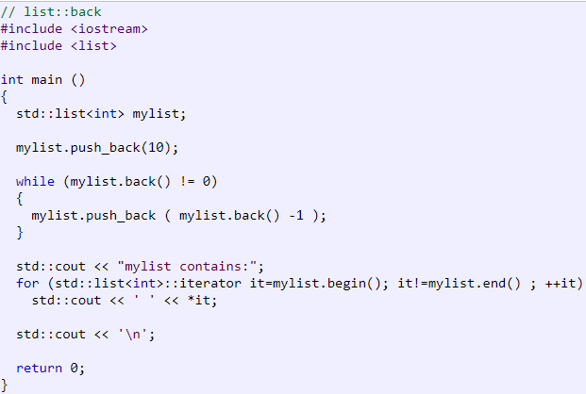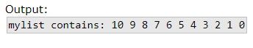

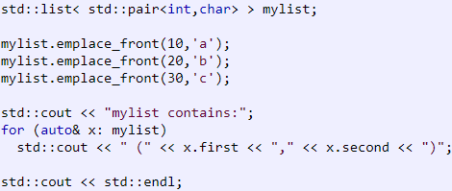**List.emplace_front(n)** -> Inserts a new element at the beginning of the [list](http://www.cplusplus.com/list), right before its current first element. This new element is constructed in place using args as the arguments for its construction.

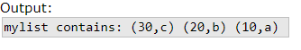

**List.assign(n)** -> Assigns new contents to the [list](http://www.cplusplus.com/list) container, replacing its current contents, and modifying its size accordingly.

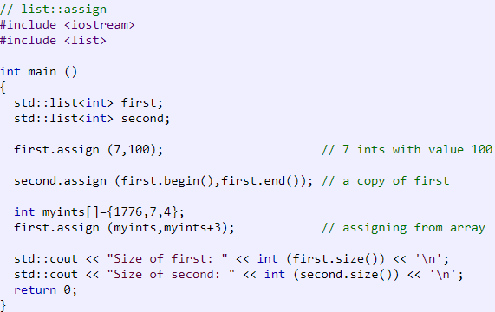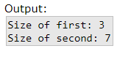

**List.push_front(n)** -> Inserts a new element at the beginning of the [list](http://www.cplusplus.com/list), right before its current first element. The content of val is copied (or moved) to the inserted element.

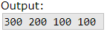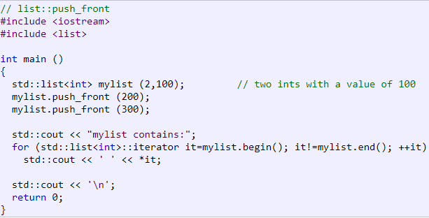

**List.pop_front()** -> Removes the first element in the [list](http://www.cplusplus.com/list) container, effectively reducing its [size](http://www.cplusplus.com/list::size) by one.

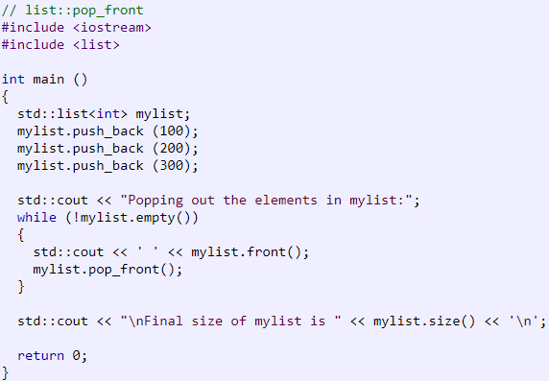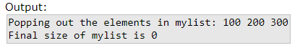

**List.emplace_back(n)** -> Inserts a new element at the end of the [list](http://www.cplusplus.com/list), right after its current last element. This new element is constructed in place using args as the arguments for its construction.

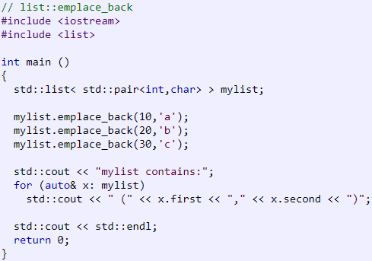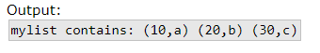

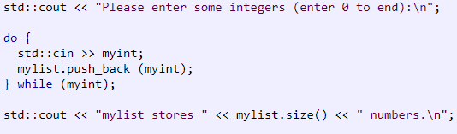**List.push_back(n)** -> Adds a new element at the end of the [list](http://www.cplusplus.com/list) container, after its current last element. The content of val is copied (or moved) to the new element.

**List.pop_back()** -> Removes the last element in the [list](http://www.cplusplus.com/list) container, effectively reducing the container [size](http://www.cplusplus.com/list::size) by one.

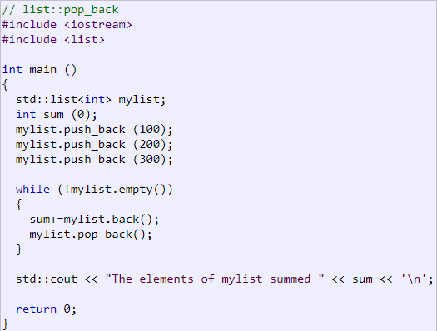

**List.emplace(n)** -> The container is extended by inserting a new element at position. This new element is constructed in place using args as the arguments for its construction.

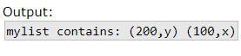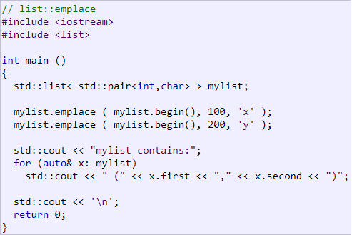

**List.insert(n)** -> The container is extended by inserting new elements before the element at the specified position.

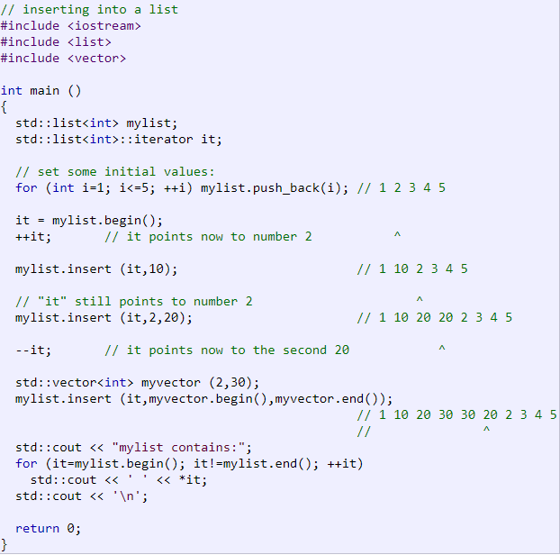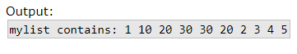

**List.remove(n)** -> Removes from the container all the elements that compare equal to val. This calls the destructor of these objects and reduces the container [size](http://www.cplusplus.com/list::size) by the number of elements removed.

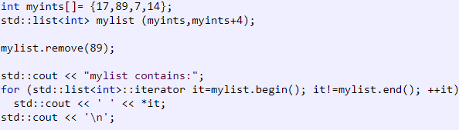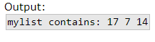

**(List/Set).erase(n)** -> Removes from the [list](http://www.cplusplus.com/list) container either a single element (position) or a range of elements ([first,last)).

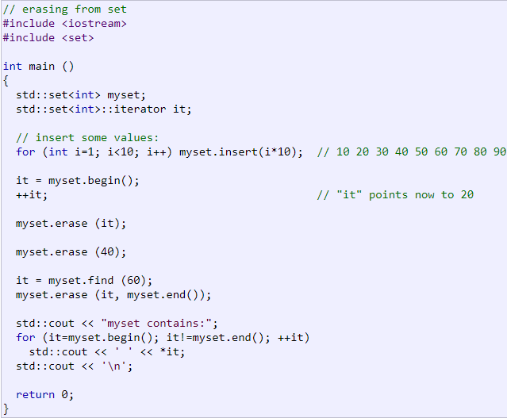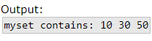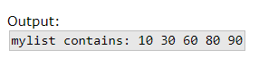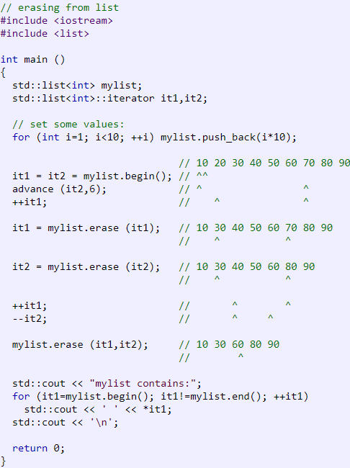

**(List/Set/Map).swap(n)** -> Exchanges the content of the container by the content of x, which is another [list](http://www.cplusplus.com/list) of the same type. Sizes may differ.

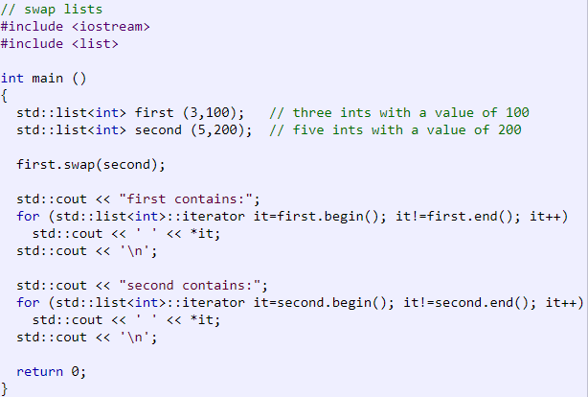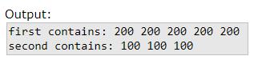

**List.resize()** -> Resizes the container so that it contains n elements.

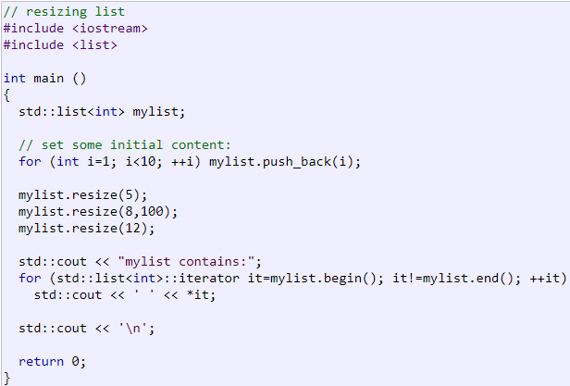

**(List/Set/Map).clear()** -> Removes all elements from the [list](http://www.cplusplus.com/list) container (which are destroyed), and leaving the container with a [size](http://www.cplusplus.com/list::size) of 0.

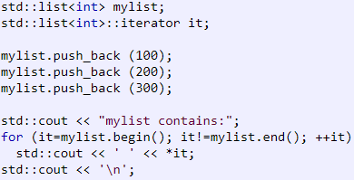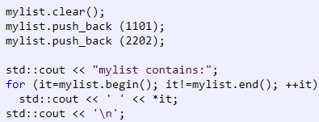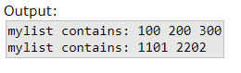

**List.splice(n)** -> Transfers elements from x into the container, inserting them at position.

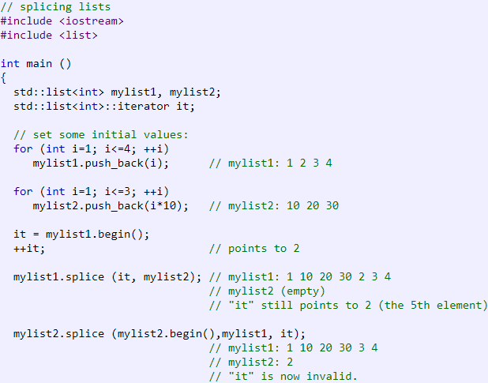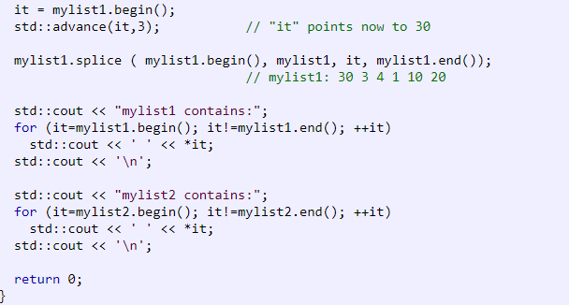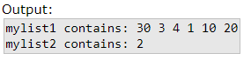

**List.remove_if(n)** -> Removes from the container all the elements for which Predicate pred returns true. This calls the destructor of these objects and reduces the container [size](http://www.cplusplus.com/list::size) by the number of elements removed.

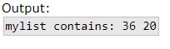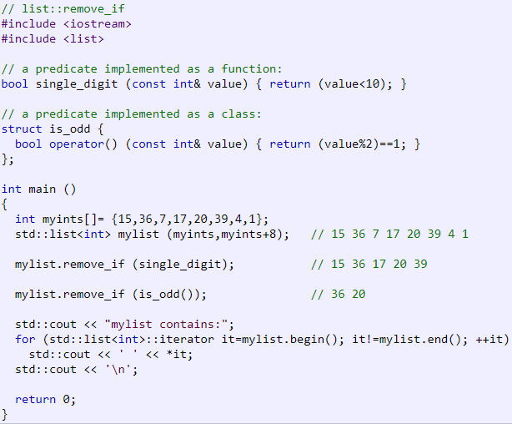

**List.unique(n)** -> The version with no parameters (1), removes all but the first element from every consecutive group of equal elements in the container.

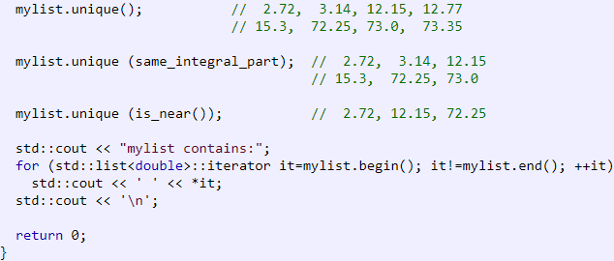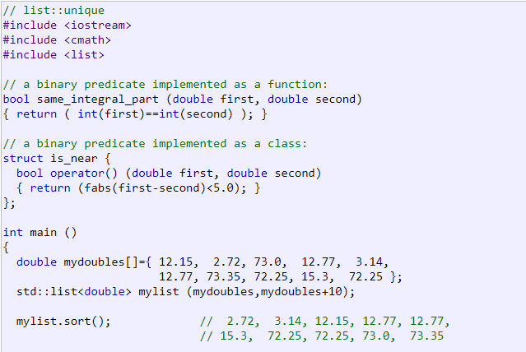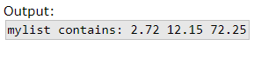

**List.merge(n)** -> Merges x into the [list](http://www.cplusplus.com/list) by transferring all of its elements at their respective ordered positions into the container (both containers shall already be ordered).

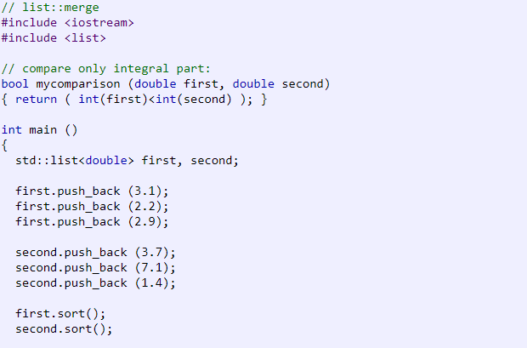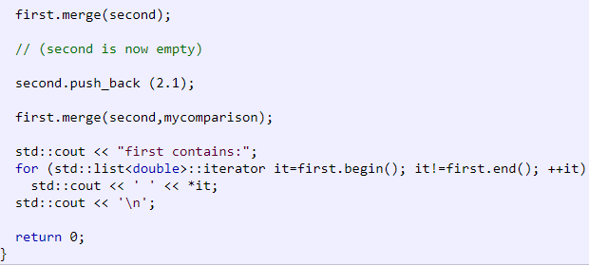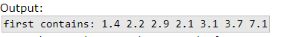

**List.sort()** -> Sorts the elements in the [list](http://www.cplusplus.com/list), altering their position within the container.

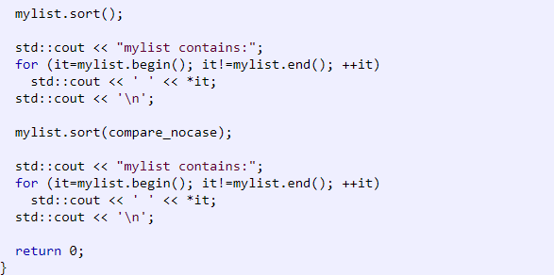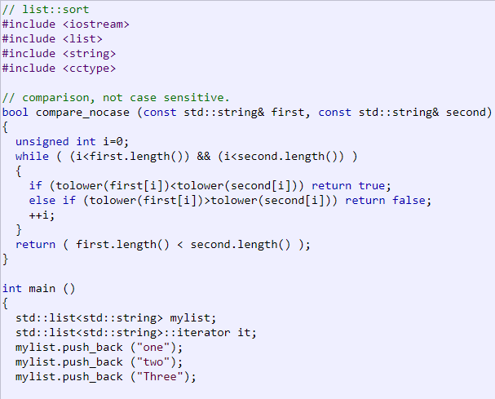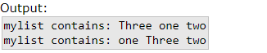

**List.reverse()** -> Reverses the order of the elements in the [list](http://www.cplusplus.com/list) container.

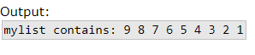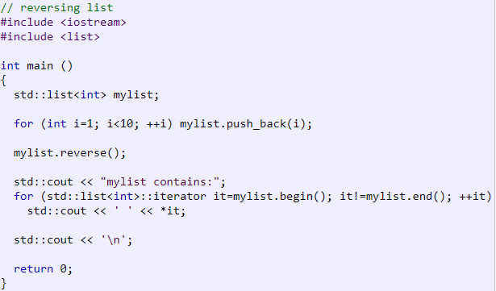

**SET**

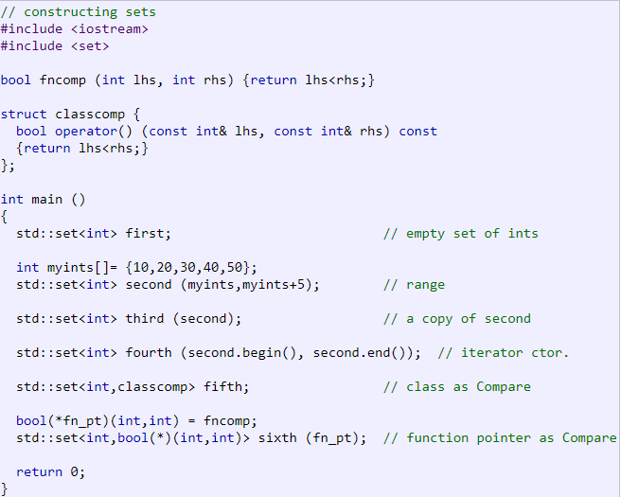**Constructor()** :

**Set.insert(n)** -> Extends the container by inserting new elements, effectively increasing the container [size](http://www.cplusplus.com/set::size) by the number of elements inserted.

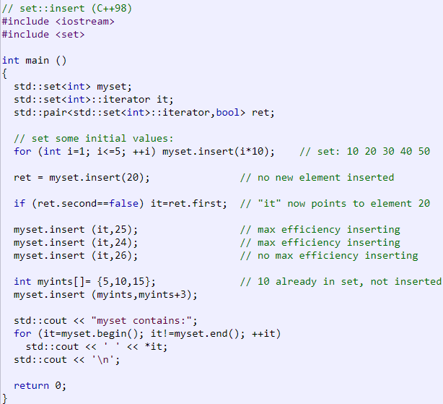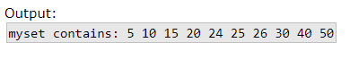

**Set.emplace(n)** -> Inserts a new element in the [set](http://www.cplusplus.com/set), if unique. This new element is constructed in place using args as the arguments for its construction.

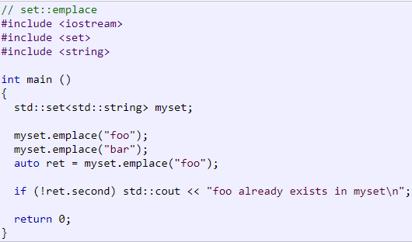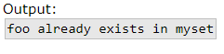

**Set.count(n)** -> Searches the container for elements equivalent to val and returns the number of matches.

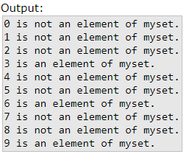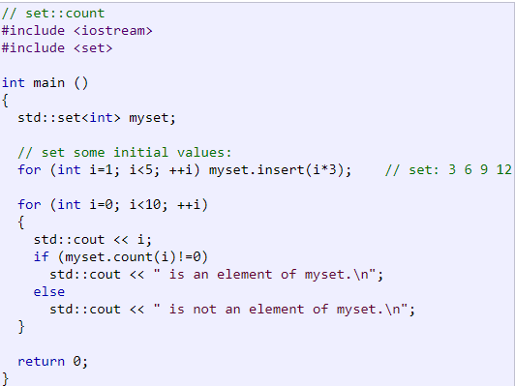

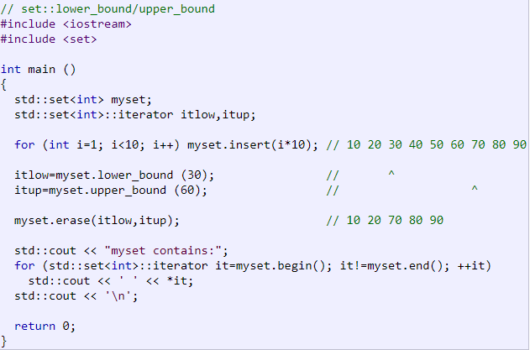**Set.lower_bound(n)** -> Returns an iterator pointing to the first element in the container which is not considered to go before val (i.e., either it is equivalent or goes after).

**Set.upper_bound(n)** -> Returns an iterator pointing to the first element in the container which is considered to go after val.

**Set.find(n)** -> Searches the container for an element equivalent to val and returns an iterator to it if found, otherwise it returns an iterator to [set::end](http://www.cplusplus.com/set::end).

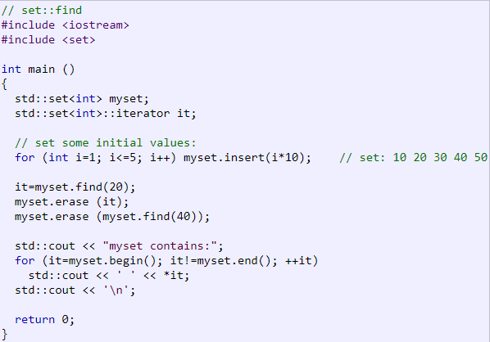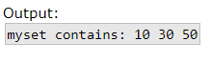

**MAP**

**Constuctor: Operator=**

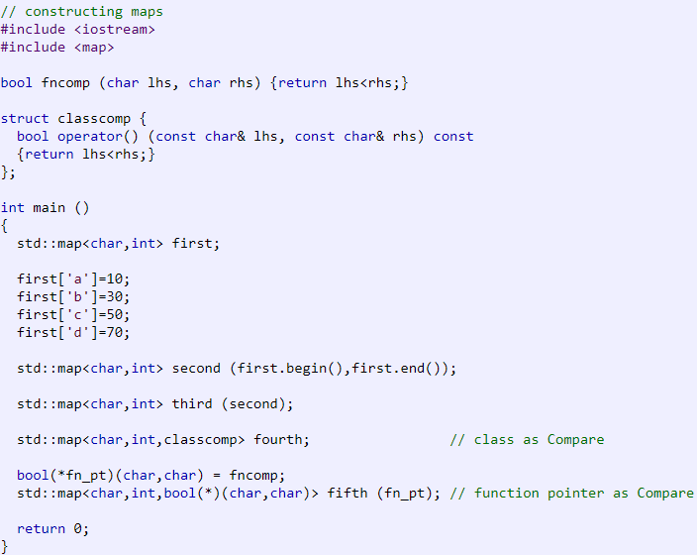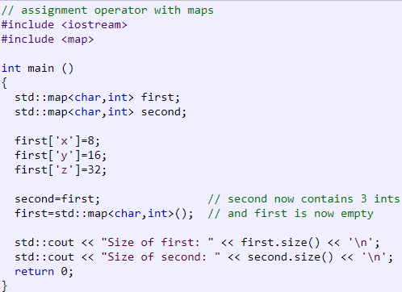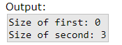

**Operator[]** -> If k matches the key of an element in the container, the function returns a reference to its mapped value.  
  
If k does not match the key of any element in the container, the function inserts a new element with that key and returns a reference to its mapped value. Notice that this always increases the [container size](http://www.cplusplus.com/map::size) by one, even if no mapped value is assigned to the element (the element is constructed using its default constructor).

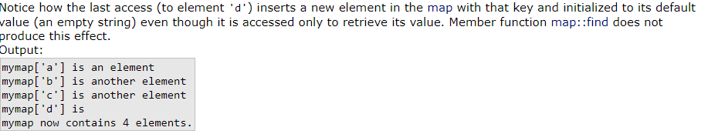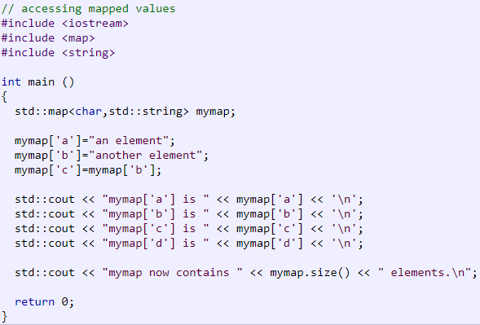

**Map.at(n)** -> Returns a reference to the mapped value of the element identified with key k.  
If k does not match the key of any element in the container, the function throws an [out_of_range](http://www.cplusplus.com/out_of_range) exception.

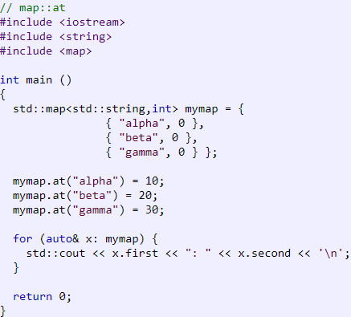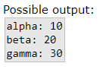

**Map.insert(n)** -> Extends the container by inserting new elements, effectively increasing the container [size](http://www.cplusplus.com/map::size) by the number of elements inserted.

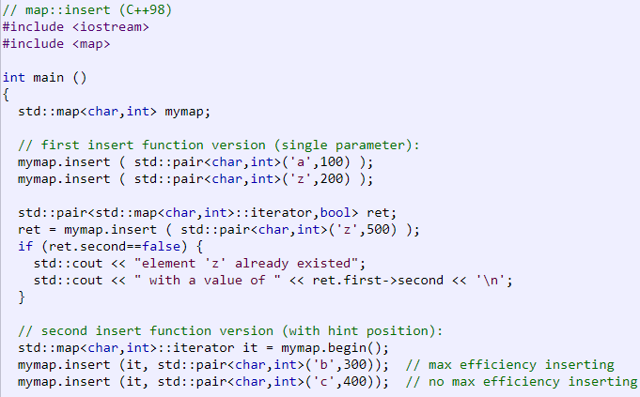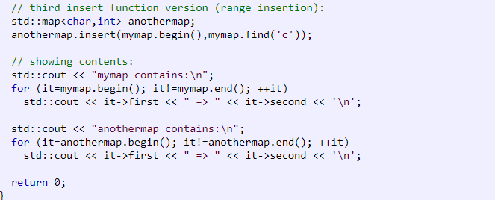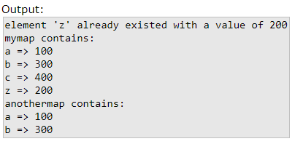

**Map.erase(n)** -> Removes from the [map](http://www.cplusplus.com/map) container either a single element or a range of elements ([first,last)).

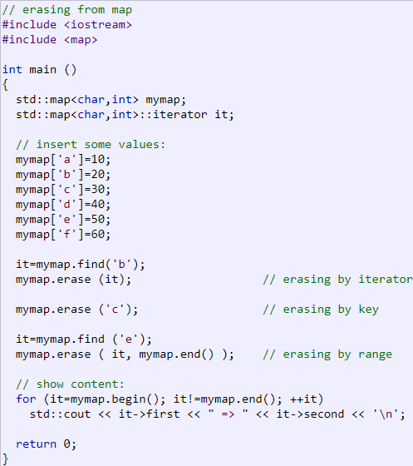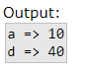

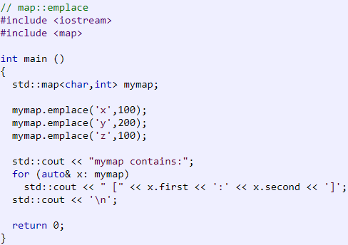**Map.emplace(n)** -> Inserts a new element in the [map](http://www.cplusplus.com/map) if its key is unique. This new element is constructed in place using args as the arguments for the construction of a value_type (which is an object of a [pair](http://www.cplusplus.com/pair) type).

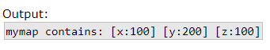

**Map.find(n)** -> Searches the container for an element with a key equivalent to k and returns an iterator to it if found, otherwise it returns an iterator to [map::end](http://www.cplusplus.com/map::end).

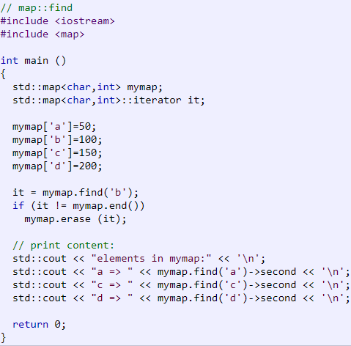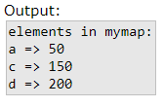

**Map.count(n)** -> Searches the container for elements with a key equivalent to k and returns the number of matches.

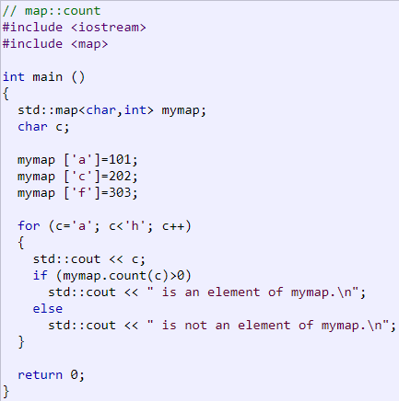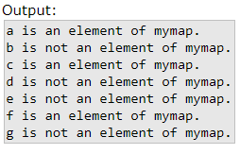

**Map.lower_bound(n)** -> Returns an iterator pointing to the first element in the container whose key is not considered to go before k (i.e., either it is equivalent or goes after).

**Map.upper_bound(n)** -> Returns an iterator pointing to the first element in the container whose key is considered to go after k.

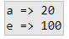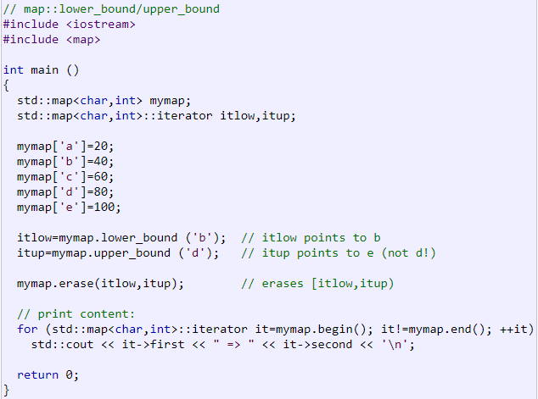

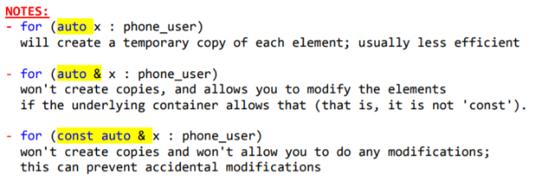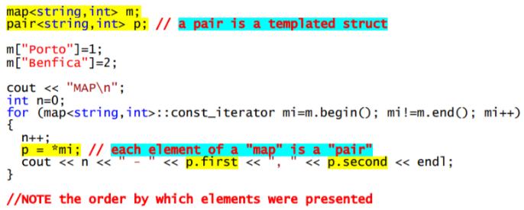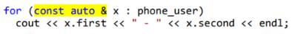

No caso de já existir um contacto com o mesmo número, o bool do pair fica falso (ao dar insert num map, se já existir essa key, não ocorre o insert):

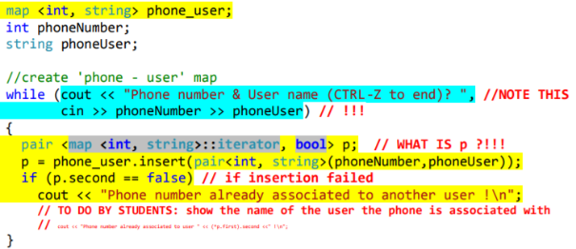

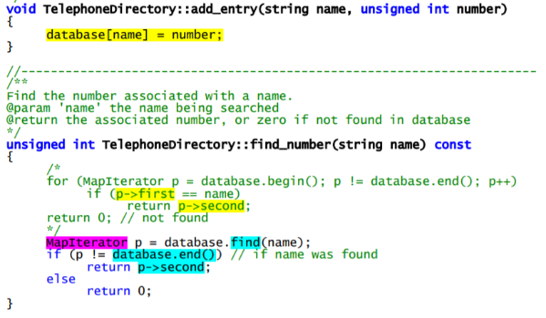**MULTIMAP permite a existência de elementos com a mesma key;**

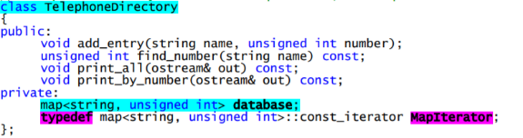

Outra forma de usar iterators:

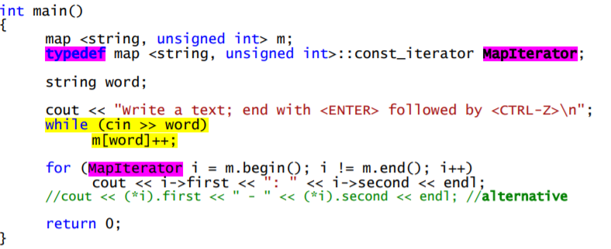

Outro exemplo:

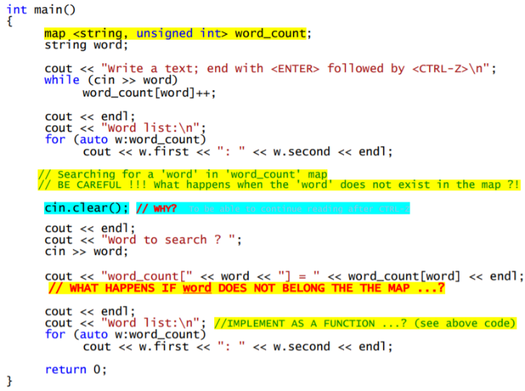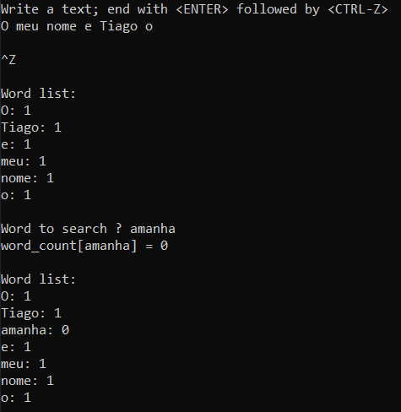

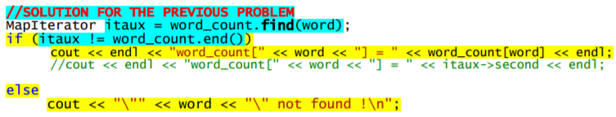

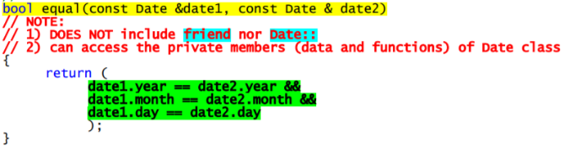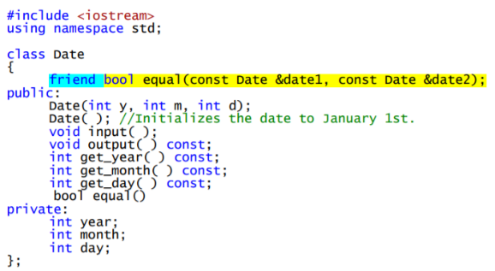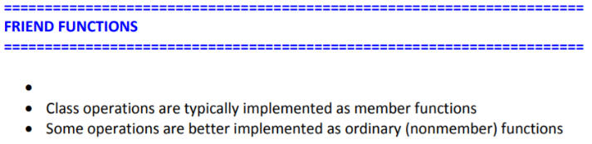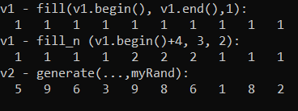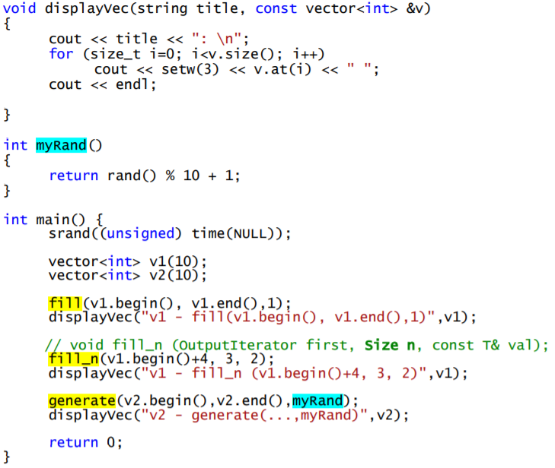

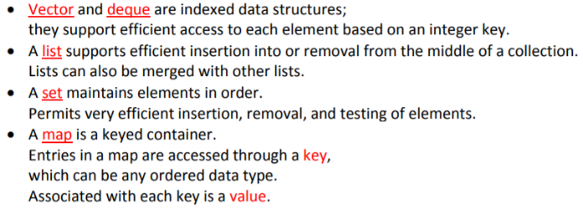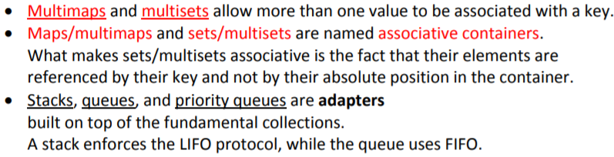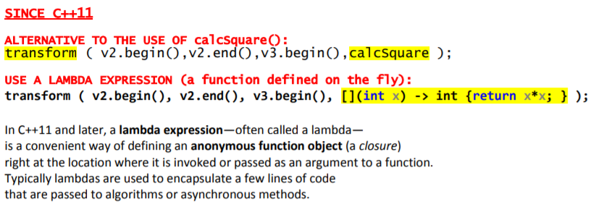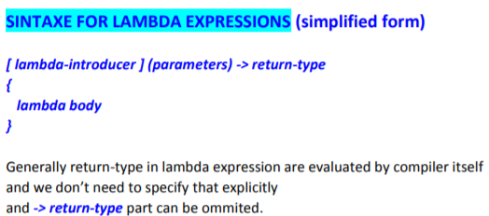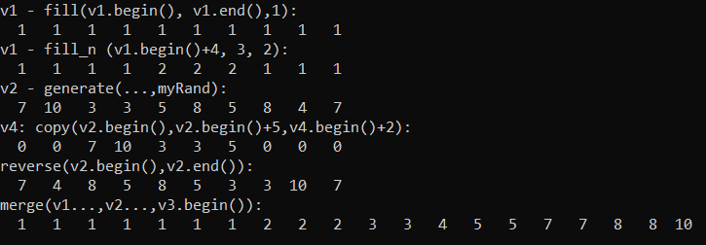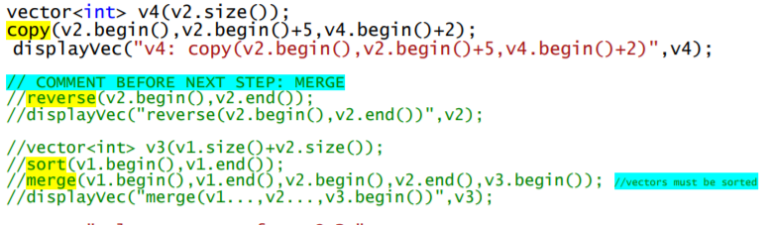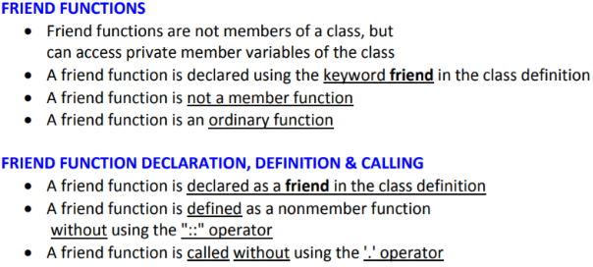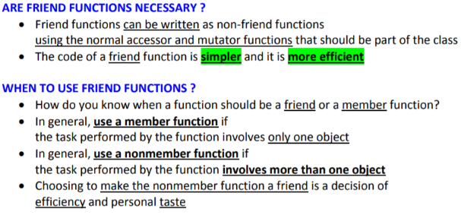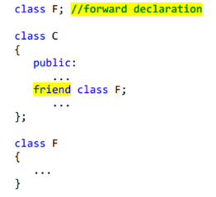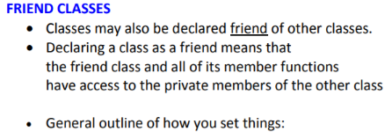



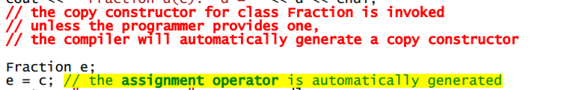

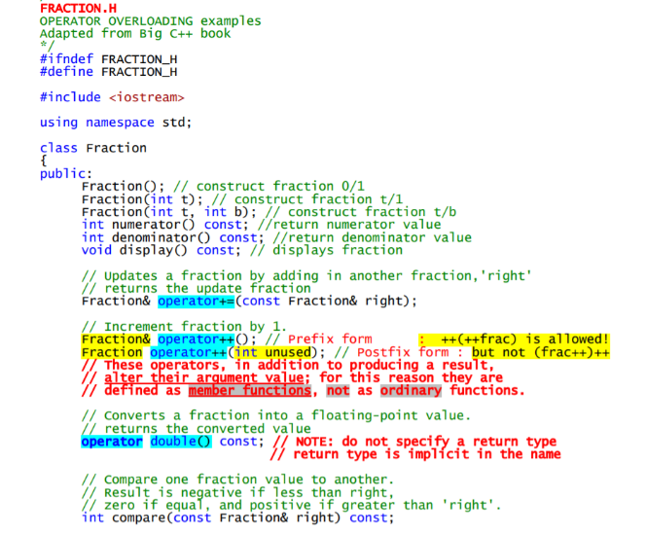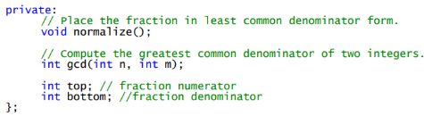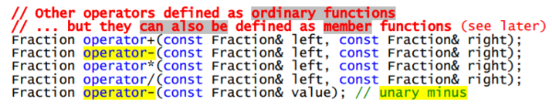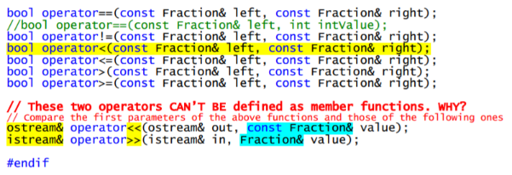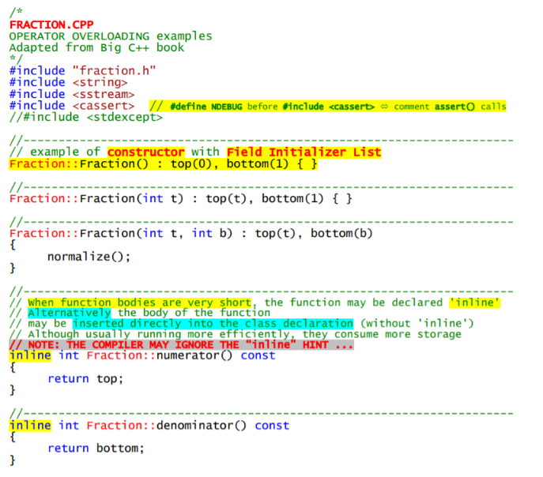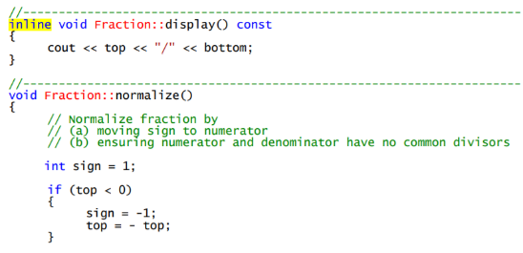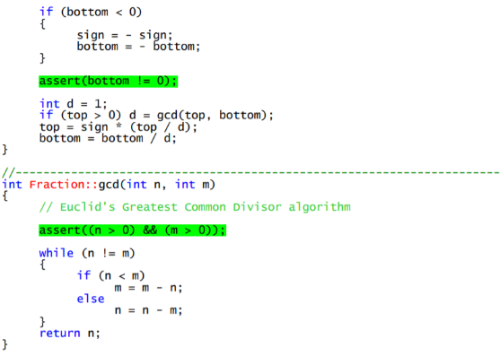

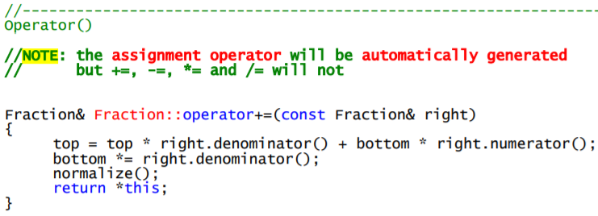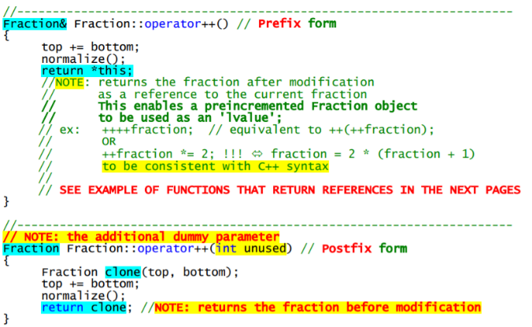

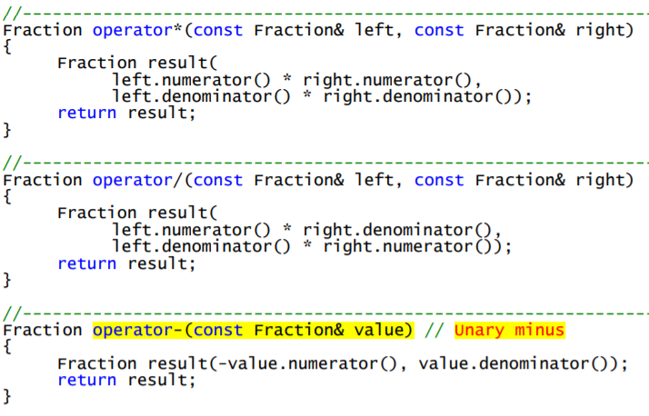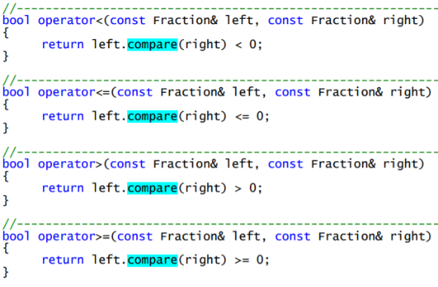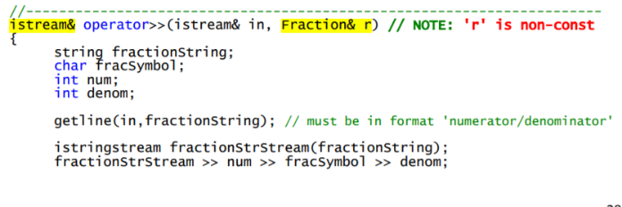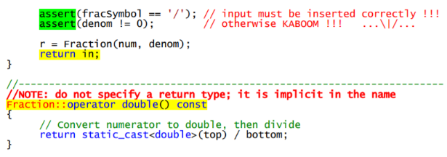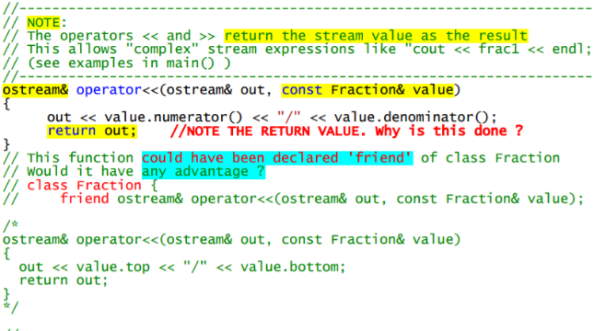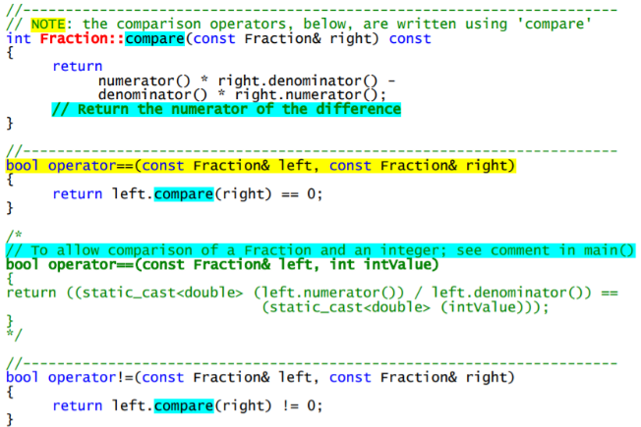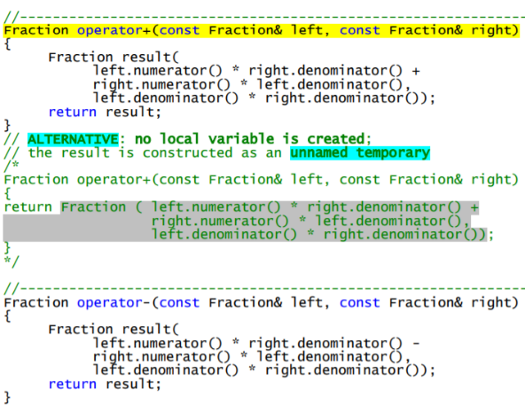

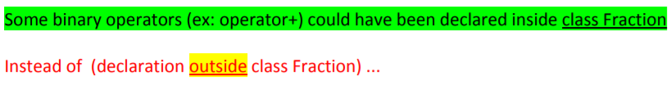

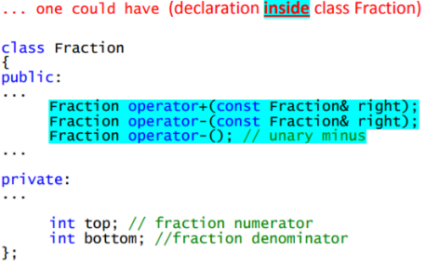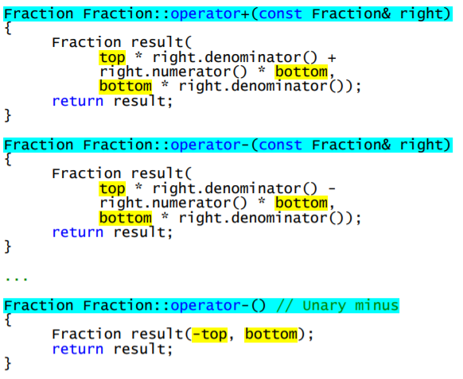

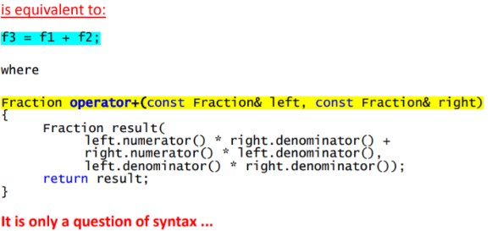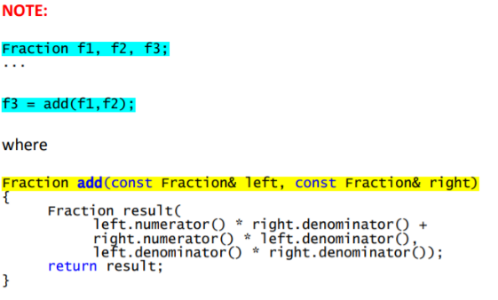

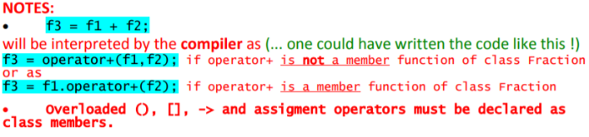

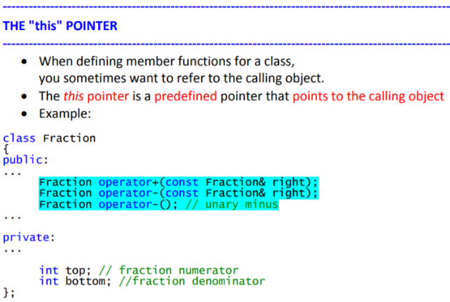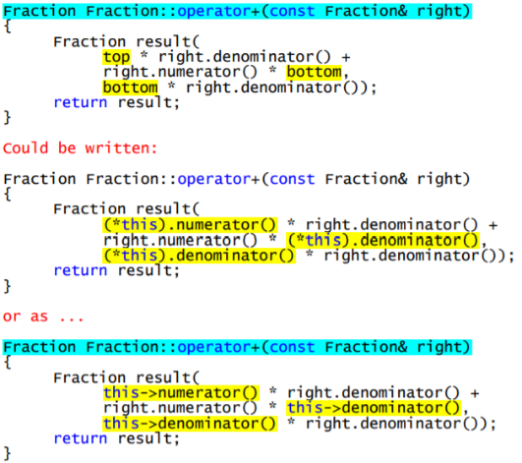

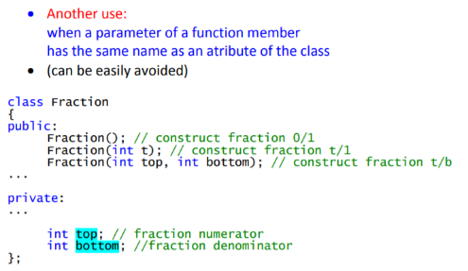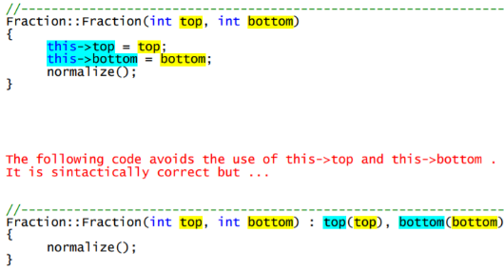

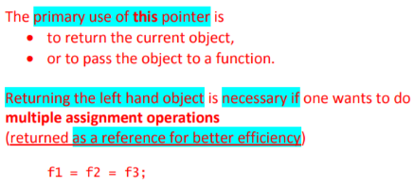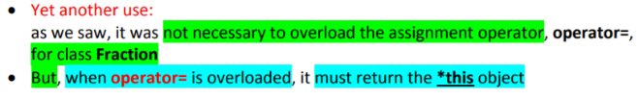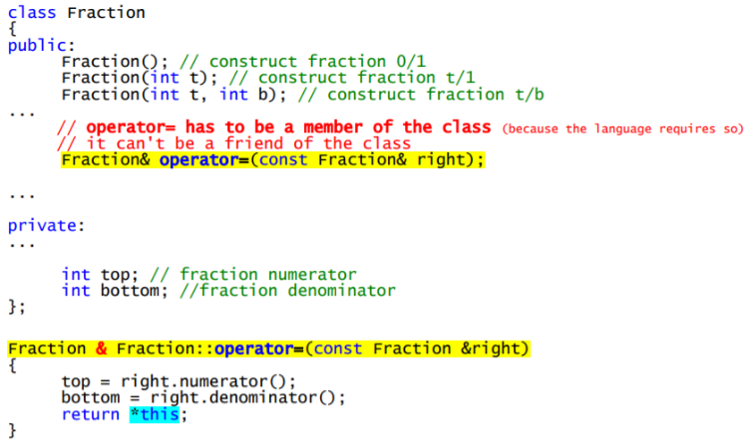

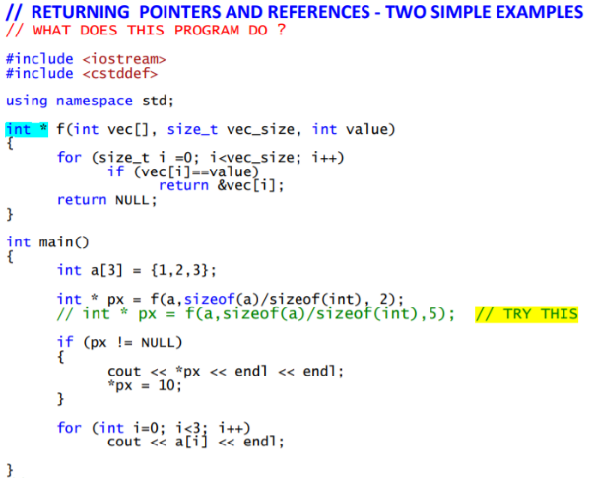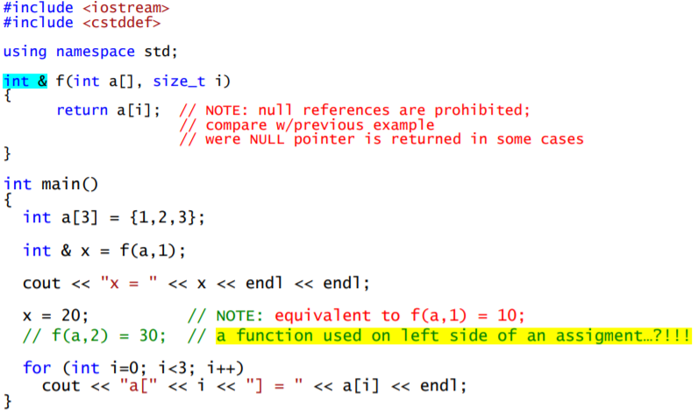

**------------------------------------------------------------------------------------------------------------------------------**

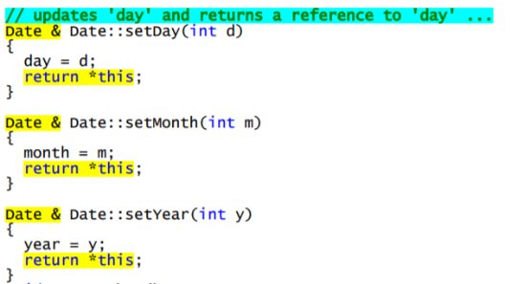

**------------------------------------------------------------------------------------------------------------------------------**

More exemples:

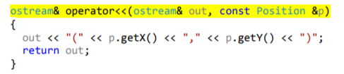

-------------------------------------------------------------------------------------------------------------------------------------

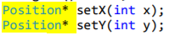

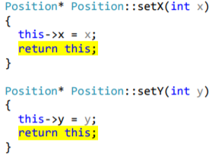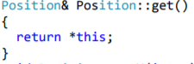



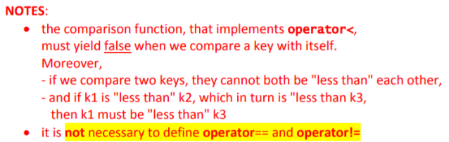Implementar operators em classes criadas para poder utilizá-las em sets (por exemplo):

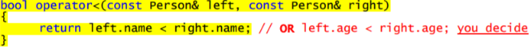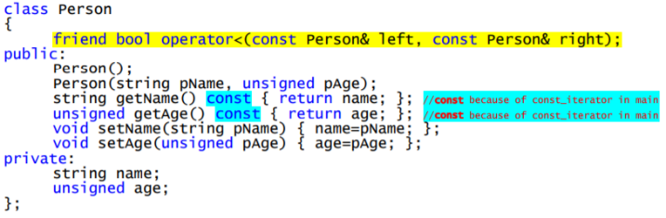

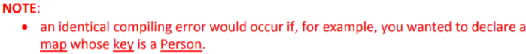No caso de não ter operador:

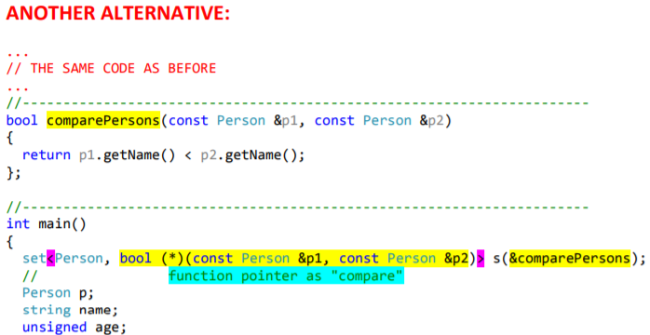

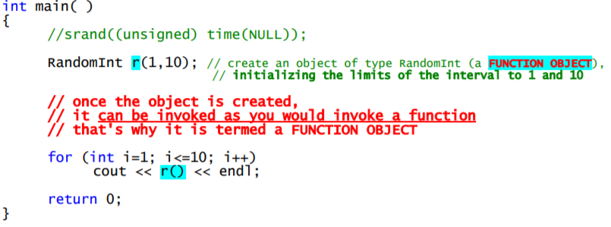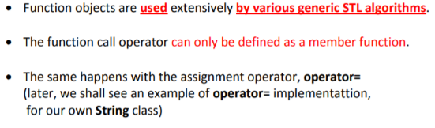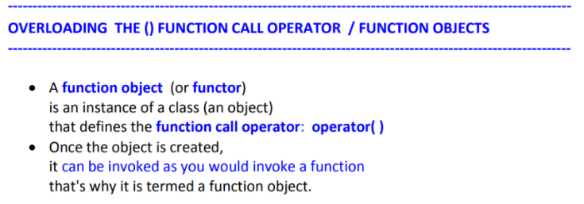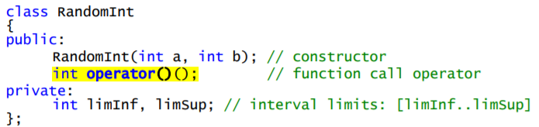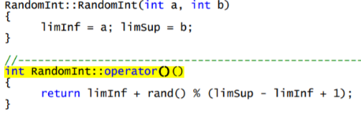

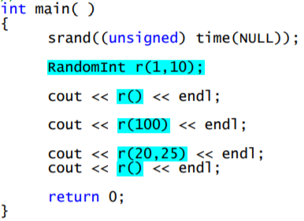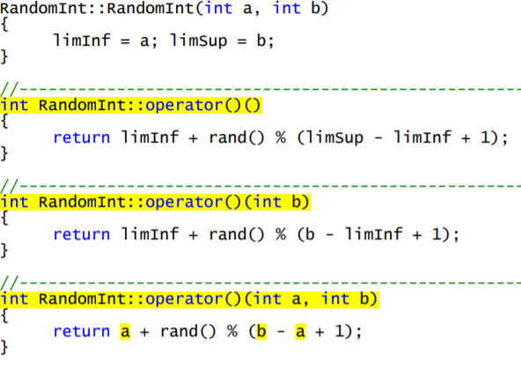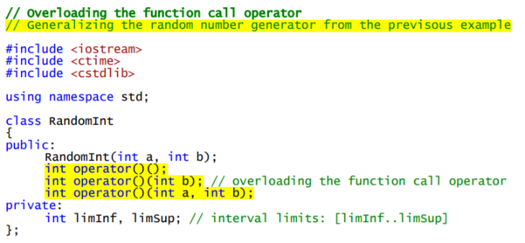

Algumas formas de usar Functions objetcs:

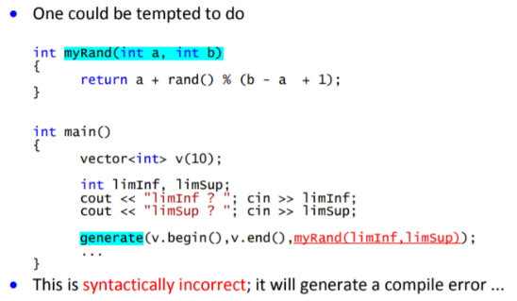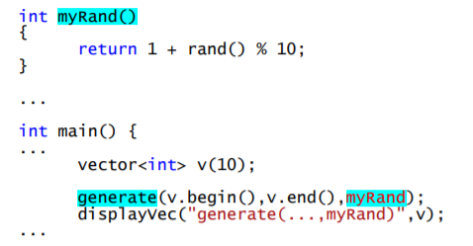

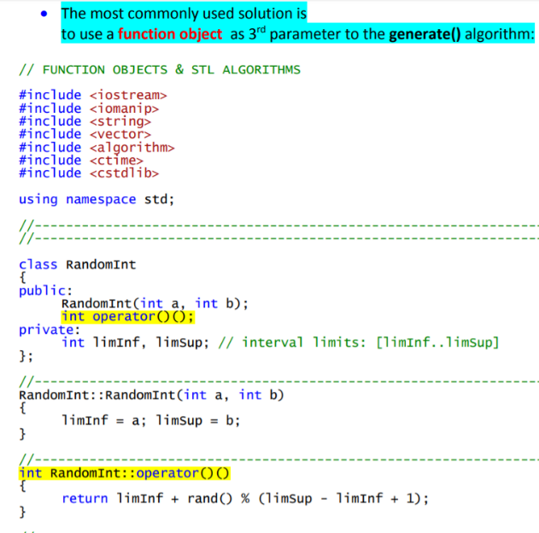Possíveis soluções:

Tornar variáveis globais;

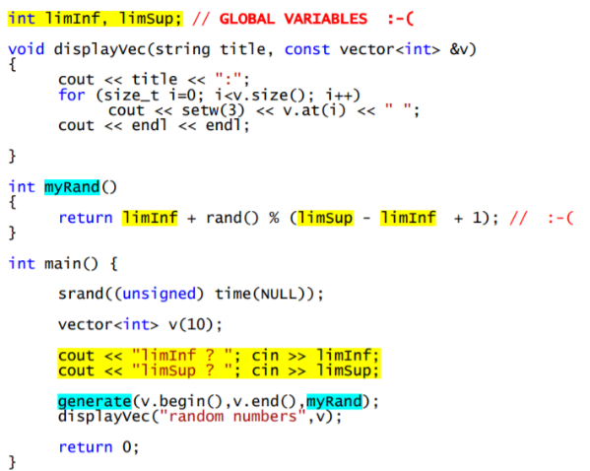 Criar uma classe;

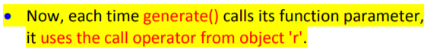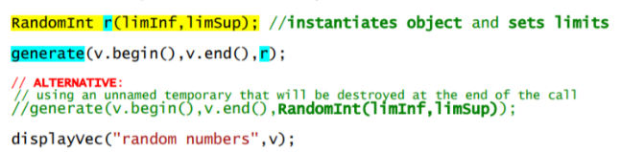Após criar a classe, na main:

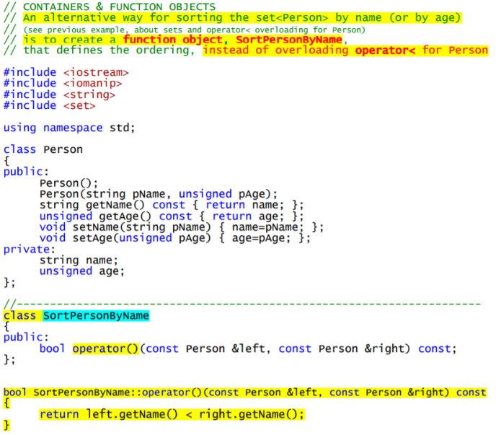

O que permite:

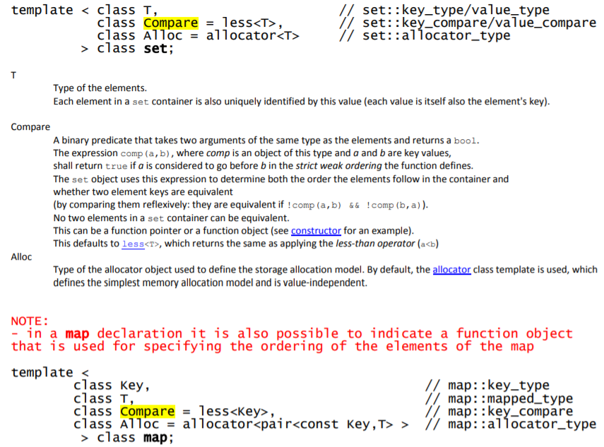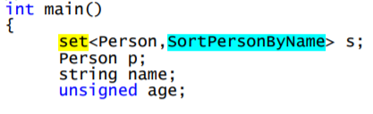

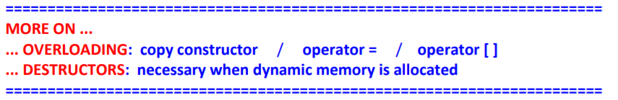

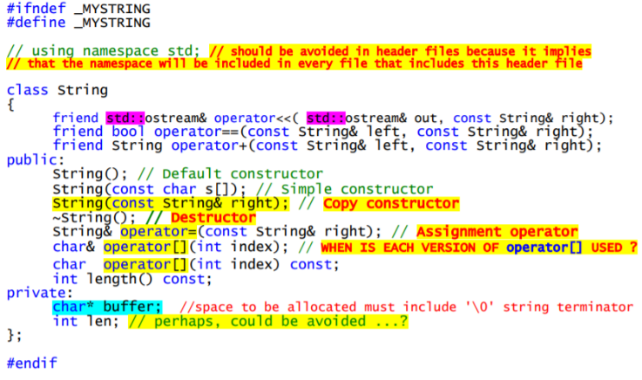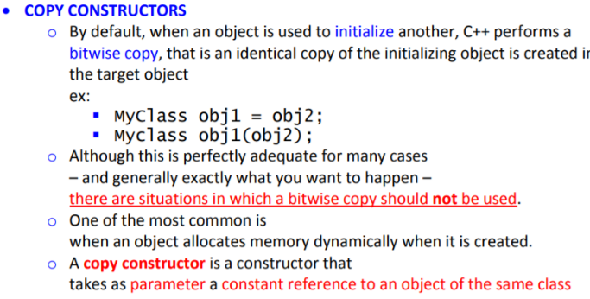

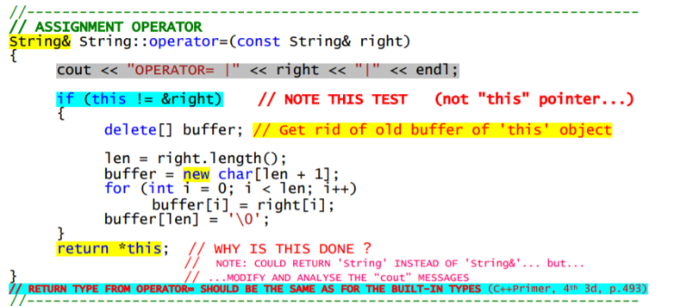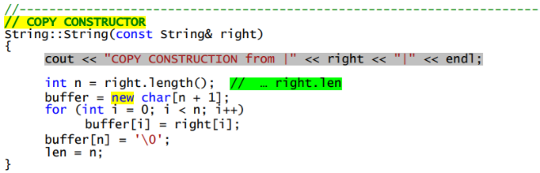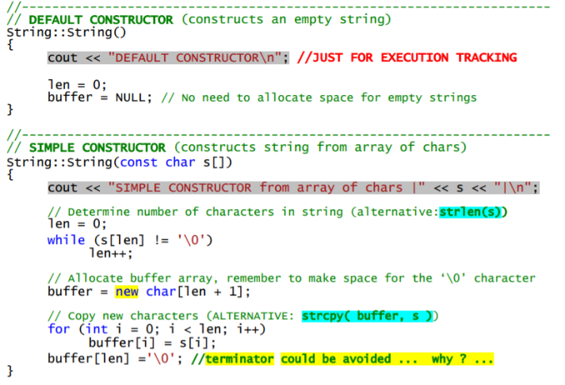

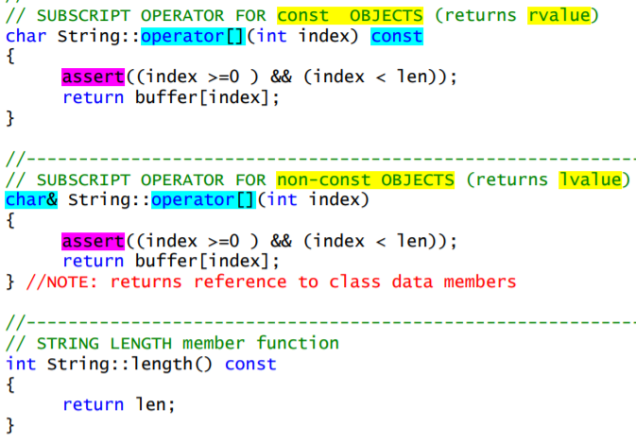

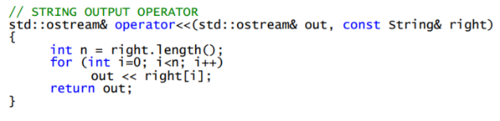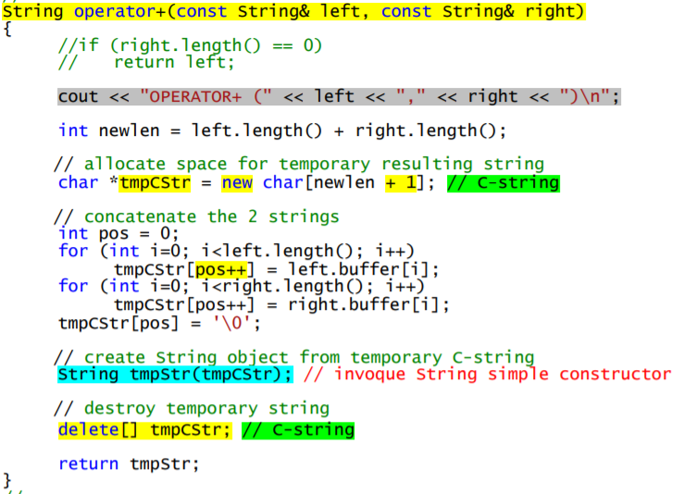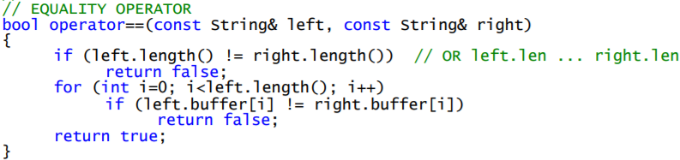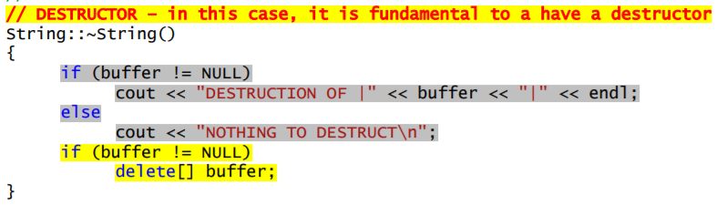

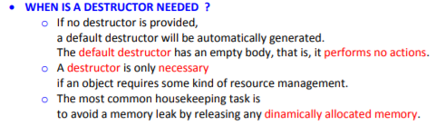

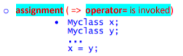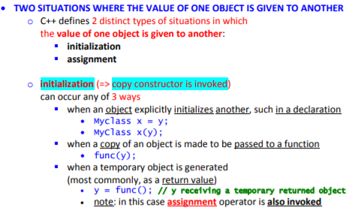

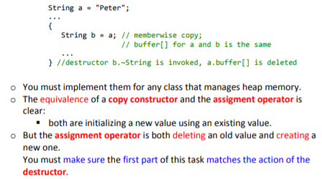

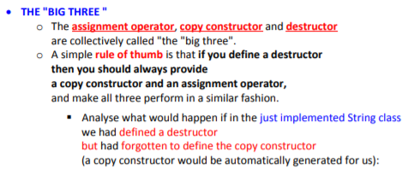

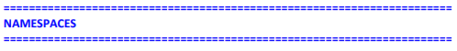

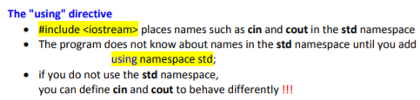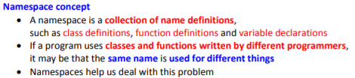

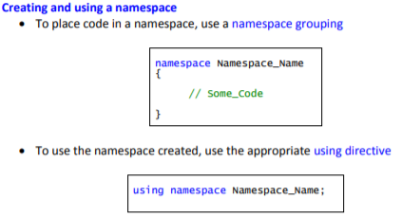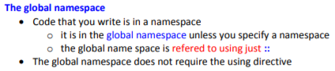

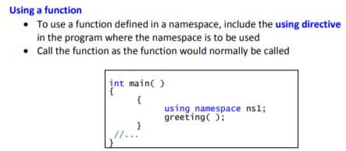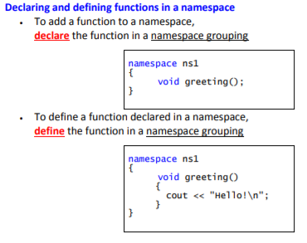

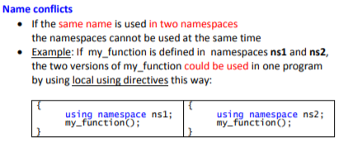

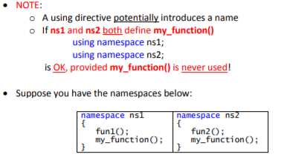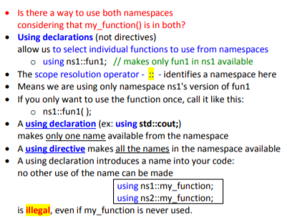

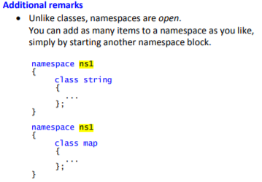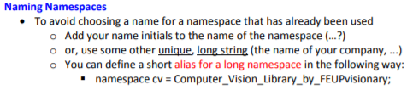

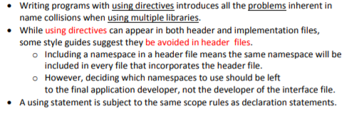

Example:

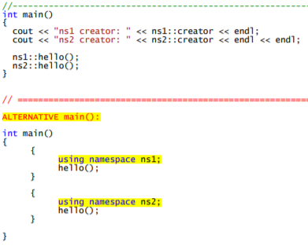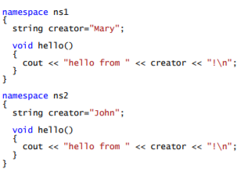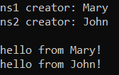

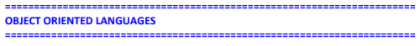

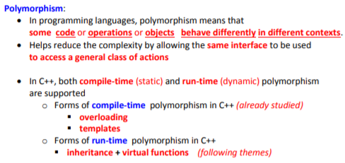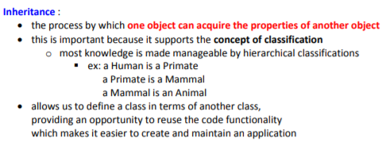

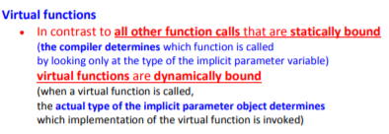

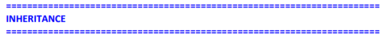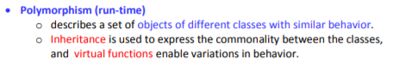

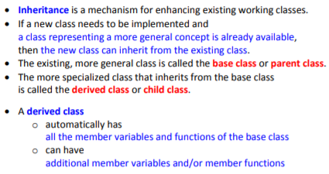

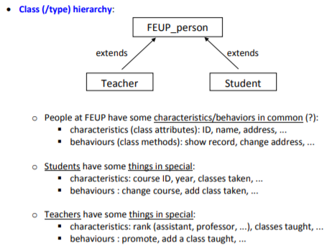

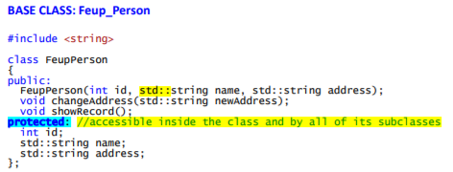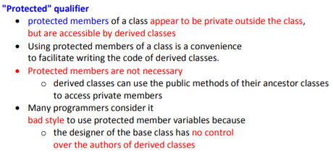

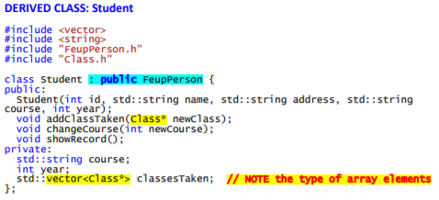

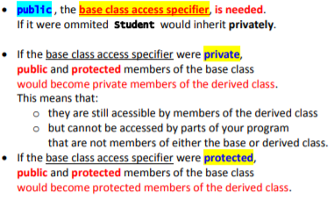

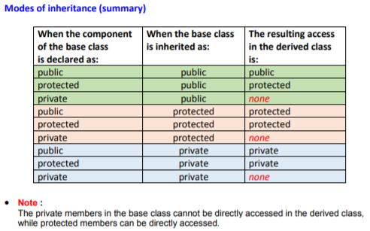

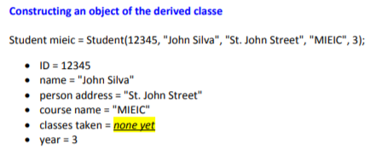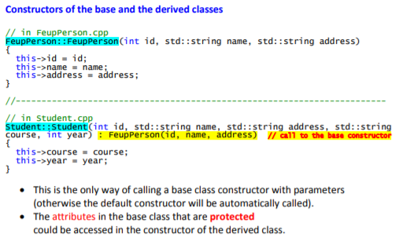

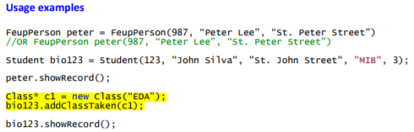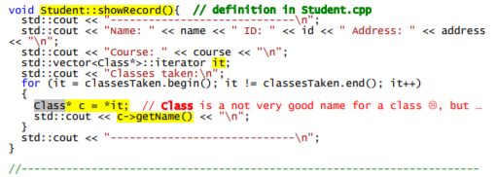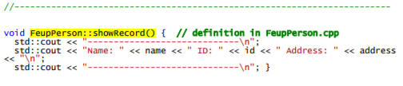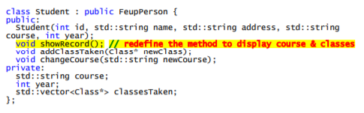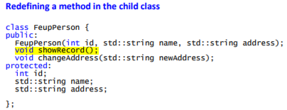

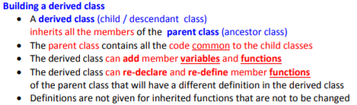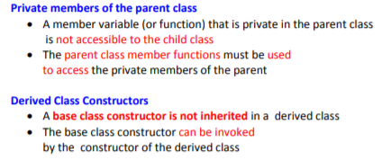

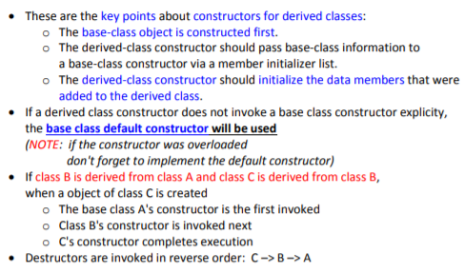

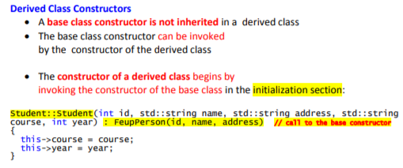

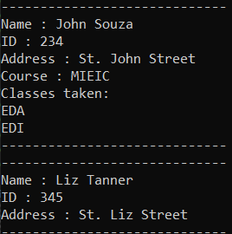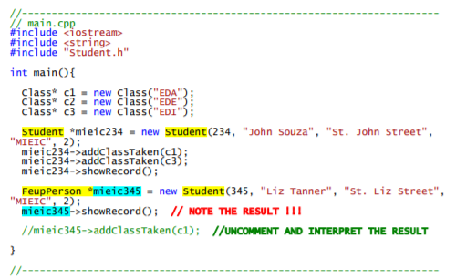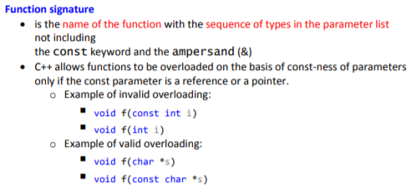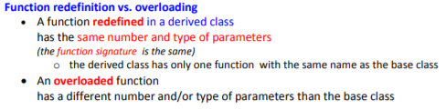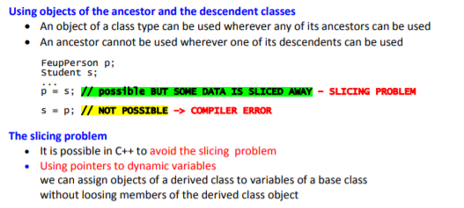

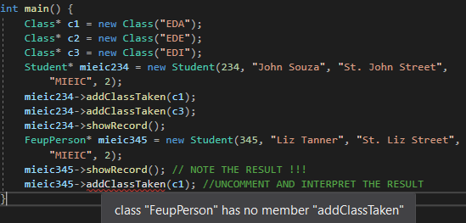



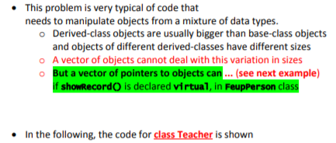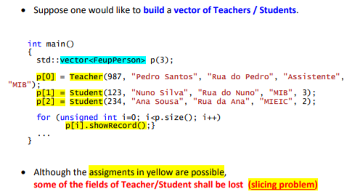

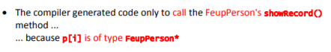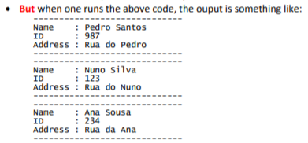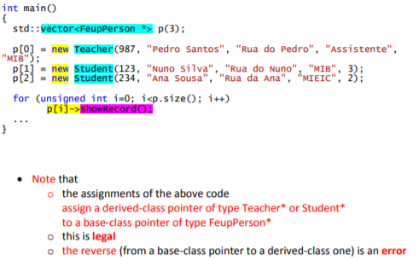

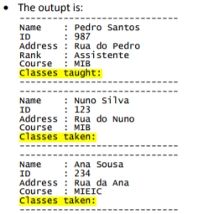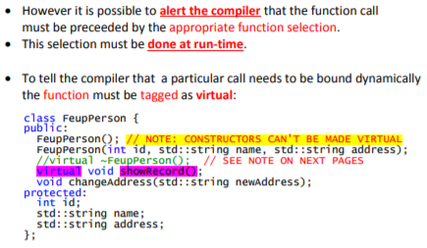

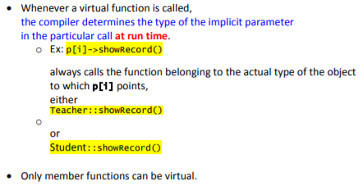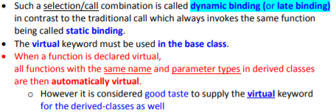

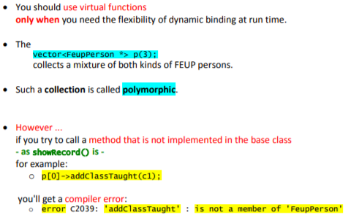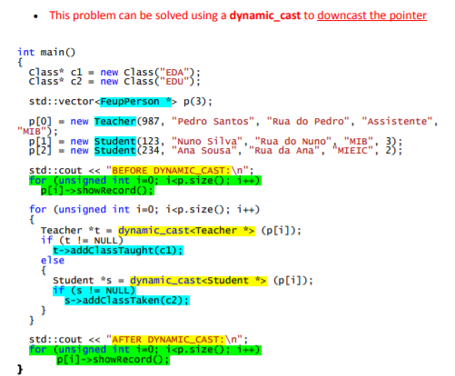

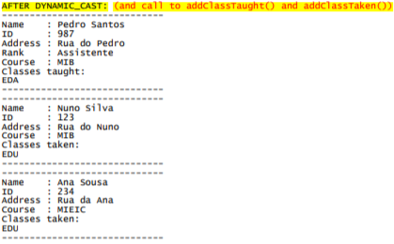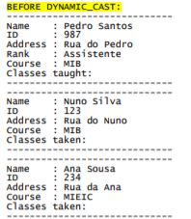

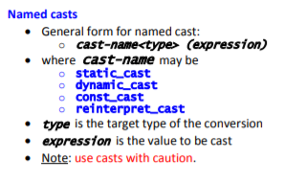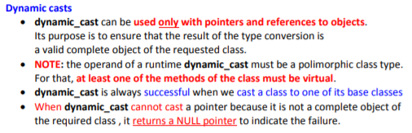

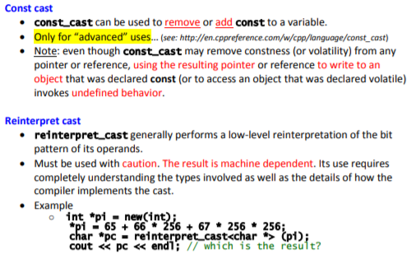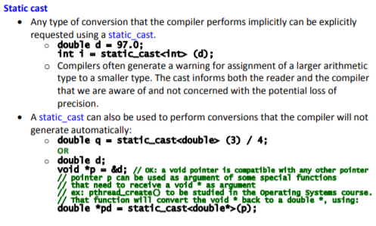

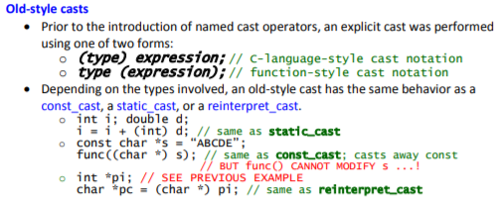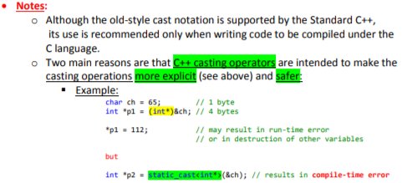

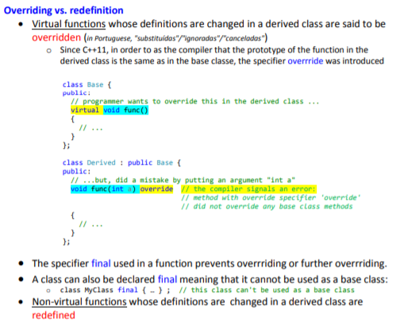

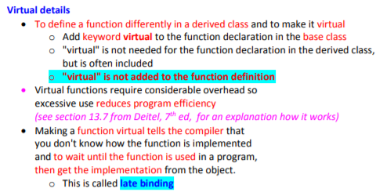

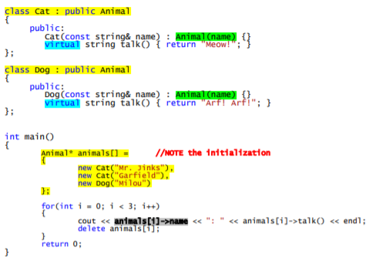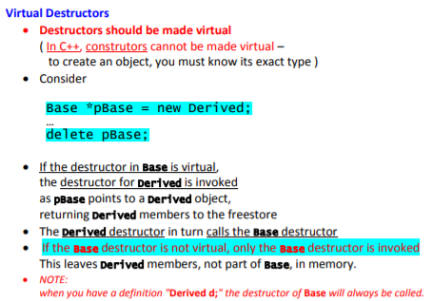

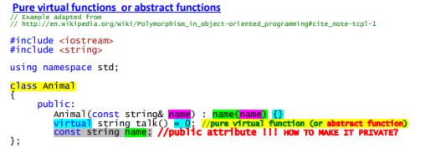

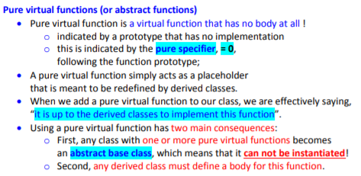

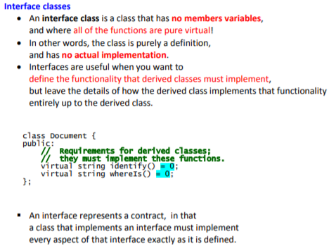

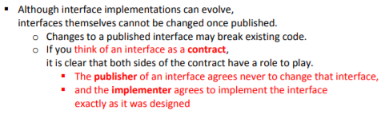

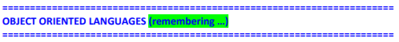

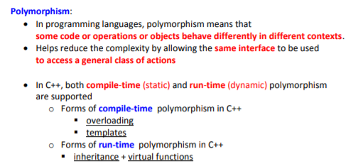

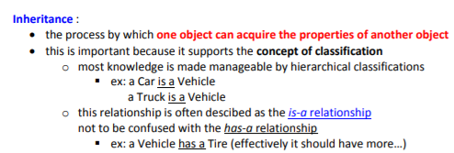

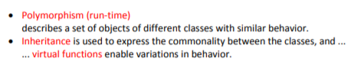

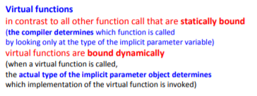

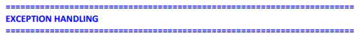

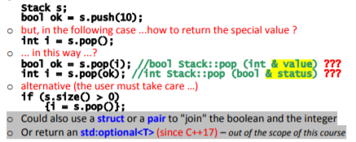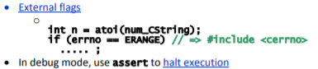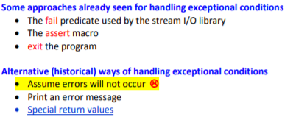

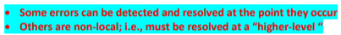

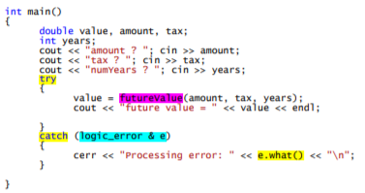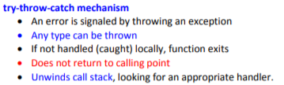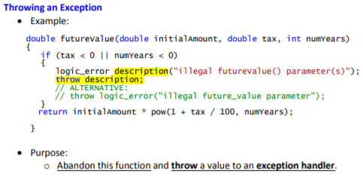

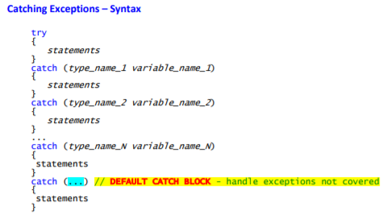

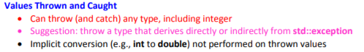

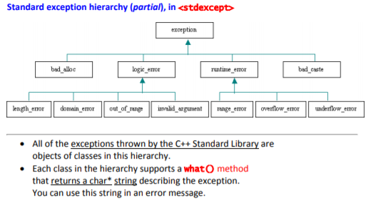

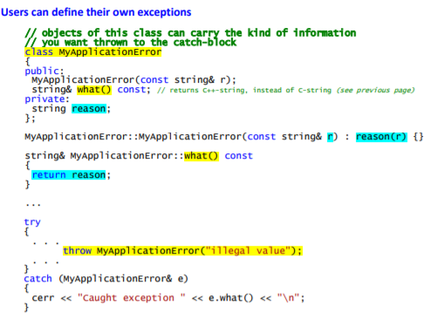

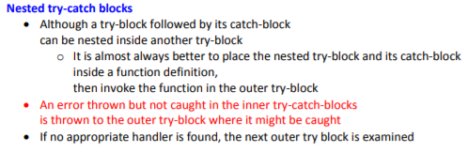

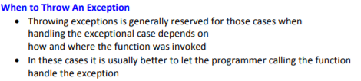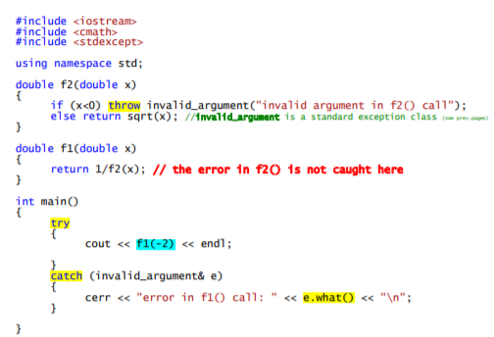

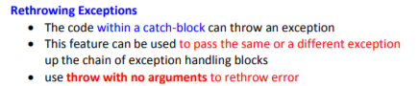

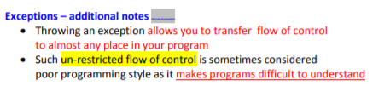

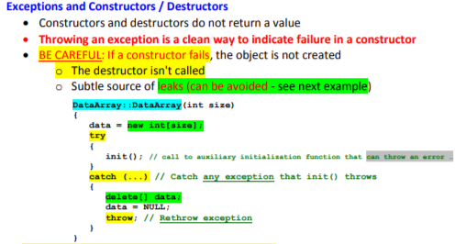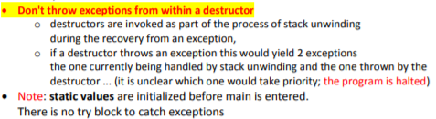

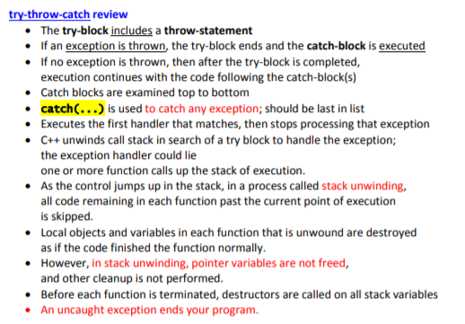

// ## Preprocessor

// Comment to end of line

/* Multi-line comment */

#include <stdio.h> // Insert standard header file

#include "myfile.h" // Insert file in current directory

#define X some text // Replace X with some text

#define F(a,b) a+b // Replace F(1,2) with 1+2

#define X \

some text // Multiline definition

#undef X // Remove definition

#if defined(X) // Conditional compilation (#ifdef X)

#else // Optional (#ifndef X or #if !defined(X))

#endif // Required after #if, #ifdef

// ## Literals

255, 0377, 0xff // Integers (decimal, octal, hex)

2147483647L, 0x7fffffffl // Long (32-bit) integers

123.0, 1.23e2 // double (real) numbers

'a', '\141', '\x61' // Character (literal, octal, hex)

'\n', '\\', '\'', '\"' // Newline, backslash, single quote, double quote

"string\n" // Array of characters ending with newline and \0

"hello" "world" // Concatenated strings

true, false // bool constants 1 and 0

nullptr // Pointer type with the address of 0

// ## Declarations

int x; // Declare x to be an integer (value undefined)

int x=255; // Declare and initialize x to 255

short s; long l; // Usually 16 or 32 bit integer (int may be either)

char c='a'; // Usually 8 bit character

unsigned char u=255;

signed char s=-1; // char might be either

unsigned long x =

0xffffffffL; // short, int, long are signed

float f; double d; // Single or double precision real (never unsigned)

bool b=true; // true or false, may also use int (1 or 0)

int a, b, c; // Multiple declarations

int a[10]; // Array of 10 ints (a[0] through a[9])

int a[]={0,1,2}; // Initialized array (or a[3]={0,1,2}; )

int a[2][2]={{1,2},{4,5}}; // Array of array of ints

char s[]="hello"; // String (6 elements including '\0')

std::string s = "Hello" // Creates string object with value "Hello"

std::string s = R"(Hello

World)"; // Creates string object with value "Hello\nWorld"

int* p; // p is a pointer to (address of) int

char* s="hello"; // s points to unnamed array containing "hello"

void* p=nullptr; // Address of untyped memory (nullptr is 0)

int& r=x; // r is a reference to (alias of) int x

enum weekend {SAT,SUN}; // weekend is a type with values SAT and SUN

enum weekend day; // day is a variable of type weekend

enum weekend{SAT=0,SUN=1}; // Explicit representation as int

enum {SAT,SUN} day; // Anonymous enum

enum class Color {Red,Blue};// Color is a strict type with values Red and Blue

Color x = Color::Red; // Assign Color x to red

typedef String char*; // String s; means char* s;

const int c=3; // Constants must be initialized, cannot assign to

const int* p=a; // Contents of p (elements of a) are constant

int* const p=a; // p (but not contents) are constant

const int* const p=a; // Both p and its contents are constant

const int& cr=x; // cr cannot be assigned to change x

int8_t,uint8_t,int16_t,

uint16_t,int32_t,uint32_t,

int64_t,uint64_t // Fixed length standard types

auto it = m.begin(); // Declares it to the result of m.begin()

auto const param = config["param"];

// Declares it to the const result

auto& s = singleton::instance();

// Declares it to a reference of the result

// ## STORAGE Classes

int x; // Auto (memory exists only while in scope)

static int x; // Global lifetime even if local scope

extern int x; // Information only, declared elsewhere

// ## Statements

x=y; // Every expression is a statement

int x; // Declarations are statements

; // Empty statement

{ // A block is a single statement

int x; // Scope of x is from declaration to end of block

}

if (x) a; // If x is true (not 0), evaluate a

else if (y) b; // If not x and y (optional, may be repeated)

else c; // If not x and not y (optional)

while (x) a; // Repeat 0 or more times while x is true

for (x; y; z) a; // Equivalent to: x; while(y) {a; z;}

for (x : y) a; // Range-based for loop e.g.

// for (auto& x in someList) x.y();

do a; while (x); // Equivalent to: a; while(x) a;

switch (x) { // x must be int

case X1: a; // If x == X1 (must be a const), jump here

case X2: b; // Else if x == X2, jump here

default: c; // Else jump here (optional)

}

break; // Jump out of while, do, or for loop, or switch

continue; // Jump to bottom of while, do, or for loop

return x; // Return x from function to caller

try { a; }

catch (T t) { b; } // If a throws a T, then jump here

catch (...) { c; } // If a throws something else, jump here

// ## Functions

int f(int x, int y); // f is a function taking 2 ints and returning int

void f(); // f is a procedure taking no arguments

void f(int a=0); // f() is equivalent to f(0)

f(); // Default return type is int

inline f(); // Optimize for speed

f() { statements; } // Function definition (must be global)

T operator+(T x, T y); // a+b (if type T) calls operator+(a, b)

T operator-(T x); // -a calls function operator-(a)

T operator++(int); // postfix ++ or -- (parameter ignored)

extern "C" {void f();} // f() was compiled in C

// Function parameters and return values may be of any type. A function must either be declared or defined before

// it is used. It may be declared first and defined later. Every program consists of a set of a set of global variable

// declarations and a set of function definitions (possibly in separate files), one of which must be:

int main() { statements... } // or

int main(int argc, char* argv[]) { statements... }

// `argv` is an array of `argc` strings from the command line.

// By convention, `main` returns status `0` if successful, `1` or higher for errors.

//

// Functions with different parameters may have the same name (overloading). Operators except `::` `.` `.*` `?:` may be overloaded.

// Precedence order is not affected. New operators may not be created.

// ## Expressions

// Operators are grouped by precedence, highest first. Unary operators and assignment evaluate right to left. All

// others are left to right. Precedence does not affect order of evaluation, which is undefined. There are no run time

// checks for arrays out of bounds, invalid pointers, etc.

T::X // Name X defined in class T

N::X // Name X defined in namespace N

::X // Global name X

t.x // Member x of struct or class t

p-> x // Member x of struct or class pointed to by p

a[i] // i'th element of array a

f(x,y) // Call to function f with arguments x and y

T(x,y) // Object of class T initialized with x and y

x++ // Add 1 to x, evaluates to original x (postfix)

x-- // Subtract 1 from x, evaluates to original x

typeid(x) // Type of x

typeid(T) // Equals typeid(x) if x is a T

dynamic_cast< T>(x) // Converts x to a T, checked at run time.

static_cast< T>(x) // Converts x to a T, not checked

reinterpret_cast< T>(x) // Interpret bits of x as a T

const_cast< T>(x) // Converts x to same type T but not const

sizeof x // Number of bytes used to represent object x

sizeof(T) // Number of bytes to represent type T

++x // Add 1 to x, evaluates to new value (prefix)

--x // Subtract 1 from x, evaluates to new value

~x // Bitwise complement of x

!x // true if x is 0, else false (1 or 0 in C)

-x // Unary minus

+x // Unary plus (default)

&x // Address of x

*p // Contents of address p (*&x equals x)

new T // Address of newly allocated T object

new T(x, y) // Address of a T initialized with x, y

new T[x] // Address of allocated n-element array of T

delete p // Destroy and free object at address p

delete[] p // Destroy and free array of objects at p

(T) x // Convert x to T (obsolete, use .._cast<T>(x))

x * y // Multiply

x / y // Divide (integers round toward 0)

x % y // Modulo (result has sign of x)

x + y // Add, or \&x[y]

x - y // Subtract, or number of elements from *x to *y

x << y // x shifted y bits to left (x * pow(2, y))

x >> y // x shifted y bits to right (x / pow(2, y))

x < y // Less than

x <= y // Less than or equal to

x > y // Greater than

x >= y // Greater than or equal to

x & y // Bitwise and (3 & 6 is 2)

x ^ y // Bitwise exclusive or (3 ^ 6 is 5)

x | y // Bitwise or (3 | 6 is 7)

x && y // x and then y (evaluates y only if x (not 0))

x || y // x or else y (evaluates y only if x is false (0))

x = y // Assign y to x, returns new value of x

x += y // x = x + y, also -= *= /= <<= >>= &= |= ^=

x ? y : z // y if x is true (nonzero), else z

throw x // Throw exception, aborts if not caught

x , y // evaluates x and y, returns y (seldom used)

// ## Classes

class T { // A new type

private: // Section accessible only to T's member functions

protected: // Also accessible to classes derived from T

public: // Accessible to all

int x; // Member data

void f(); // Member function

void g() {return;} // Inline member function

void h() const; // Does not modify any data members

int operator+(int y); // t+y means t.operator+(y)

int operator-(); // -t means t.operator-()

T(): x(1) {} // Constructor with initialization list

T(const T& t): x(t.x) {}// Copy constructor

T& operator=(const T& t)

{x=t.x; return *this; } // Assignment operator

~T(); // Destructor (automatic cleanup routine)

explicit T(int a); // Allow t=T(3) but not t=3

T(float x): T((int)x) {}// Delegate constructor to T(int)

operator int() const

{return x;} // Allows int(t)

friend void i(); // Global function i() has private access

friend class U; // Members of class U have private access

static int y; // Data shared by all T objects

static void l(); // Shared code. May access y but not x

class Z {}; // Nested class T::Z

typedef int V; // T::V means int

};

void T::f() { // Code for member function f of class T

this->x = x;} // this is address of self (means x=x;)

int T::y = 2; // Initialization of static member (required)

T::l(); // Call to static member

T t; // Create object t implicit call constructor

t.f(); // Call method f on object t

struct T { // Equivalent to: class T { public:

virtual void i(); // May be overridden at run time by derived class

virtual void g()=0; }; // Must be overridden (pure virtual)

class U: public T { // Derived class U inherits all members of base T

public:

void g(int) override; }; // Override method g

class V: private T {}; // Inherited members of T become private

class W: public T, public U {};

// Multiple inheritance

class X: public virtual T {};

// Classes derived from X have base T directly

// All classes have a default copy constructor, assignment operator, and destructor, which perform the

// corresponding operations on each data member and each base class as shown above. There is also a default no-argument

// constructor (required to create arrays) if the class has no constructors. Constructors, assignment, and

// destructors do not inherit.

// ## Templates

template <class T> T f(T t);// Overload f for all types

template <class T> class X {// Class with type parameter T

X(T t); }; // A constructor

template <class T> X<T>::X(T t) {}

// Definition of constructor

X<int> x(3); // An object of type "X of int"

template <class T, class U=T, int n=0>

// Template with default parameters

// ## Namespaces

namespace N {class T {};} // Hide name T

N::T t; // Use name T in namespace N

using namespace N; // Make T visible without N::

// ## `memory` (dynamic memory management)

#include <memory> // Include memory (std namespace)

shared_ptr<int> x; // Empty shared_ptr to a integer on heap. Uses reference counting for cleaning up objects.

x = make_shared<int>(12); // Allocate value 12 on heap

shared_ptr<int> y = x; // Copy shared_ptr, implicit changes reference count to 2.

cout << *y; // Dereference y to print '12'

if (y.get() == x.get()) { // Raw pointers (here x == y)

cout << "Same";

}

y.reset(); // Eliminate one owner of object

if (y.get() != x.get()) {

cout << "Different";

}

if (y == nullptr) { // Can compare against nullptr (here returns true)

cout << "Empty";

}

y = make_shared<int>(15); // Assign new value

cout << *y; // Dereference x to print '15'

cout << *x; // Dereference x to print '12'

weak_ptr<int> w; // Create empty weak pointer

w = y; // w has weak reference to y.

if (shared_ptr<int> s = w.lock()) { // Has to be copied into a shared_ptr before usage

cout << *s;

}

unique_ptr<int> z; // Create empty unique pointers

unique_ptr<int> q;

z = make_unique<int>(16); // Allocate int (16) on heap. Only one reference allowed.

q = move(z); // Move reference from z to q.

if (z == nullptr){

cout << "Z null";

}

cout << *q;

shared_ptr<B> r;

r = dynamic_pointer_cast<B>(t); // Converts t to a shared_ptr<B>

// ## `math.h`, `cmath` (floating point math)

#include <cmath> // Include cmath (std namespace)

sin(x); cos(x); tan(x); // Trig functions, x (double) is in radians

asin(x); acos(x); atan(x); // Inverses

atan2(y, x); // atan(y/x)

sinh(x); cosh(x); tanh(x); // Hyperbolic sin, cos, tan functions

exp(x); log(x); log10(x); // e to the x, log base e, log base 10

pow(x, y); sqrt(x); // x to the y, square root

ceil(x); floor(x); // Round up or down (as a double)

fabs(x); fmod(x, y); // Absolute value, x mod y

// ## `assert.h`, `cassert` (Debugging Aid)

#include <cassert> // Include iostream (std namespace)

assert(e); // If e is false, print message and abort

#define NDEBUG // (before #include <assert.h>), turn off assert

// ## `iostream.h`, `iostream` (Replaces `stdio.h`)

#include <iostream> // Include iostream (std namespace)

cin >> x >> y; // Read words x and y (any type) from stdin

cout << "x=" << 3 << endl; // Write line to stdout

cerr << x << y << flush; // Write to stderr and flush

c = cin.get(); // c = getchar();

cin.get(c); // Read char

cin.getline(s, n, '\n'); // Read line into char s[n] to '\n' (default)

if (cin) // Good state (not EOF)?

// To read/write any type T:

istream& operator>>(istream& i, T& x) {i >> ...; x=...; return i;}

ostream& operator<<(ostream& o, const T& x) {return o << ...;}

// ## `fstream.h`, `fstream` (File I/O works like `cin`, `cout` as above)

#include <fstream> // Include filestream (std namespace)

ifstream f1("filename"); // Open text file for reading

if (f1) // Test if open and input available

f1 >> x; // Read object from file

f1.get(s); // Read char or line

f1.getline(s, n); // Read line into string s[n]

ofstream f2("filename"); // Open file for writing

if (f2) f2 << x; // Write to file

// ## `string` (Variable sized character array)

#include <string> // Include string (std namespace)

string s1, s2="hello"; // Create strings

s1.size(), s2.size(); // Number of characters: 0, 5

s1 += s2 + ' ' + "world"; // Concatenation

s1 == "hello world" // Comparison, also <, >, !=, etc.

s1[0]; // 'h'

s1.substr(m, n); // Substring of size n starting at s1[m]

s1.c_str(); // Convert to const char*

s1 = to_string(12.05); // Converts number to string

getline(cin, s); // Read line ending in '\n'

// ## `vector` (Variable sized array/stack with built in memory allocation)

#include <vector> // Include vector (std namespace)

vector<int> a(10); // a[0]..a[9] are int (default size is 0)

vector<int> b{1,2,3}; // Create vector with values 1,2,3

a.size(); // Number of elements (10)

a.push_back(3); // Increase size to 11, a[10]=3

a.back()=4; // a[10]=4;

a.pop_back(); // Decrease size by 1

a.front(); // a[0];

a[20]=1; // Crash: not bounds checked

a.at(20)=1; // Like a[20] but throws out_of_range()

for (int& p : a)

p=0; // C++11: Set all elements of a to 0

for (vector<int>::iterator p=a.begin(); p!=a.end(); ++p)

*p=0; // C++03: Set all elements of a to 0

vector<int> b(a.begin(), a.end()); // b is copy of a

vector<T> c(n, x); // c[0]..c[n-1] init to x

T d[10]; vector<T> e(d, d+10); // e is initialized from d

// ## `deque` (Array stack queue)

// `deque<T>` is like `vector<T>`, but also supports:

#include <deque> // Include deque (std namespace)

a.push_front(x); // Puts x at a[0], shifts elements toward back

a.pop_front(); // Removes a[0], shifts toward front

// ## `utility` (pair)

#include <utility> // Include utility (std namespace)

pair<string, int> a("hello", 3); // A 2-element struct

a.first; // "hello"

a.second; // 3

// ## `map` (associative array - usually implemented as binary search trees - avg. time complexity: O(log n))

#include <map> // Include map (std namespace)

map<string, int> a; // Map from string to int

a["hello"] = 3; // Add or replace element a["hello"]

for (auto& p:a)

cout << p.first << p.second; // Prints hello, 3

a.size(); // 1

// ## `unordered_map` (associative array - usually implemented as hash table - avg. time complexity: O(1))

#include <unordered_map> // Include map (std namespace)

unordered_map<string, int> a; // Map from string to int

a["hello"] = 3; // Add or replace element a["hello"]

for (auto& p:a)

cout << p.first << p.second; // Prints hello, 3

a.size(); // 1

// ## `set` (store unique elements - usually implemented as binary search trees - avg. time complexity: O(log n))

#include <set> // Include set (std namespace)

set<int> s; // Set of integers

s.insert(123); // Add element to set

if (s.find(123) != s.end()) // Search for an element

s.erase(123);

cout << s.size(); // Number of elements in set

// ## `unordered_set` (store unique elements - usually implemented as a hash set - avg. time complexity: O(1))

#include <unordered_set> // Include set (std namespace)

unordered_set<int> s; // Set of integers

s.insert(123); // Add element to set

if (s.find(123) != s.end()) // Search for an element

s.erase(123);

cout << s.size(); // Number of elements in set

// ## `algorithm` (A collection of 60 algorithms on sequences with iterators)

#include <algorithm> // Include algorithm (std namespace)

min(x, y); max(x, y); // Smaller/larger of x, y (any type defining <)

swap(x, y); // Exchange values of variables x and y

sort(a, a+n); // Sort array a[0]..a[n-1] by <

sort(a.begin(), a.end()); // Sort vector or deque

reverse(a.begin(), a.end()); // Reverse vector or deque

// ## `chrono` (Time related library)

#include <chrono> // Include chrono

using namespace std::chrono; // Use namespace

auto from = // Get current time_point

high_resolution_clock::now();

// ... do some work

auto to = // Get current time_point

high_resolution_clock::now();

using ms = // Define ms as floating point duration

duration<float, milliseconds::period>;

// Compute duration in milliseconds

cout << duration_cast<ms>(to - from)

.count() << "ms";

// ## `thread` (Multi-threading library)

#include <thread> // Include thread

unsigned c =

hardware_concurrency(); // Hardware threads (or 0 for unknown)

auto lambdaFn = [](){ // Lambda function used for thread body

cout << "Hello multithreading";

};

thread t(lambdaFn); // Create and run thread with lambda

t.join(); // Wait for t finishes

// --- shared resource example ---

mutex mut; // Mutex for synchronization

condition_variable cond; // Shared condition variable

const char* sharedMes // Shared resource

= nullptr;

auto pingPongFn = // thread body (lambda). Print someone else's message

[&](const char* mes){

while (true){

unique_lock<mutex> lock(mut);// locks the mutex

do {

cond.wait(lock, [&](){ // wait for condition to be true (unlocks while waiting which allows other threads to modify)

return sharedMes != mes; // statement for when to continue

});

} while (sharedMes == mes); // prevents spurious wakeup

cout << sharedMes << endl;

sharedMes = mes;

lock.unlock(); // no need to have lock on notify

cond.notify_all(); // notify all condition has changed

}

};

sharedMes = "ping";

thread t1(pingPongFn, sharedMes); // start example with 3 concurrent threads

thread t2(pingPongFn, "pong");

thread t3(pingPongFn, "boing");

// ## `future` (thread support library)

#include <future> // Include future

function<int(int)> fib = // Create lambda function

[&](int i){

if (i <= 1){

return 1;

}

return fib(i-1)

+ fib(i-2);

};

future<int> fut = // result of async function

async(launch::async, fib, 4); // start async function in other thread

// do some other work

cout << fut.get(); // get result of async function. Wait if needed.